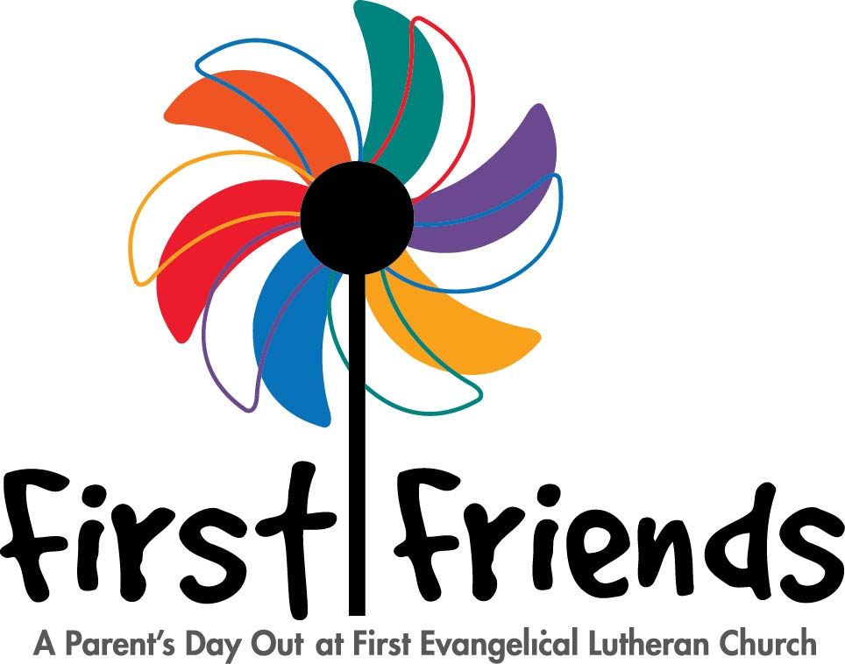
Office Use Only
Registration Fee Paid: Yes __________
Supply Fee Paid: Yes _________________
Amount _________ Check # __________
Date Received ________________________
Immunization Record: Yes _________
Monthly Tuition _____________________
Sibling _____________ Age _____________
Class _______________ Start: ___________

Registration Form
Full Name of Child _________________________ ________________________ ____________________________
First Middle Last

Name Child Goes By ____________________________ Sex ________ Date of Birth ______-______-_______
Mother’s Name _________________--____________ Father’s Name____________________________________
Does child live with both parents? Yes _________ No ________ If not, with whom? ______________
Street Address or PO Box_________________________________________________________________________
City/State ________________________________________ Zip Code _____________________________________
Email Address ______________________________________________
Home Phone __________________ Mother’s Cell _________________ Father’s Cell ____________________
Church Member? Yes __________No __________ If yes, where______________________________________
Interested in Church Membership at First Evangelical Lutheran? Yes_________ No_________
Persons to whom child may be released and relationship to child:
_____________________________________________________________________________________________________
Name of person authorized to act for parent in case of emergency:
Name: __________________________________________ Phone: ________________________________________
Child’s Physician _______________________________________ Phone: ________________________________
Does your child have allergies? Yes ______No_______ If yes, what? ____________________________
Please give any other information the teacher should know about your child’s physical condition, habits, likes and dislikes, nap time, etc.
_____________________________________________________________________________________________________
_____________________________________________________________________________________________________
Signature ____________________________________________________________Date _______________________
Amanda McClanahan, First Friends Director • First Evangelical Lutheran Church• 1311 Holman Street, Houston, TX 77004• (713) 529-3589 • felchouston.org

