First Annual Tims Ford Powersports – SCTN Bass Open Tournament
28 April 2019, SUNDAY, Winchester City Park/Bass Club Ramp
Benefiting the Tennessee BASS Nation Junior Division State Championship fund and SCTN BASS Nation High School Scholarships

Open to ALL ANGLERS (You do not need to be a member of BASS)
Entry Fee $100 (includes Big Fish)
Safe Daylight Start, First flight of 25 boats due in at 2pm, second flight 2:15pm….
Teams may consist of 1 or 2 anglers

Starting position will be determined as registration is received
5 fish limit any combination
Smallmouth 18 inch minimum
Largemouth and Spotted Bass 15 inches

For more information contact Jake Davis at 615-613-2382 or msbassguide@comcast.net
Mail Entries to: SCTN BASS Nation (Jake Davis) 383 Oak Circle, Winchester TN 37398 or drop them off at Tims Ford Powersports, Lynchburg Rd, Winchester TN
Do not mail checks past 22 April 2019…. Make all checks or money orders payable to: SCTN BASS Nation High School/Youth, 27 Apr 2019, Saturday Early Registration will be at Tims Ford Power Sports from 2pm to 5pm. Registrations will be accepted until the start of the tournament. 3pm - 27 April 2019, no entry fee drawing for a New Sea-Doo Jet-ski/Wave Runner from Tims Ford Powersports, must be present to win!
Guaranteed Payout 1st place $3000, 2nd $2000, 3rd $1000, 4th $800, 5^{th $}600, 6^{th $}500, 7th $400, 8th $300 9th $250 10th $250 Big Largemouth $250 Big Smallmouth $250
**Additional positions will be added to the payout based upon number of boats over 70, at a rate of 1 place for every 5 entries.

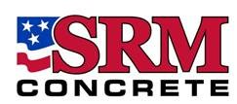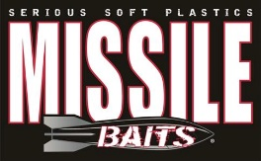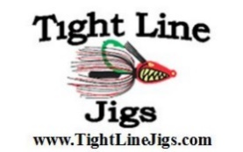

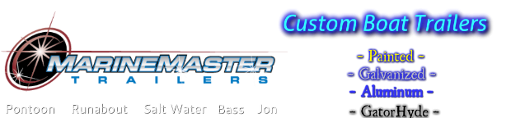

- Life Vest/Person Flotation Devises must be worn by all individuals on board anytime the main motor is in use, ALL Buckles buckled, and all zippers zipped all the way up **Tennessee State Law require all individuals 12 years of age and younger to wear a PFD at all times while on the deck of a vessel.
- You must maintain 50 yards away from another competitor, unless you invite the competitor in…once you invite a competitor in all are invited.
- NO trolling and NO Live bait
- NO Hole sitting (You may NOT have anyone sit/hold/block and area)
- Alabama/Tennessee rigs are authorized, must meet TWRA Regulations or Alabama Regulations if in Alabama Waters.
- Anglers will present the days catch to the scales. Bass presented for weigh-in, which fail to measure the official length, shall result in a penalty of 1 pound for each such bass, which penalty shall be deducted from the total score of the competitor. Short fish will not be weighed. Dead fish penalty is .25 pounds.
- You MUST cull immediately upon catching your sixth fish….at no time will anglers have more than 5 fish in the livewell.
- All Tennessee Wildlife Resource Agency rules must be adhered to at all times. It is the Anglers responsibility to be familiar with and understand TWRA Regulations. If you have a question, contact the tournament Director.
- All Protest or complaints shall be filed either prior to the start of the weigh in or 15 minutes after the scales are closed…
- POLYGRAPH Test will be administered.
- The Tournament Director reserves the right to reject any entry and His decision is final.
- Participation Agreement In signing this agreement, I hereby agree to be bound by and comply with all tournament rules, payment schedules, late fines and regulations. I expressly assume all risks associated with the tournament series and I hereby release B.A.S.S., LLC, its parent, affiliated and subsidiary companies, Tennessee B.A.S.S. Nation, the hosts, sponsors and tournament series officials from all claims of death, injury and/or property damage incurred by me in connection with my participation in this tournament series. If using a boat in this event, including official practice, I certify that I now have or will obtain prior to the tournament series, boat owners liability insurance (including coverage for third party property damage and bodily injury) with no “tournament exclusion,” having a minimum limit of $300,000 per occurrence. The insurance must be issued by a reputable insurer rated A or better by A.M. Best and Company. Policy must include international waters, or a separate policy for international waters must be obtained if I choose to fish international waters during applicable B.A.S.S. events. At B.A.S.S.’s request, I will provide satisfactory evidence of that insurance. I hereby agree to waive my rights of privacy or publicity with regard to the programs of the tournament in which I appear and consent to B.A.S.S., LLC (and its parent, affiliated and subsidiary companies, its owners, directors, employees and agents and those acting under their permission or upon their authority), copyrighting, distributing, televising, publishing and using in any way the audio and visual portions of any television videotape, film and photographs or pictures of me or of interviews, scenes or other sequences in which I may be included, and any reproduction thereof, anywhere at any time through any medium or media for advertising, promotion, trade, television programming or other lawful purpose whatsoever; and I shall not be entitled to receive any royalties or other compensation in connection with such use.
If you have questions, please contact the SCTN Regional Director Capt Jake Davis at 615.613.2382 or via email at msbassguide@comcast.net
Boater Name: _______________________________________________Signature: ____________________
Address: ___________________________________________________ Cell Number__________________
Box number Street City Zip Email____________________

Co-Angler Name: ___________________________________________Signature: ____________________
Address: ___________________________________________________ Cell Number__________________
Box number Street City Zip Email____________________

Mail Entries to: SCTN BASS Nation (Jake Davis) 383 Oak Circle, Winchester TN 37398
Date Received: _________________ Boat Number: ___________________
Boat Number Rosters/Results will be post on SCTN Website www.sctnbassnation.com and www.facebook.com/SCTRTNHSBASSNation

