SOP Driving Record
If you would like to provide driving services with Pikes Peak Respite Services, you will need to turn in a driving record. Your driving record can be obtained online or through mail via your states DMV website.
Main MVR Page, Colorado: Motor Vehicle Record | Department of Revenue - Motor Vehicle (colorado.gov)
Request Driving Record Online, Colorado: CO myDMV (colorado.gov)

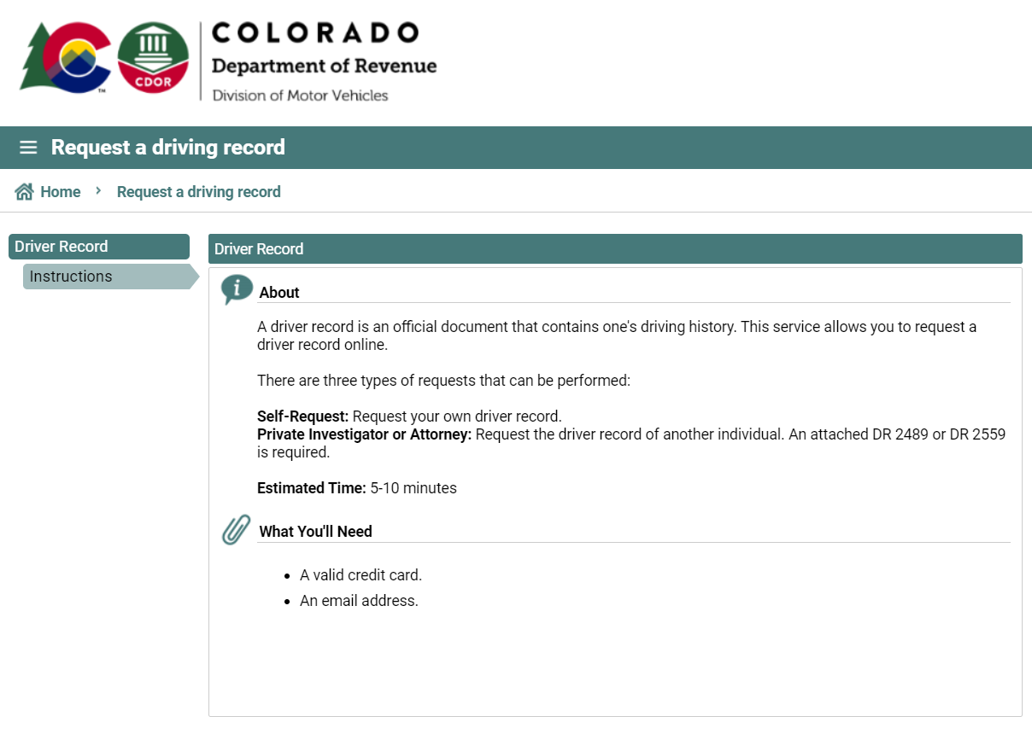

Requesting Your Driving Record
- The Colorado Division of Motor Vehicles maintains driving records that reflect activity posted to the driver record for the past seven years.
  - The record cannot be limited to show periods of less than seven years.
- Motor vehicle records are maintained in accordance with State and Federal laws including the Fair Credit Reporting Act and the requirements of the Federal Trade Commission.

