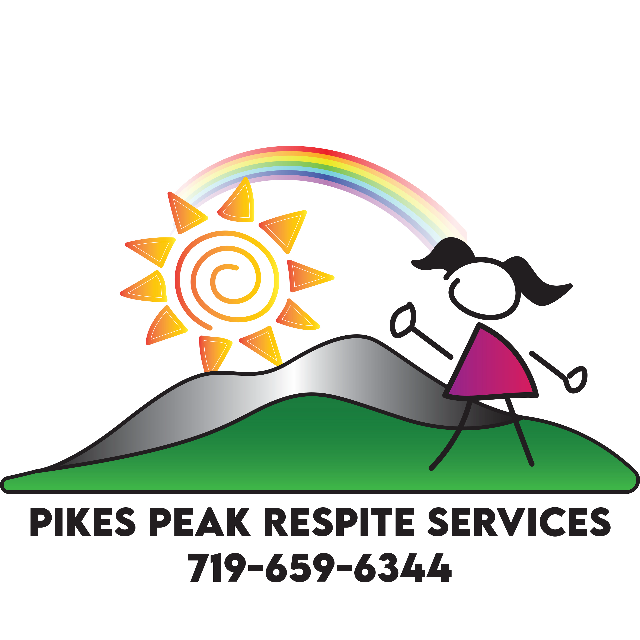
POLICY AND PROCEDURE ON MEDICATION ADMINSTRATION, DISTRIBUTION, PROCUREMENT, STORAGE, DISPOSAL, THE USE OF MEDICATION REMINDER BOXES, AND GASTROSTOMY SERVICES

Definitions:
Administration- assisting a person to ingest, inhale, apply or while using universal precautions insert medication rectally or vaginally, including prescription drugs in accordance with written or printed directions of the person’s attending physician or other authorized practitioner or as written on the prescription label making a written record with regard to each medication administered. The written record will include the time and amount taken. Administration does not include making any judgment, evaluation, assessment or injecting any medication, monitoring medication, or self-administration of medication including prescription drugs and including the self-injection of medication by the person in service. Administration does also mean ingestion through gastrostomy tubes or naso-gastric tubes if administered by a person authorized pursuant to Section 25.5-10-204(2)(j) and 27-10.5-103(2)(i), C.R.S., supervised by a licensed physician or nurse.

Approved training entity (ATE)- An agency, association, facility, person, institution or organization that is approved by the Department to provide a suitable classroom and clinical experience for people taking medication administration training to become qualified medication administration personnel (QMAP).
Approval- indication that a particular medication administration training program meets Department standards.
Authorized practitioner – an attending physician or other person authorized by law to prescribe treatment, medication or medical devices holding a current unrestricted license to practice and acting within the scope of such authority.
Classroom- portion of the training program where students taking QMAP training receive instruction in the principles of safe medication administration including the components outlined throughout this policy and procedure, classroom training can be done either in person or electronically.
Competency evaluation- An exam offered by an ATE that must be taken and passed as a condition of becoming a QMAP, or the written and clinical exam administered by the Department before July 1, 2017.
Controlled substance- medication that is regulated and classified by the Controlled Substances Act at 21 U.S.C. §812 as being schedule II through V.
Course content- both the classroom and skills practice required of the ATE as a condition of Department approval.
Department- the Department of Public Health and Environment.
Facility- as related to services offered by this Agency refers to all services funded through and regulated by the Department pursuant to Article 6 of Title 25.5, C.R.S., in support of people affected by intellectual and developmental disabilities, commonly referred to as “Pikes Peak Respite Services Academy” throughout this policy and procedure
Gastrostomy services- assistance with the ingestion of food or administration of medication through gastrostomy tubes
Medication administration training program (training program)- course of study that is approved by the Department that meets the requirements laid out throughout this policy and procedure
Medication reminder box (MRB)- a compartmentalized container designed to hold medications for distribution according to a time element such as day, week, or other such portions
Monitoring- Reminding the person receiving services to take medication(s) at the time ordered by the authorized practitioner, or handing a person receiving services a container or lawfully labeled medication package assembled by an authorized practitioner for the visual observation of the person receiving services to ensure compliance with taking the medication; making a written record of the person receiving services’s compliance with regard to each medication, including the time taken; and notifying the authorized practitioner if the person receiving services refuses or is unable to comply with the practitioner’s instructions regarding the medication.
Nurse- a person holding a current unrestricted license to practice pursuant to Article 38 of Title 12, C.R.S. acting within the scope of such authority.
Program coordinator- the person designated by an ATE acting as liaison to the Department responsible for transmitting the names of students who have passed the competency examination, submitting applicable fees and ensuring course content is updated as needed.
Qualified instructor- nurse, pharmacist, physician or physician assistant with an active, unrestricted Colorado license.
Qualified manager- a person who is the owner or operator of the facility or a supervisor designated by the owner or operator of the facility for the purpose of implementing sections 25-1.5-303, C.R.S. who has completed QMAP training pursuant to section 25-1.5- 303, C.R.S., or is a licensed nurse, licensed physician, or licensed pharmacist in the State of Colorado.
Qualified medication administration person/QMAP- a person who passed a competency evaluation administered by the Department before July 1, 2017, or passed a competency evaluation administered by an ATE on or after July 1, 2017, whose name appears on the Department’s list of persons who have passed such competency evaluation.
Self-administration- a person’s ability to take medication independently without any assistance from another person.
Skills practice- the portion of the QMAP training program conducted in person and not electronically where students practice medication administration skills and application of classroom principles in a simulated care setting under the direct supervision of qualified instructor

Policy: Pikes Peak Respite Services will shall presume each person receiving services is capable of self-administration of medication unless they are determined otherwise. Pikes Peak Respite Services will encourage and empower the people they support to be as independent as possible and desired in the administration of medications.
Pikes Peak Respite Services personnel, contractors and providers will follow the following guidelines regarding Medication Administration, Procurement, Disposal, Distribution, Storage, and the use of Medication Reminder Boxes.
Pikes Peak Respite Services shall provide sufficient supports to persons receiving services in the use of prescription and non-prescription medications to protect their health and safety of persons. Decisions concerning the type and level of supports provided shall be based on the abilities and needs of the person receiving services as determined by assessment and shall be in compliance with these rules.
It is the policy of this agency that this information be conveyed in understandable terms. Clarification on any part of the policy and procedure is always available upon request.

Procedures Related to Employment/Contract Status and QMAP training
- Pikes Peak Respite Services shall ensure that there is a qualified medication administration person onsite any time medication is administered, including when medication is administered pro re nata (PRN) or “as needed.”

- Pikes Peak Respite Services shall conduct a criminal background check on each employee or contractor who is not licensed to administer medications prior to employment/implementation of the working contract or promotion to a position in which he or she has access to medications. Conditions for employment/contractual working agreements are discussed in more detail in the Agency’s Personnel and Training policy and procedure including criteria for:
  - investigating and evaluating any criminal offenses shown on the background check
  - monitoring any person hired/contracted with having a criminal offense history

- As a condition of employment/contract or promotion to a position where the person has access to medications Pikes Peak Respite Services requires each QMAP and/or qualified manager to sign a disclosure statement under penalty of perjury stating that they have never had a professional license to practice nursing, medicine, or pharmacy revoked in Colorado or any other state for reasons directly related to the administration of medications.

- Pikes Peak Respite Services will ensure that anyone employed or contracted with, who is not licensed to administer medications, is included on the Department’s list of QMAPs.

- Pikes Peak Respite Services will ensure that all QMAPs hired have on-the-job training focusing on the unique needs of Pikes Peak Respite Services and the people receiving services.

- Pikes Peak Respite Services shall ensure that any QMAP person hired on or after July 1, 2017 is adequately supervised until they have successfully completed the training. No employee or contractor will work alone with a person receiving services who requires medication administration without first completing all requirements to become a QMAP including competency evaluation, documentation of completion shall be maintained in the personnel file.

- Documentation of QMAP training will be maintained in each employee or contractor’s personnel file.

Procedures Related for ATE Approval
- Any agency, association, facility, person, institution or organization desiring to become an approved training entity shall:

- Submit an application and all required attachments for its proposed medication administration training program in the form and manner required by the Department

- Designate a program coordinator who shall be responsible for compliance with the contents of this policy and procedure.

- A training entity shall not conduct any trainings or enroll students in a medication administration training program until it has received approval from the Department. Students attending and completing a non-approved program are not eligible for inclusion on the Department’s public list of persons who have passed the QMAP competency evaluation and a facility shall not allow such person to administer medications.

Procedures Related to ATE QMAP Training Attendees
- The ATE shall ensure that all applicants wishing to enroll in a training program to become a QMAP provide proof of being at least eighteen 18 years of age. It is the policy of Pikes Peak Respite Services to not hire, contract with or otherwise employ anyone under the age of 18.

- Prior to enrollment in the training, the ATE shall provide each applicant with a written statement regarding the basic reading, writing and math skills that an applicant must have to successfully complete the course.

Procedures Related to the Contents of the ATE’s QMAP Training
- The course content shall be developed, implemented, and managed by the training entity and approved by the Department.

- Prior to implementation, each ATE shall promptly provide the Department with information regarding any anticipated changes that significantly alter the approved course content or competency evaluation.
- The course content shall contain the required items specified by the Department and outlined in the following procedures.

- Classroom and skills practice in the content outlined in the following procedures must be completed before students are permitted to move on to the competency exam.

- Both the Classroom and skills practice shall be taught and overseen by a qualified instructor.

- The competency evaluation shall administered by a qualified instructor and include both written and practical skills testing. Successful demonstration of competencies will be documented and maintained in each employee or contractor’s personnel file.

- The written portion of the competency evaluation shall cover, at a minimum, all the required curriculum content set forth in the content section detailed below.

- The practical skills portion of the competency evaluation shall assess, at a minimum, whether each student is capable of safe, sanitary and accurate medication administration from preparation to allowable routes of administration and documentation.

- ATEs shall retain student competency evaluation records for a minimum of three years. Pikes Peak Respite Services will obtain and maintain documentation of completion in each employee or contractor personnel file.

Classroom and Skills Practice Content
- The principles of administering medications that minimally include the scope of service of a QMAP including, but not limited to:
  - Authorized settings and requirements
  - Medication restrictions
  - Roles, responsibilities and cautions
- Seven rights of medication administration
  - Right Person
  - Right Medication
  - Right Dosage
  - Right Time
  - Right Route
  - Right Documentation
  - Right to Refuse
- Routes and forms of acceptable medication administration
- How to read, understand and validate medication orders
- Expiration and refill dates.
- The uses and forms of drugs including but not limited to:
  - The purpose of prescribed medications.
  - Controlled substance classification and accountability.
- Medication effects including therapeutic, side, and adverse effects.
- When, where and how to properly navigate appropriate medication reference resources.
- Medication administration records (MARs) including, but not limited to:
- Medication timing options- specified and time window
- Rules and practice for documenting administration of medication to person receiving services or client.
- Communication and interpersonal skills for addressing unique needs and behaviors of people who are elderly, have impaired physical capacity, impaired cognitive ability, mental health issues, behavioral issues, dementia and/or Alzheimer's.
- Infection control: Pikes Peak Respite Services completes training on infection control and universal precautions in their required Health and Safety training
- Safety and emergency procedures: Please also refer to the Agency’s Requirements for Safety Control Procedure policy and procedure and also Requirements for Emergency Control Procedure policy and procedure.
- Drug diversion awareness including the prevention and reporting of abuse, neglect and misappropriation of the property belonging to people receiving services/exploitation. Please also refer to Pikes Peak Respite Services’s policy on Mistreatment, Abuse, Neglect and Exploitation.
- Medication administration procedures including, but not limited to:
  - Administering, monitoring and self-administration
  - Administering PRN medications in accordance with scope of practice
  - Standards, precautions and safe practice
  - Preparing or altering medication for administration in accordance with manufacturer’s instructions and authorized practitioner’s orders
  - Counting, administering and documenting controlled substances
  - Proper documentation of medication administration
  - Determining, documenting and reporting medication errors
  - Medication storage and disposal
  - Filling and administration of medication reminder boxes and day/trip packs.

Procedures Related to Medication Administration Standards of Practice
- Both Prescription and non-prescription medications shall be administered by a QMAP using only upon current written orders from an authorized practitioner.
- New orders from an authorized practitioner shall be obtained and followed whenever a person receiving services to the facility after an inpatient hospitalization.
- Non-prescription medications shall be labeled with the person’s full first and last name.
- No person receiving services shall be allowed to take medication belonging to another person. QMAPs shall not give medication to anyone other than the person receiving services that it was ordered for.
- QMAPs shall not administer medication through a gastrostomy tube, administer insulin, unless specifically authorized to do so pursuant to additional rules adopted by the Department of Health Care Policy and Financing or the Department of Human Services. Completion of this additional training and competency evaluation shall be maintained in that QMAPs personnel file.
- QMAPs shall not administer any type of injections, except an Epi Pen, and only when trained.
- A QMAP shall not administer epinephrine injections unless:
  - Directed to do so by a 911 emergency call operator as an urgent first aid measure, or
  - After completing training in an anaphylaxis program conducted by a nationally recognized organization and receiving authorization following completion of the training program to use an epinephrine injector pursuant to section 25-47- 103, C.R.S.
- The contents of any medication container without a label or with an illegible label shall be destroyed and disposed of immediately.
- Medication destruction and disposal
  - Medication disposal shall be completed in a safe manner, for example by taking to a licensed pharmacist for disposal.
  - Documentation of disposal shall be completed and maintained.
  - Anyone who is QMAP trained and approved by the Agency can complete medication disposal and complete the documentation of completion. A person receiving services can complete the disposal if they are independent in their medication administration and assessed with demonstrated skill to complete the task of disposal safely. Documentation of the skills assessment will be included in the quarterly medication skills assessment maintained in the client record.
- Medication that has a specific expiration date shall not be administered after that date. Any expired medication shall be disposed of in a safe manner, as outlined above.
- All medications managed by Pikes Peak Respite Services shall have documentation that discontinued, out dated, or expired medications are either returned to the person receiving services, or if having the legal authority that persons guardian or legal representative with instructions for their proper disposal, or promptly disposed of by the facility if the person receiving services, or where applicable, their legal representative consents. Medication disposal shall be completed in a safe manner, for example by taking to a licensed pharmacist for disposal. Documentation of disposal shall be completed and maintained.
- A record of missing, destroyed or contaminated medications shall be maintained along with documentation for all disposed medications.

Procedures Related to Medication Reminder Boxes or Systems (MRBs)
- People receiving services who self-administer medication may use MRBs. Should Pikes Peak Respite Services use MRBs for people who are not self-administering a nurse or QMAP shall be available to assist with or administer from the MRB.
- Qualified Managers will provide oversight and monitoring in the use of MRBs.
- Only authorized practitioners, nurses or QMAPs are permitted to assist people receiving services with MRBs.
- Each QMAP assisting a person receiving services with a MRB shall be familiar with the type and quantity of medication in each compartment of the box.
- Each QMAP assisting with or administering from a MRB shall, immediately after assisting or administering, record the assist or administration on the person’s medication administration record forms (MAR) that has been developed or acquired and maintained by the facility.
- The MAR shall contain complete instructions for the administration of each medication.
- The MAR shall contain a space for specific entry for each medication given that including the date, time and amount of the medication, along with the signature of the person administering the medication.
- The facility shall be responsible for administering the correct medications to its person receiving services as outlined in this policy and procedure and the QMA training in a manner consistent with the provisions of section 25-1.5-303, C.R.S.
- MRBs are allowable only if such containers have been filled and properly labeled. Filling and labeling shall be completed by:
  - A licensed pharmacist pursuant to Article 42.5 of Title 12, C.R.S.
  - A nurse licensed pursuant to Article 38 of Title 12, C.R.S,.
  - A QMAP with oversight and monitoring by a Qualified Manager
  - Through the gratuitous care of family members or friends of the person receiving services
- A label shall attached to each medication reminder box including this information:
  - The name of the person receiving services
  - The name of each medication
  - The dosage of each medication
  - The quantity of each medication
  - The route of administration, only medications intended for oral ingestion may be placed in an MRB.
  - The time that each medication is ordered to be administered
- Each MRB shall have a corresponding MAR where all administration is documented immediately after administration.
- If an authorized practitioner orders any changes to any medication for the person receiving services, the facility shall discontinue use of the MRB until it has been properly refilled according to the change ordered.
- If any medication in the MRB is not consistent with the labeling, the QMAP shall not administer the medication to the person receiving services and shall immediately notify the person who filled the MRB, Pikes Peak Respite Services director or designee so the discrepancy can be resolved prior to administering from the MRB. The QMAP may resume the administration or assistance to the person receiving services from the MRB once the problem with the medication(s) is resolved and all medications are correctly refilled in the MRB.
- Any and all medication problem(s) shall be resolved prior to the next administration.
- PRN or “as needed” medications of any kind shall not be placed in an MRB.
- Any medications with special instructions for administration instead of routinely administered medications shall not be placed in an MRB. For example, a medication to be taken an hour before eating, or 30 minutes after eating, etc.
- Medications in the MRB shall only be used at the time specified on the box. MRBs shall not be filled for more than two weeks at a time.
- Any medication reminder “day packs” or “trip packs” assembled for administration outside of Pikes Peak Respite Services shall comply with all of the requirements listed above.
- Day medication is to be taken in MRB

Procedures Related to the Storage of Medication
- All medication shall be stored on-site, this includes medication that is placed in a MRB filled by staff, a family member or other designated person.
- All controlled substances shall be stored under double lock, counted and signed for at the end of every shift in the presence of either two (2) QMAPS or a QMAP and a qualified manager. If this is not possible, the QMAP going off-duty shall count and sign for the controlled substances and the next on-duty QMAP shall verify the count and sign. If the count cannot be verified, the discrepancy shall be immediately reported to Pikes Peak Respite Services Director.
- All prescription and non-prescription medications shall be stored under proper conditions in regards to temperature and light and will be maintained and stored in a manner that ensures the safety of all person receiving services. Medication shall not be stored with disinfectants, insecticides, bleaches, household cleaning solutions, or poisons.
Procedures Related for Gastrostomy Services
- Licensed Group Residential Services and Supports (GRSS) settings shall comply with all applicable regulations at 6 C.C.R. 1011-1; Chapter VIII, Section 17 for the administration of gastrostomy services.
- Gastrostomy services shall not be administered by an unlicensed individual unless that individual is trained and supervised by a licensed physician, nurse, or other practitioner. The licensed nurse, physician or other practitioner overseeing the initial and periodic training shall document in the employee or contractor record:
  - The date or dates on which the training occurred
  - Documentation confirming that, in the opinion of such licensed nurse, physician, or other practitioner, the unlicensed individual has reached proficiency in performing all aspects of the individualized protocol referred to in section 8.7417.E.1
  - The legible signature and title of such licensed nurse, physician, or other practitioner.
- A licensed nurse, physician or other authorized health care practitioner shall monitor each unlicensed person performing the gastrostomy services for a person receiving services on a quarterly basis during the first year
and semi-annually thereafter, unless more frequent monitoring is required by the individualized protocol.

- The supervising practitioner shall document each instance of monitoring in the record of the
Member.
- Pikes Peak Respite Services shall ensure that a physician, licensed nurse, or other practitioner has developed a written, individualized gastrostomy service protocol for each person receiving services that requires such service, and that the protocol is updated each time the orders change for that person’s gastrostomy services
- Pikes Peak Respite Services shall maintain the individualized protocol in the record of the person receiving services
- The protocol shall include, at a minimum
  - The proper procedures for preparing, storing, and administering gastrostomy services
  - The proper care and maintenance of the gastrostomy site
  - needed materials and equipment
  - The identification of possible problems associated with gastrostomy services
  - A list of health professionals to contact in case of problems, including the physician of the individual receiving gastrostomy services and the licensed nurse(s) and/or physician(s) who are responsible for monitoring the unlicensed person(s) performing gastrostomy services pursuant to section 8.7417.
- Pikes Peak Respite Services shall ensure that a physician, licensed nurse, or other practitioner provides training to any unlicensed individual who may provide gastrostomy services.
- Documentation of initial and any subsequent training shall be kept in the person receiving services’ record.
- Pikes Peak Respite Services shall ensure that the physician, licensed nurse, or other practitioner observes and documents the unlicensed individual performing gastrostomy services and documents the monitoring in the record of the person receiving gastrostomy services.
- For each gastrostomy service received, Pikes Peak Respite Services shall ensure the following documentation is included in the person’s record:
  - A written record of each nutrient and fluid administered
  - The beginning and ending time of nutrient or fluid intake
  - The amount of nutrient or fluid intake
  - The condition of the skin surrounding the gastrostomy site
  - Any problem(s) encountered and action(s) taken
  - The date and signature of the person performing the procedure.

Reference: 6 CCR 1011-1 Chap 24
10 C.C.R. 2505-10 Section 8.7201.L
Section 8.7202.Q
Section 8.7405
Section 8.7416
Section 8.7417
6 C.C.R. 1011-1; Chapter VIII, Section 17
Section 25-1.5-303(1) C.R.S.
Section 25-1.5-103 and 25-1.5-301 through 25-1.5-303, C.R.S.
Section 25.5-10-204(2)(j) and 27-10.5-103(2)(i), C.R.S
Section 25-1.5-303, C.R.S.
Section 25-47- 103, C.R.S.
Article 42.5 of Title 12, C.R.S.,
Article 38 of Title 12, C.R.S
Article 6 of Title 25.5, C.R.S.,
21 U.S.C. §812
Home and Community Based Services Settings Final Rule
Personnel and Training Policy and Procedure
Requirements for Emergency Control Procedure Policy and Procedure
Requirements for Safety Control Procedure Policy and Procedure
Mistreatment, Abuse, Neglect and Exploitation Policy and Procedure

