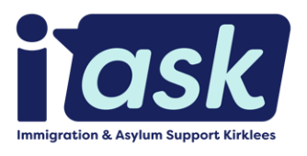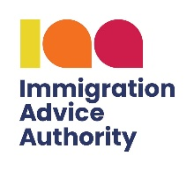

IASK REFERRAL FORM

IASK provides legal support (IAA Level 2 Asylum and Immigration casework) and complex welfare assistance to people seeking asylum, refugees, and migrants across Kirklees.
We also provide housing and tenancy support specifically for refugees with leave to remain.

About the person making the referral
Name
Job Title/Organisation
Telephone
Email
Referral Date

About the person being referred
Name |  |  |  |  | Nationality
Gender |  |  |  |  | Date of Birth
Languages spoken
Legal Status | Asylum Seeker |  | Refugee |  |  | Migrant |  | British  Citizen |  |  | Other
Level of English | None |  | Basic |  |  | Intermediate |  | Advanced
Interpreter Required | Yes |  | No
Telephone number(s)
Email (if they have one)
Address (if they have one)
Dependant family members | Name |  |  |  |  |  | Relationship to person being referred |  |  |  |  | Age

Type of Support | Please Tick (X) | Brief Explanation of the Client’s Circumstance
Legal Advice
Welfare Support
Post Decision Support
Housing/Tenancy Support

Additional Notes

Other Organisations
Are there any other organisations involved in supporting the individual being referred and/or their family? (e.g. social worker, lawyer, other support worker, etc.) If yes, please give details.
Name | Job Title | Organisation | Contact Tel/Email

Risk Assessment
 | Tick | Please give details
Violence/aggression | ☐
Mental health issues | ☐
Physical health issues (inc. COVID vulnerability) | ☐
Learning difficulties | ☐
Substance misuse | ☐
Domestic violence | ☐
Criminality | ☐
Child sexual exploitation | ☐
(Potential) Victim of human trafficking | ☐
Social care involvement | ☐
Safeguarding concerns | ☐

Who we are
IASK is a Kirklees-based charity set up to support asylum seekers and recently granted refugees.

What we do with your data
The information you have provided on this form will be stored and processed by us in order to:
- determine what service you are eligible to receive from us and
- decide what our advice to you will be and how best to act on your behalf, as instructed by you.

How long we keep your data
If we are not able to offer a service, we will destroy the data provided on this form immediately.
If we are able to offer you a service, we will retain the data in our electronic and other records.
Any client can withdraw consent for us to hold and process their data, at any time, by informing us verbally or in writing. To request your data to be destroyed, write to us at our email address (below). In any event, we will destroy all data we hold 7 years after the last contact with a client.

When and how we share your data
Upon registration at IASK, we will ask all new clients to sign a Client Personal Data Consent form.
We will not request other organisations to provide personal data without this consent nor without explaining why such data may enable us to work in the client's interest.

Please send the completed referral form to:
info@i-ask.co.uk

IMPORTANT INFORMATION

We are changing the way we deliver our services!
From April 2026, we will run one weekly drop-in on Thursdays, 1pm to 4pm, at the Quaker Meeting House, alongside prebooked appointments and support groups during the week to better support clients with complex cases.
We will no longer manage Welcome Mentor Befrienders.
Thank you.

