Contact Center Business Use Cases and Outcomes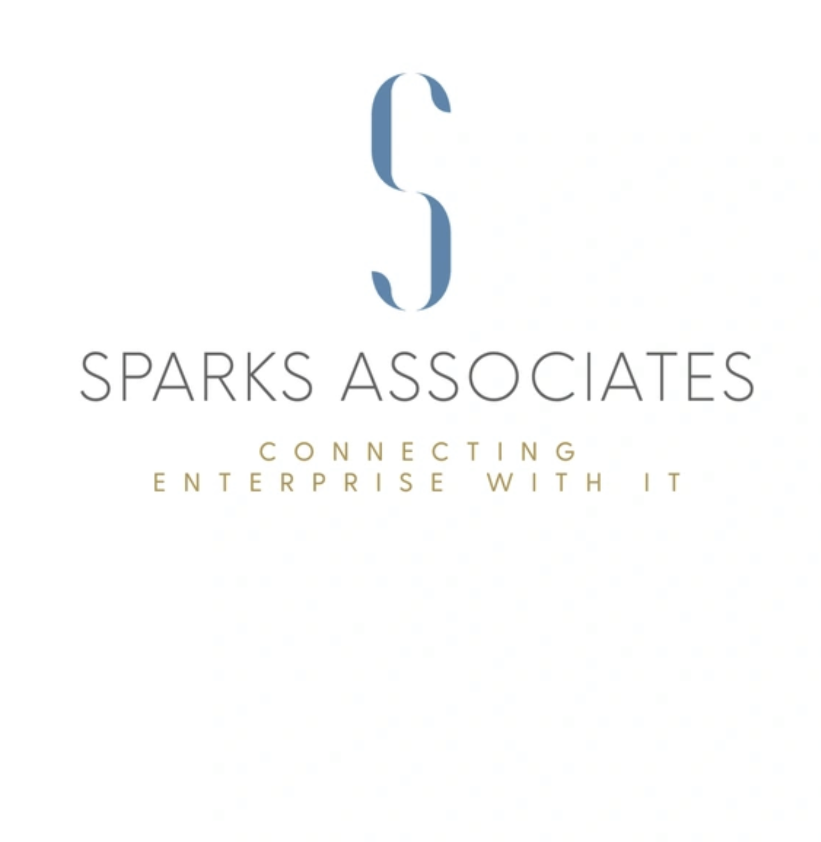

Fortune 1000 Health Benefits Company

# PROBLEM

This company was experiencing a high abandonment rate as well as insufficient caller information. This contributed to long wait times and poor customer experience. Agent burnout and attrition cost the company in retaining talent.

# SOLUTION

A complete overhaul of their IVR was the first step in providing the right choices at the right time to the right customer. Adding a backdoor number for internal customers to access the helpdesk allowed for a singular skill that could get those in need of IT support back out to their jobs quickly without sacrificing customer hold times. The addition of data and back-end intelligence integration allowed the agents to rapidly answer calls, make the needed changes or notes to aid the external customers and speed the calls along. The enablement of screen recording and surveys allowed for continues measuring and improvements.

# OUTCOMES

* Skills Based Routing along with a revised IVR separated and gave priority to the right calls, elevating the overall customer experience.
* Rapid IT help provides internal workers to resolve issues quickly and remain productive.
* Positive input from customers and solicited changes elevated the CSAT by more than 80%.
* Data integration speed calls along and prevented agent burn-out.

Large West Coast Higher Education Institution

# PROBLEM

Lower than industry standard scores for IT’s customer service.

# SOLUTION

An intelligent IVR that identified high value customers' priority to top-skilled agents. Quality Management systems were implemented to score, revise and train all agents and provide a cohesive experience across channels.

OUTCOMES

* 20% improvement in customer service scores.
* Agent retention.

## Fortune 200 Financial Services Company

# PROBLEMS

They are hiring new and inexperienced agents without a common vocabulary of what “Customer Excellence” means. Sub-problem: IT segregated and disjointed throughout a large metropolitan area with little opportunity to interact.

# SOLUTION

All levels of agents attend standardized training that was brought forth by recording and QM. The team implemented AI to supplement agent interactions and provided Agent Assist to show the agent, based on the current context, the next best step to take to speed the call along.

# OUTCOMES

* Strengthened agent confidence and aided in faster onboarding and productivity, and that resulted in lower turnover rates with agents.
* Streamlined and standardized the level of care for all interactions.
* Elevated CSAT by over 15%
* Reduced AHT by 25%