GREEN MEMO | 
 | STAY INFORMED AND ENGAGED WITH THE SUSTAINABLE PRACTICES ON THIS PRODUCTION AS WE WORK TOGETHER TO MINIMIZE OUR ENVIRONMENTAL IMPACT ON THE PLANT

  - [ENTER NAME]
FEEL FREE TO CONTACT OUR STAINABILITY ADVISOR WITH ANY INQUIRIES REATED TO OUR SUSTAINABILITY EFFORTS. ENTER ANY INFO ABOUT THE SUSTAINABILIYT ADVISOR AND WHAT THEY DO.
[ENTER EMAIL ADDRESS]

SUSTAINABILITY HIGHLIGHTS


SPECIAL EQUIPMENT
ENTER ANY INFO ON SUSTAINABLE EQUIPMENT LIKE BATTERY POWERED GENERATORS, VOLT STACKS, LED LIGHTS, ETC.
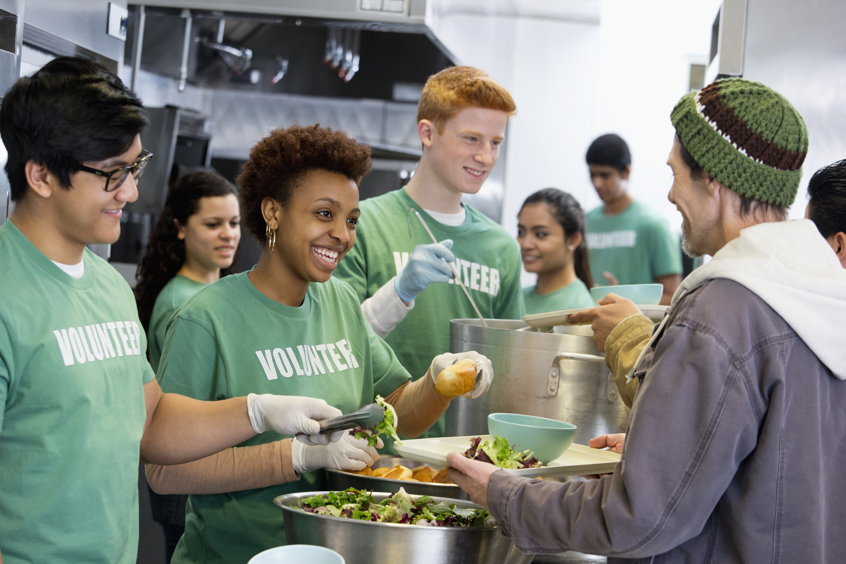

FOOD WASTE
ENTER ANY INFO ON WHAT YOU ARE DOING TO ELIMINATE OR DECREASE FOOD WASTE. WHO ARE YOU DONATING LEFT OVER FOOD TO FOR EXAMPLE? KEEP TRACK OF HOW MANY MEALS YOU HAVE DONATED AND WHERE. ARE YOU USING LOCAL INGREDIENTS? DO YOU HAVE A RELATIONSHIP WITH LOCAL FOOD PROVIDERS. THIS IS ALSO WHERE YOU CAN PROVIDE INFORMATION ON HOW PRODUCTION IS COMPOSTING FOOD WASTE. ADD PHOTOS!
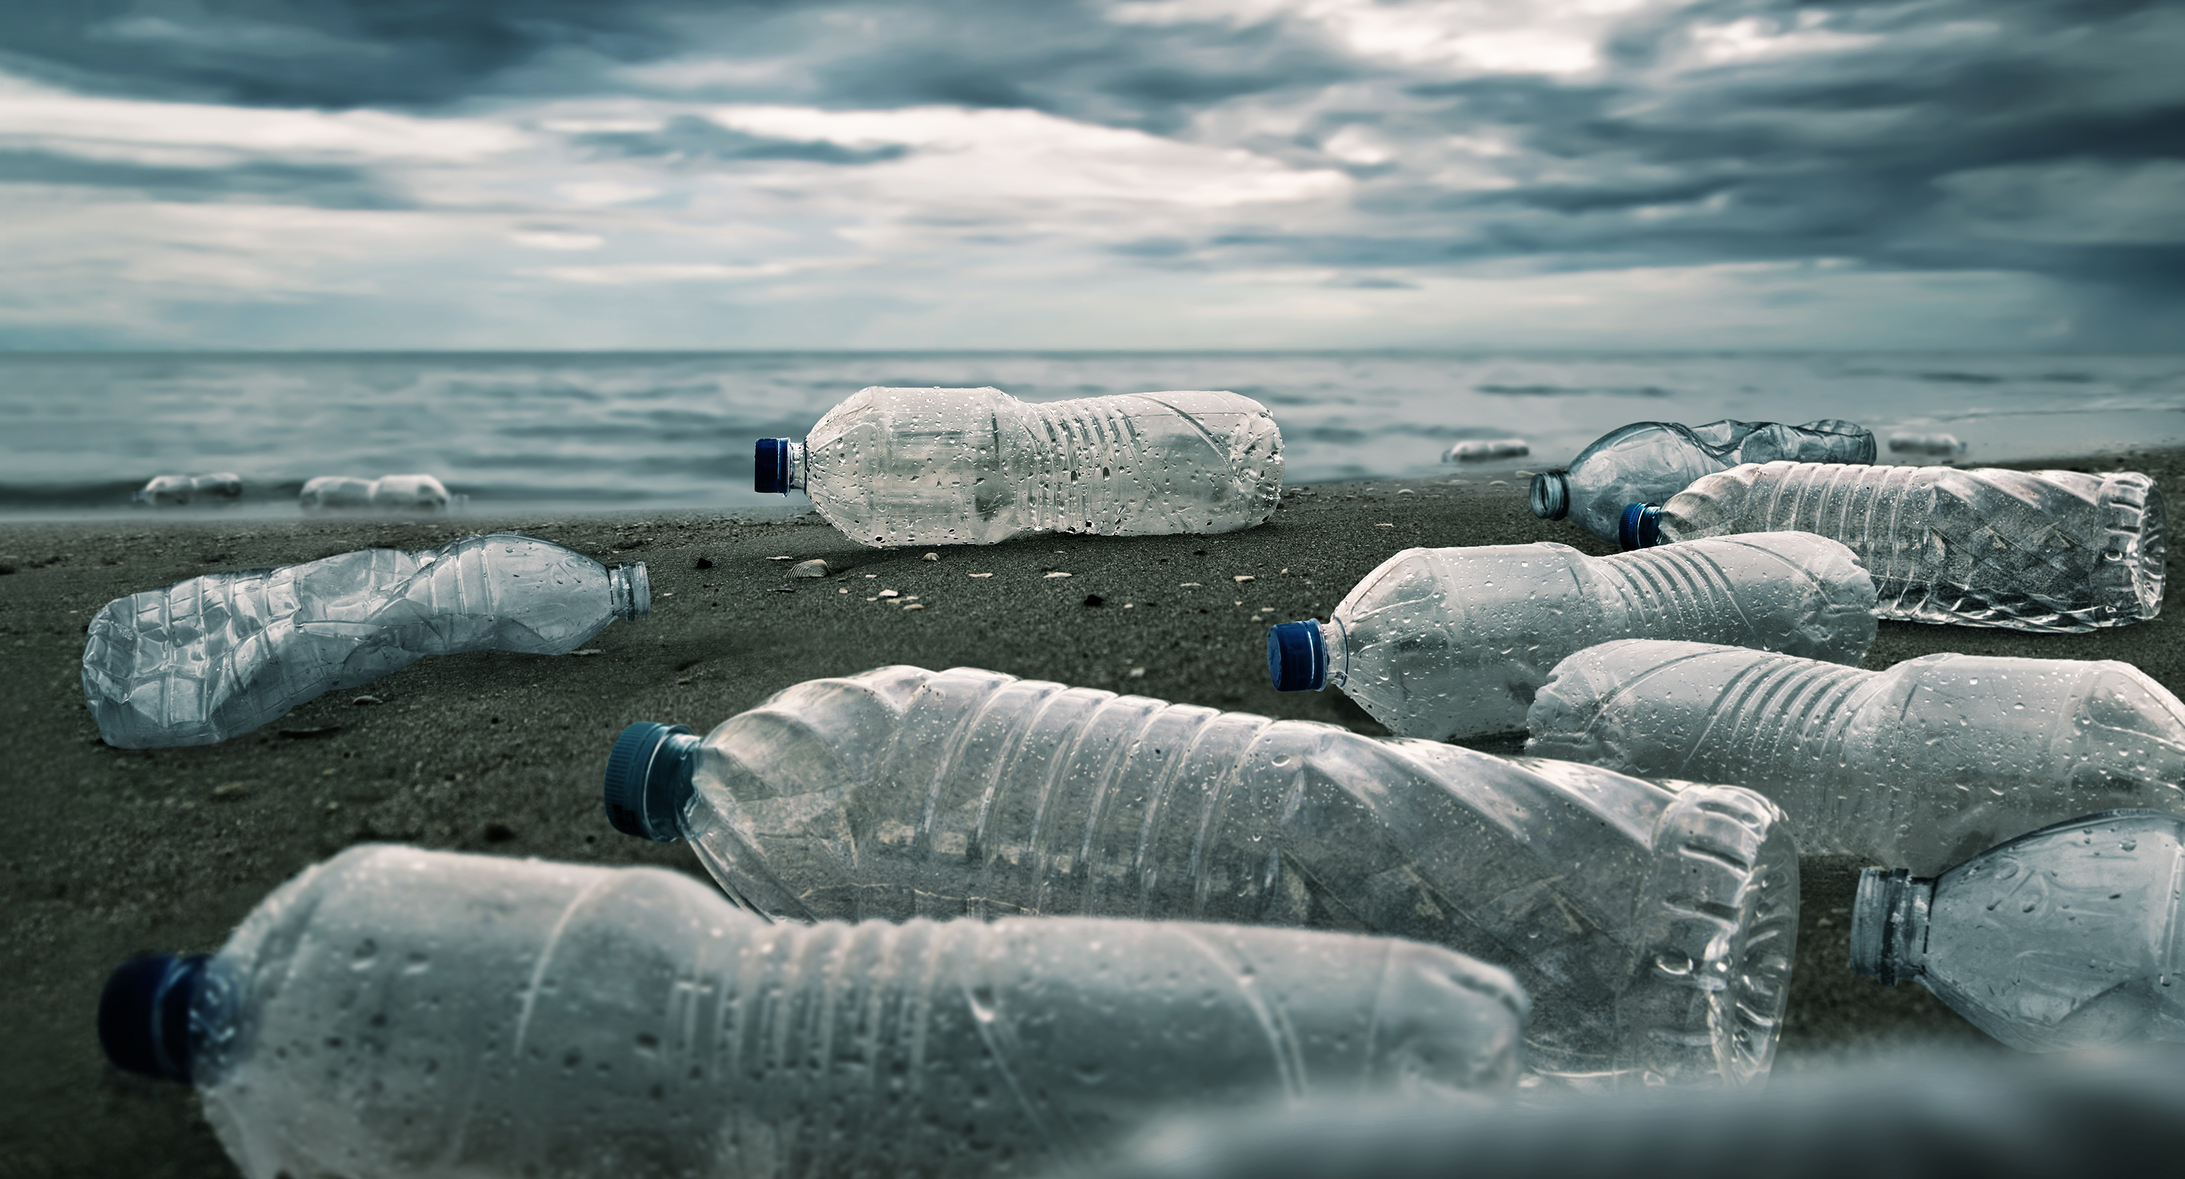

WATER REFILL STATIONS
ENTER INFO ABOUT WHERE THE REFILL STATIONS ARE LOCATED. ADD PHOTOS OR A MAP. ADD A NOTE ABOUT BRINGING YOUR OWN REUSABLE WATER BOTTLE. KEEP TRACK OF HOW MANY PLASTIC WATER BOTTLES YOU HAVE PREVENTED FROM GOING TO THE LANDFILL. IF YOU HAVE A POLICY ON PLASTIC WATER BOTTLES, PUT IT HERE TOO!

SUSTAINABILITY HIGHLIGHTS
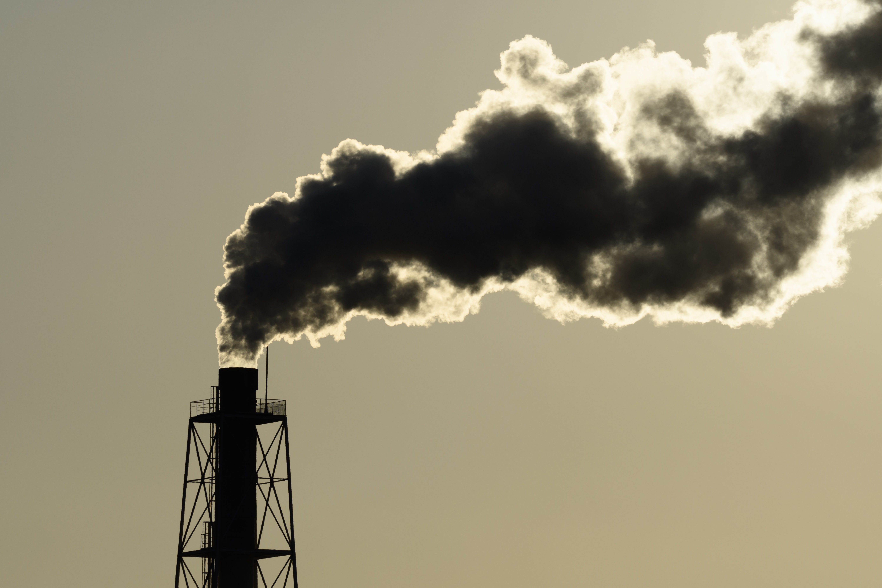

EMISSIONS
ENTER ANY INFO ON GRID TIE-INS THAT HAVE BEEN SET UP FOR ASSIST PRODUCTION. EXPLAIN WHAT A TIE-IN IS AND WHAT THE BENEFITS ARE. IF YOU HAVE BATTERY POWERED GENERATOR(S) ADD INFO ABOUT IT HERE. ADD SOME PHOTOS TOO!


VEHICLE EMISSIONS
ENTER ANY INFO ON ELECTRIC OR HYBRID VEHICLES BEING USED ON SET. THIS IS A GREAT PLACE TO ADD YOUR PRODUTION’S NO-IDLING POLICY AND ANY TIPS TO AVOID IDLYING.


REUSABLE DISHES
ENTER INFO ABOUT REUSABLE DISHES BEING PROVIDED FOR MEALS. YOU SHOULD ALSO SPEAK TO THE COMPOSTABLE PRODUCTS USED WHEN REUSABLE DISHES ARE NOT AVAILABLE. ALSO PROVIDE ADVICE ON HOW TO PROPERLY DISPOSE OF THE COMPOSTABLE PRODUCTS.


CIRCULAR ECONOMY
ENTER INFO ABOUT RENTALS AND DONATIONS OF ITEM FROM AND FOR PRODUCTION. FOR EXAMPLE, WARDROBE SALES, SET SALES, PROPS RENTALS, DONATIONS OF USED AND LEFTOVER LUMBER, DONATIONS OF LEFTOVER PAINT, AND ANY OTHER RELEVANT WAY YOU ARE ADDING TO THE CIRCULAR ECONOMY.

WHAT GOES IN WHICH BIN?
ADD PHOTOS HERE OF WHICH BINS YOU ARE USING ON YOUR PRODUCTION AND LABLE WHAT GOES IN EACH BIN
RECYCLING BINS: PLASTIC BOTTLES, TIN CANS, PLASTIC FOOD CONTAINERS, NO GLASS!
GARBAGE BINS: FOOD WRAPPERS, COFFEE CUPS, PLASTIC FORKS
COMPOST BINS: FOOD SCRAPS, BONES, PAPER, NAPKINS
RECYCLING PAPER: PAPER, CARDBOARD, BOOKS, MAGAZINES
DO YOU ALSO HAVE BINS FOR RECYLING:
INK AND TONER CARTRIDGES
WRITING INSTRUMENTS
LED LIGHTING
BATTERIES
ELECTRONIC WASTE
TERRACYCLE PROGRAMS COLLECTION AREAS

HELPFUL RESOURCES
ADD ANY GUIDES AND IMAGES FOR REDUCE, REUSE, AND RECYCLING PROCESSES. ADD WHAT IS RELEVANT TO YOUR PRODUTION AND YOUR EMPLOYEES!

LINKS TO COMMUNITY GROUPS
https://mmsb.nl.ca
https://curbitstjohns.ca
https://www.secondharvest.ca
https://www.productcare.org/products/paint/newfoundland/
https://seasideapparel.ca/pages/recycle-on-the-rock
https://www.staples.ca/a/content/sustainability
https://www.terracycle.com/en-CA/
https://econext.ca/members/directory/
https://www.homeagainfb.ca
https://www.againandagain.ca

LINKS TO INDUSTRY TRAINING
https://amt-lab.org/blog/2021/12/what-does-sustainability-look-like-in-the-film-industry
https://www.creativebc.com/reel-green/
https://dgcgreen.ca
https://www.greenproductionguide.com/tools/
https://www.greensparkgroup.com
https://wearealbert.org/events/training/
https://www.mpa-canada.org/what-we-do/going-green/

