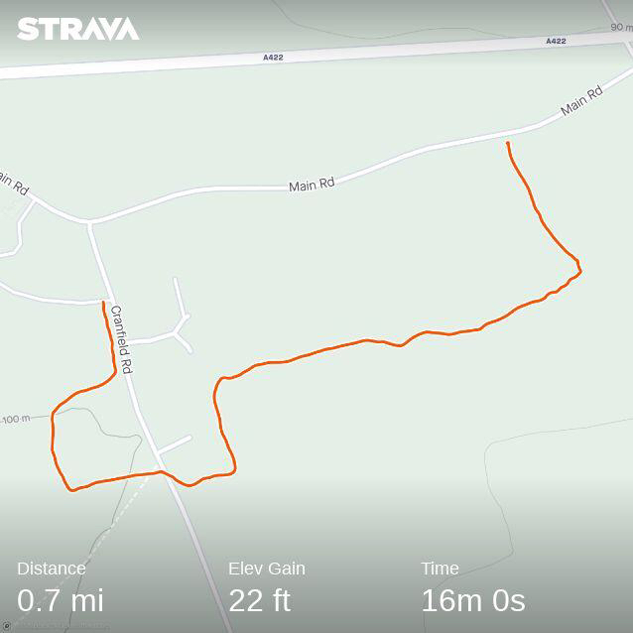
Permissive Footpath ( Astwood )
The Permissive Footpath with permission of Quakers House Estates has start points at;
Cranfield Rd Entrance to Manor farm – Gate on Left
Cranfield Rd Entrance Gate to Bridleway or opposite to Right of houses
Main Road – Past all housing through Single Bar Galvanised Steel Gate ( with Log in Front )
The path is well signposted, please observe these. A pleasant walk, generally even ground, it can be muddy at times, and has wide ranging views of the local countryside.
Linked with the road, taken as a loop it can be just over a mile in length.

*A permissive path, is a path whose use is allowed by the landowner.

