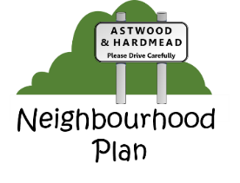
If you require a copy of the Neighbourhood plan and cannot view it online via the Astwood and Hardmead website http://astwoodandhardmead.co.uk/neighbourhood-plan then please email us at NHPAstwoodhardmead@gmail.com or write to us at Neighbourhood Plan, Church Barn, Main Road, Astwood, Newport Pagnell, MK16 9JS and the committee will post a copy of the plan to your home address. Please ensure you provide your name and address in your correspondence.
The plan can also be viewed in the Village Hall windows, written comments may be forwarded to the above address
If you have any questions, do not have access to email or the internet and would like a copy of the neighbourhood plan then please call us on 07884 376954 and we will post a copy to your address.
If you get the answerphone please leave your name, contact number and address for a prompt response.

