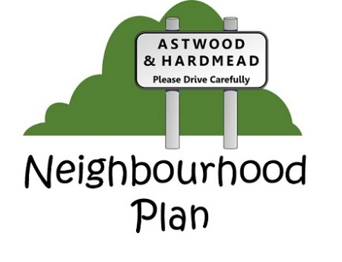

Neighbourhood Plan update – May 2020
The Neighbourhood Plan has now progressed to the point where it will be issued for review & response by the Parish – this is the “The Public Consultation Period”; the NHP steering committee have committed a great deal of time & effort to get to this phase, and wish to express their thanks to the Parish for their input and support.

What is The Public Consultation Period?
During this phase you are encouraged to read and provide feedback on the policies presented by the Plan; these policies describe the Parish Council’s strategy to manage issues such as Housing Design & Development, Economy & Environment, and Community Facilities.
This phase will run for 6 weeks between 1st June 2020 and 13th July 2020.

What do I need to do?
You need to read the Neighbourhood plan and provide feedback or comments if you so wish, especially if you feel strongly against a policy. The contents of this plan are based on the questionnaire results, feedback from the public-facing events and the recent survey on your preferred site allocation for development. The plan is based on analysed data gathered from the residents and does not reflect the Parish Council or NHPs steering committee’s views.

How do I get a copy of the Neighbourhood Plan?
A copy of the Neighbourhood plan can be found
- On the Astwood and Hardmead website: www.astwoodandhardmead.co.uk;
- Via the Astwood & Hardmead WhatsApp group;
- Laminated and displayed in the windows of the village hall;
- If you request a copy of the plan, it can either be emailed or posted to you;
Please ensure if you request a copy via email/post you provide the relevant details (email/postal address)

How do I provide feedback if I have any?
If you have any comments or feedback, or wish to request a copy of the Plan please use:
NHPAstwoodhardmead@gmail.com

What happens after the consultation period is over?
The plan is submitted to the MK Council for examination and then a referendum is planned which allows the residents of Astwood and Hardmead to vote on its contents. The NHP committee will communicate when the referendum will take place.
If the plan is voted on and we agree as a majority the plan gets ratified, it then forms part of the MK Council plan. This means large developments will not be prioritised in Astwood and we may protect our village from unwanted change.
This is the Parish’s ONE CHANCE to do this – please support us in protecting the villages of Astwood and Hardmead.

