Chiropractic Case History

Name______________________________________________ Sex M F X Date__________________________________

Address___________________________________ City_________________ State _________________Zip_______________

Cell. Phone (_______)___________________Date of Birth_________________ Referred by ________________________________

Email address _____________________________________________

Occupation_______________________________________ Employer__________________________________________

Have you ever received Chiropractic Care? Yes No If yes, when? And why _______________________________

Recent accidents or falls ____________________________________________________________Date_____________

Please check all insurance/coverage options that may be applicable to your case:  Major Medical  Medicare
 Auto Accident  Worker's Compensation  No Coverage

Insurance Company: ____________________________________Insurance ID______________________

1. Chief Complaint: _________________________________________________________________________________________

Complaint Began when and how? ________________________________________________________________________________

Please circle the Quality of the complaint/pain: dull aching sharp shooting burning throbbing deep nagging other _______

Does this complaint/pain radiate or travel (shoot) to any areas of your body? Where?________________________________________

Do you have any numbness or tingling in your body? Where? __________________________________________________________

Grade Intensity/Severity (No complaint/pain) 0 1 2 3 4 5 6 7 8 9 10 (Worst possible pain/complaint imaginable)

How frequent is complaint present, how long does it last? _____________________________________________________________

Does anything worsen the complaint? ___________________________________________________________________________

Does anything make the complaint better? ________________________________________________________________________
Describe your problems

Numbness = = =
Dull Ache OOO
Burning XXX
Sharp/Stabbing / / /
Pins, Needles + + +
Other ______ ^ ^ ^

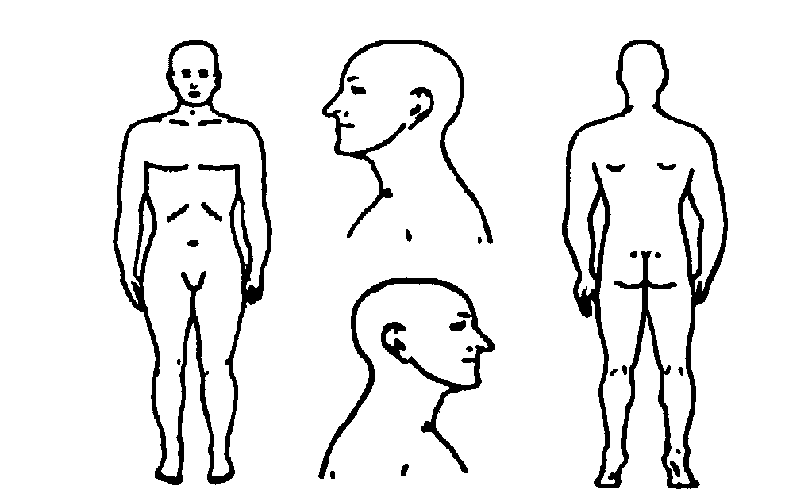
2. Other problems:___________________________________________________________________________________________

- Previous interventions, treatments, medications, surgery, or care you’ve sought for your complaints: _________________

________________________________________________________________________________________________________

- Past Health History (circle): Ankle Pain Arm Pain Arthritis Asthma Back Pain Broken Bones Cancer
Chest Pain Depression Diabetes, Dizziness , Elbow Pain Epilepsy, Eye/Vision Problems , Fainting, Fatigue Foot Pain Genetic Spinal Condition , Hand Pain , Headaches, Hearing Problems, Hepatitis, High Blood Pressure, Hip Pain, HIV/Aids, Jaw Pain, Joint Stiffness, Knee Pain, Leg Pain, Menstrual Problems, Mid-Back Pain , Heart Problem, Multiple Sclerosis, Neck Pain Neurological Problems Pacemaker
Parkinson’s Polio Prostate Problems Shoulder Pain Significant Weight Change
Spinal Cord Injury Sprain/Strain Stroke Others: ______________________________

- Previous illnesses you’ve had in your life: ____________________________________________________________________

____________________________________________________________________________________________________________

B. Previous injury, traumas, broken bones:____________________________________________________________________

___________________________________________________________________________________________________________

- Allergies ________________________________________________________________________________________________

- Medications and reasons for taking _________________________________________________________________________
_____________________________________________________________________________

- Surgeries: and dates
__________________________________________________________________________________________________________________________________________________________

- Females/ Pregnancies and outcomes:
Pregnancies/Date of Delivery or Outcome
_____________________________________________________________________________

- Family Health History:
Associated health problems of relatives: ___________________________________________________________________________

____________________________________________________________________________________________________________
Deaths in immediate family: Cause of parents or siblings death Age at death
__________________________________________________________________________________________________________________________________________________________

- Social and Occupational History:

Work hours/week __________ Alcohol intake _____________/week Tobacco ______packs/week Vaping________

Recreational Drugs ______________ Other_____________________________________________________

Exercise____________________________________________________________________________________

Anything else you feel is important to mention related to your health__________________________________________________

I have read the above information and certify it to be true and correct to the best of my knowledge, and hereby authorize this office of Chiropractic to provide me with chiropractic care, in accordance with this state's statutes. I authorize this office to send and receive information related to the health of the patient and any information needed to process insurance claims. I assign my health benefits to this office. Missed office visits visit charge of $50. Note there is a 24 hour cancelation policy or a $50 fee without a reasonable reason.

Parent or Guardian Signature _______________________________________________________ Date ________________________

Print Name __________________________________

