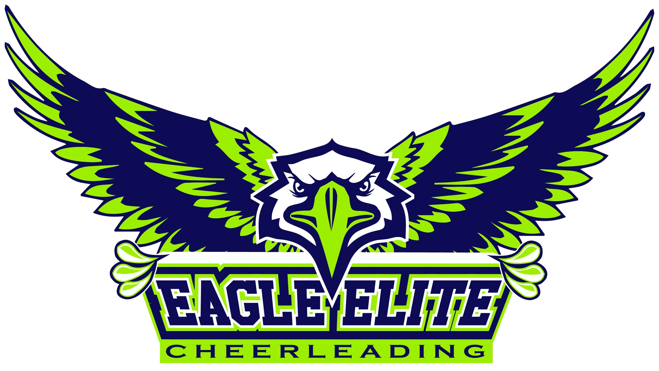

**FREQUENTLY ASKED QUESTIONS:**

**How do I know which class to enroll my child in?** Tumbling classes are done by skill and cheer combo classes are done by age. Our tumbling progression is Beginning Tumbling (until bridge kick over on the floor is consistent w/out a spot), Back Handspring (until standing & running multiples are consistent w/out a spot), Tucks (until standing & running are consistent w/out a spot), then Advanced Tumbling (layouts, twisting, etc)

**What is the difference between Tumbling Classes and Cheer Combo Classes?** Cheer Combo is a combination of jumps, motion technique, conditioning, and tumbling. Tumbling Classes simply focus on tumbling and the muscles needed to do that tumbling.

**Who will be instructing my child?** We are proud to have the only fully USASF certified coaching staff in Columbia. All staff are also CPR/First Aid Certified. Coaches Kelly Eagle, Casey Regan, Otonye Jack, Brandie Morgan-Jack, Jeseca Downes, Savannah Davis and Keona Smith coach competitive teams as well as recreational classes.

**What should my child wear to class?** Any comfortable shorts and shirt/tank are just fine. Cheerleaders tumble in shoes, so please wear tennis shoes. These don’t have to be cheer shoes. Any athletic tennis shoes are fine. Students with long hair should wear it up, and no jewelry please.

**Is there a session/certain number of weeks I will need to commit to?** Classes are all drop-in, so you don't commit to any session or certain number of weeks. You only pay for  
the classes you attend. If you miss a class, you simply don't pay for it. Optional punch cards make check in even easier.

**Do I need to notify you in advance that I will be attending a class?** No need to tell us in advance that you are going to attend. If you show up, you can participate!

**Can I try a class first?** The very first class is a free trial!

**How much do I pay if we enjoy our free trial and decide to return?** All recreational classes are $15 per time. The first class that you pay for, you will have a $40 annual registration fee plus your class cost, so the total for the first paid class would be $55 and then only $15 each class after that. Optional punch cards available (buy 10 classes, get one free)

**Can I come to more than one class in a week?** You are welcome to come to more than one class per week...one every other week...whatever works best for you. We are very flexible.

**Where is the facility?** The address is 2309 Industrial Drive, Columbia, MO 65202 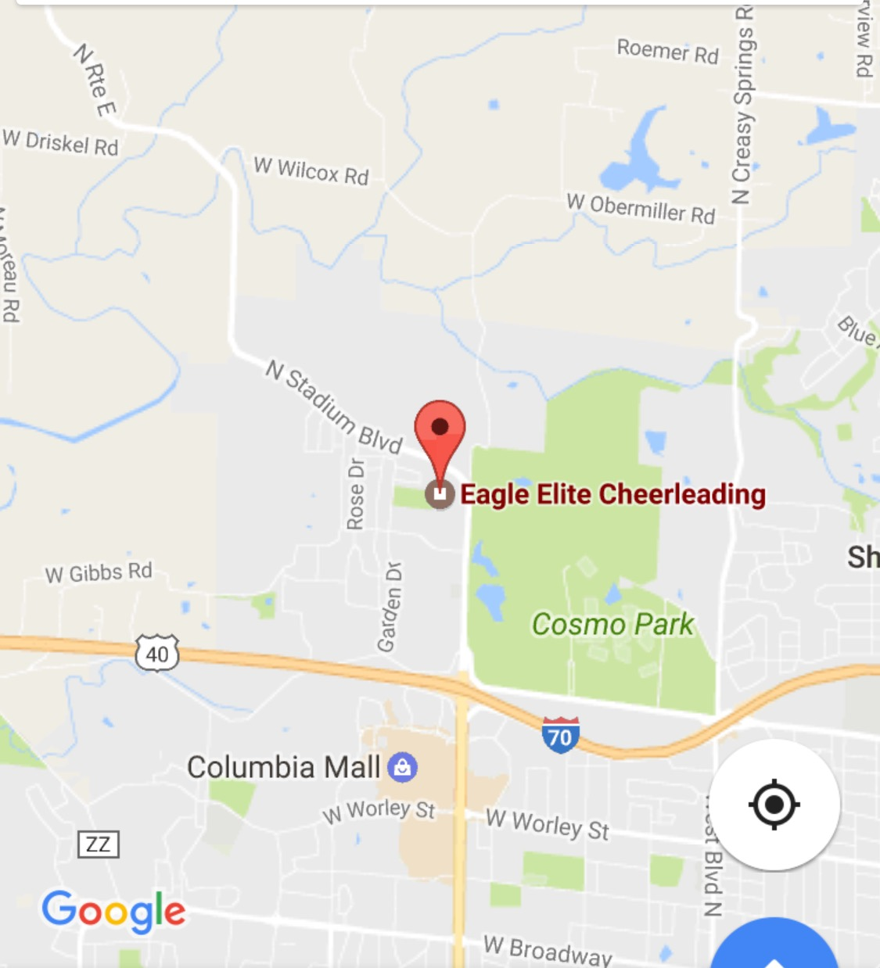

**Can I pay for classes in advance?** We offer optional punch cards that are buy 10 classes, get one free, so you get 11 classes for $150.

**What if I am interested in competitive team?** Competitive team tryouts are May 12th, 2018. Pricing available upon request. Please see the front desk or email eagleelitecheerleading@gmail.com for more information. **Hope to see you soon!  
Call us at 573-397-6114 for any additional questions!**