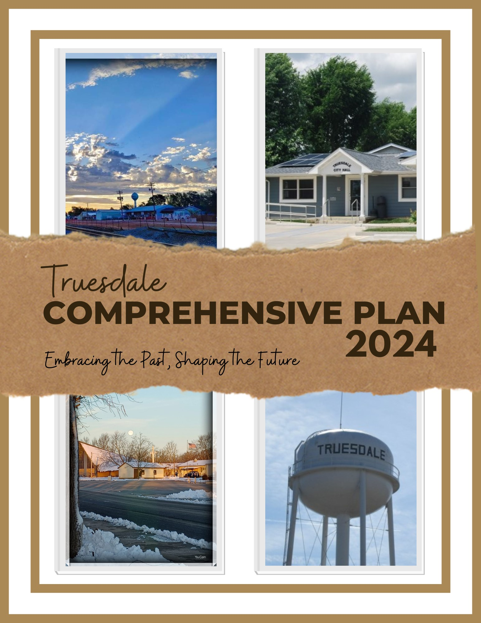
ACKNOWLEDGEMENTS

Board of Aldermen
Chris Watson- Mayor July 10, 2017- June 28, 2023
Jerry Cannon, Mayor- Appointed June 28, 2023, Elected April 2, 2024
Joe Brooks- Alderman
Kari Hartley- Alderman
Justin Naranjo- Alderman
Mike Thomas- President of the Board of Aldermen
Elsa Smith-Fernandez- City Clerk

Planning & Zoning Commission
Donald Smith- Chairperson
Kelly Riehl- Co-Chairperson
Melissa Bachamp- Member
Gary Burke- Member
Kari Hartley- Alderman
Amanda Lefholz- Member
Mike Miller- Member
Cindy Williams- Member (Term ended December 2023)

Comprehensive Plan Committee
Jerry Cannon- Mayor
Gary Burke- P&Z Member
Amanda Lefholz- P&Z Member
Eric Lewis- Member
Katie Lewis- Member
Bert Michelson- Member
Mike Miller- P&Z Member
Mike Thomas- President of the Board of Aldermen
Cindy Williams- P&Z Member
Elsa Smith-Fernandez- City Clerk

Consultants
Boonslick Regional Planning Commission

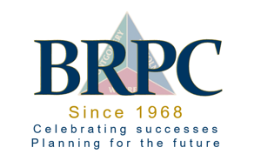

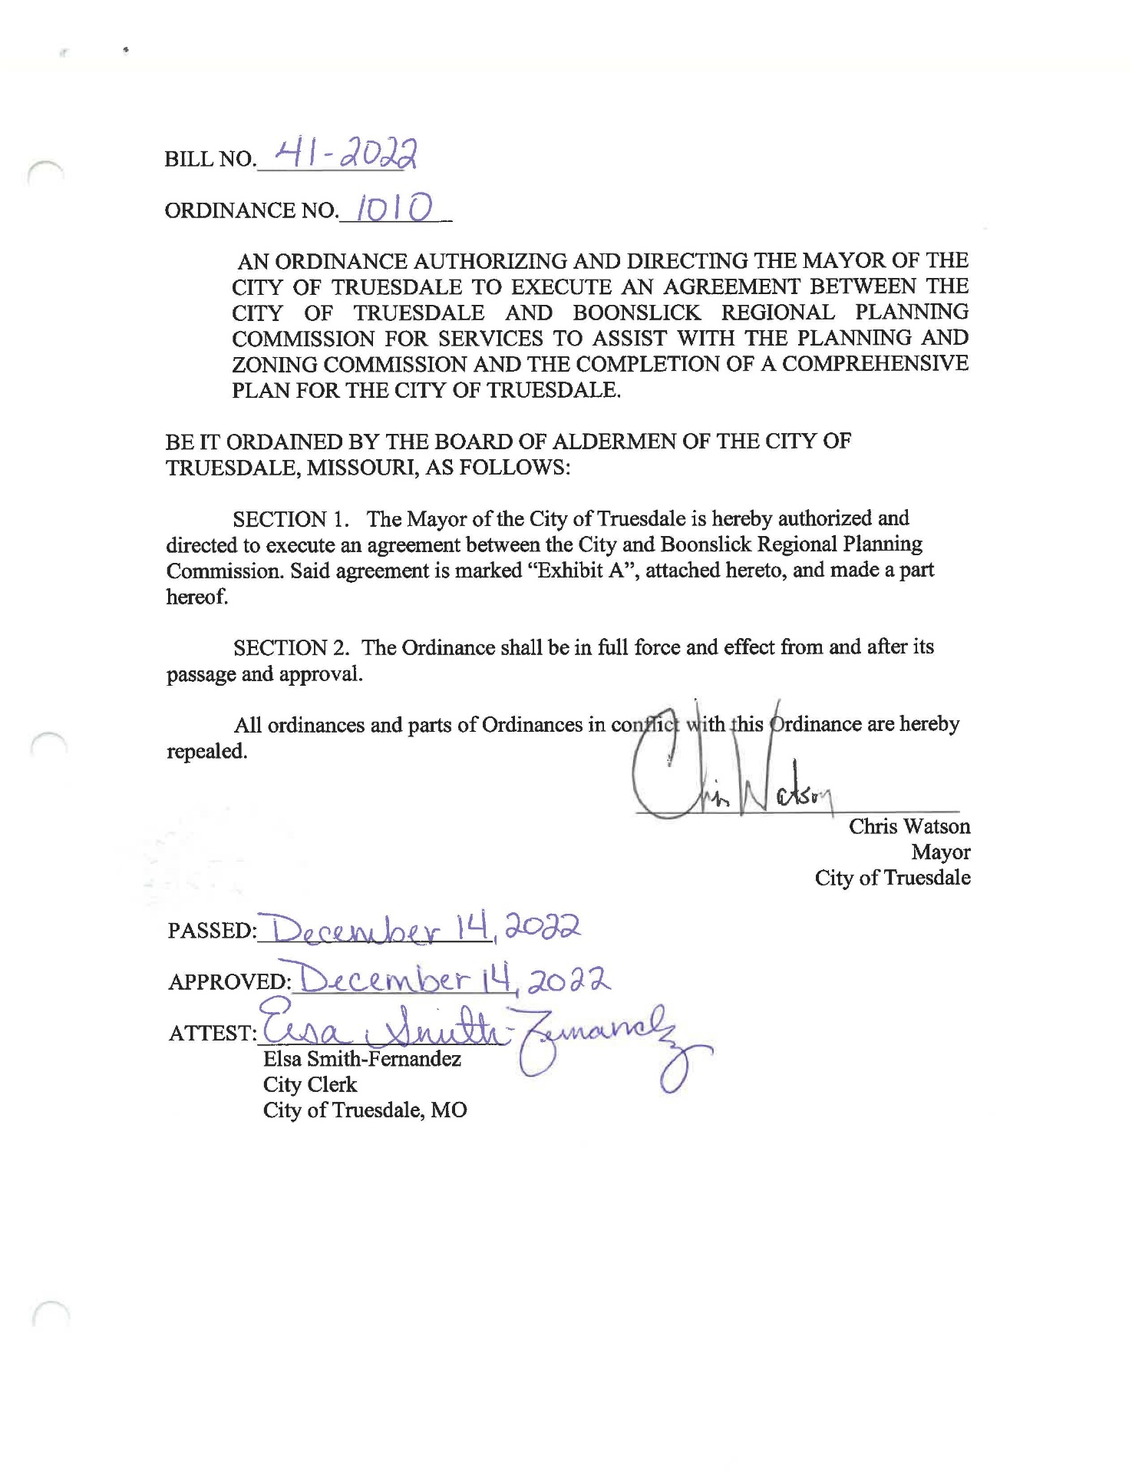
TABLE OF CONTENTS

Section One: Introduction
Introduction 7
Value of a Comprehensive Plan 7
Methodology 8
History of Truesdale 8

Section Two: Existing Conditions
Geography 13
Climate 13
Physiography 14
Geology 14
Natural Constraints 14 Man-Made Constraints 15
Socioeconomic…………………………………………………………………………...15 Population………………………………………………………………………………. 15
Racial Composition 17
Household Composition 17
Poverty 21
Educational Attainment 22
Economy and Employment 22
Occupation and Industry 24

Section Three: Community Assets and Institutions
Churches 27
City Buildings 27
City Government Services 27
Communications 27
Education 27
Nonprofit Organizations 28
Parks and Recreation 28
Public Safety 28
Transportation 28
Utilities 29
Water and Wastewater 29
Financial Resources 29

Section Four: Current and Future Land Use
Current and Future Land Use 32

Section Five: Community Response and Plan Modules
Community Response 34

Section Six: Implementation Plan
Introduction 36
Capital Improvement Plan 36
Plan Goals- Robust Active Living Opportunities 38
Plan Goals- Quality and Diverse Housing 39
Plan Goals- Thriving Local Economy 40
Plan Goals- Transportation/Mobility 42
Plan Goals- Municipal Services and Public Infrastructure 42
Plan Goals- Parks and Recreation 44

Appendices
Appendix A- Community Survey Results 46
Appendix B- Active Transportation Plan Attached
Appendix C- Current Zoning Map Attached
Appendix D- Current Land Use Map Attached

Remainder of page intentionally left blank

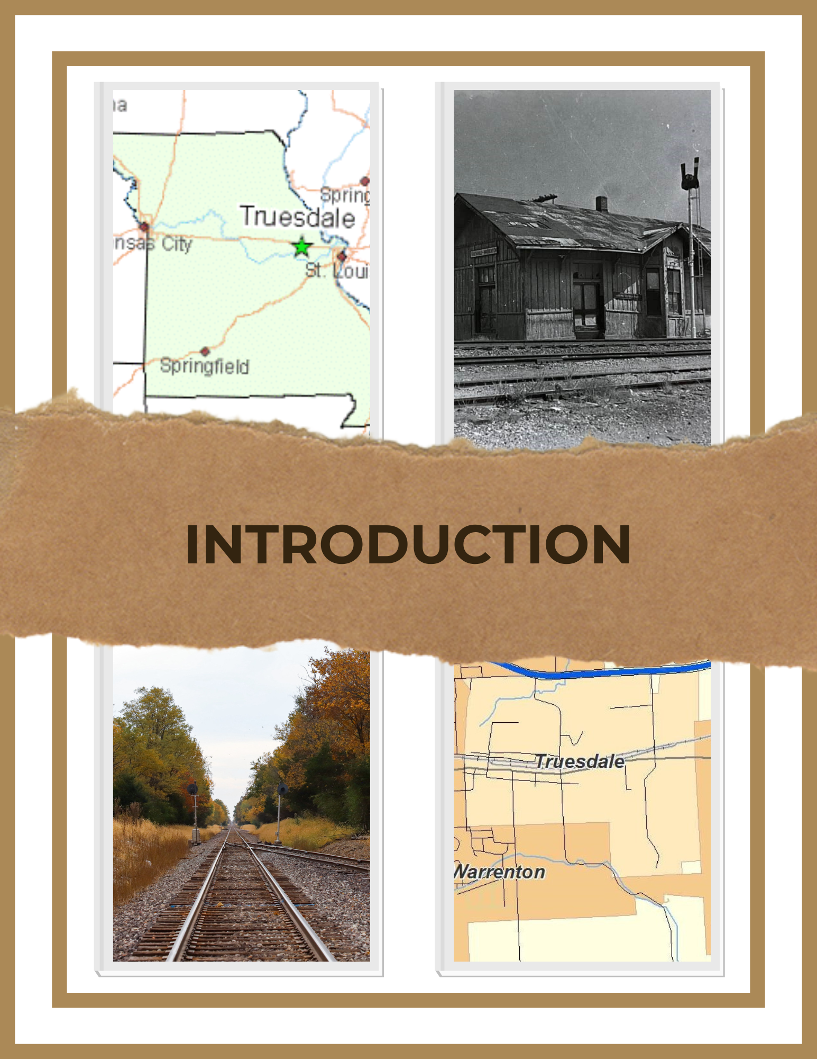
SECTION ONE: INTRODUCTION
A Comprehensive Plan is a public document that serves as a community guide for the future development and redevelopment of the City. Comprehensive Plans look at a range of existing conditions within the community and make general recommendations for the future, planning for about a 20-year time horizon. The Comprehensive Plan is developed with input from citizens and guidance from the taskforce members, and is ultimately adopted by the City Council. Thereafter, it provides a framework for important decisions in the community such as where growth should occur, how land should be used, and where spending priorities should be placed for the next ten to twenty years.

Comprehensive Plans are general in nature but provide the legal basis for key land management tools like planning and zoning, and subdivision regulations. This plan was compiled with input from surveys sent out to citizens and businesses who serve the Truesdale community, the taskforce members, Planning and Zoning Commission members, and representatives from the elected officials of the City. The focus of this effort was to develop a local, community-led vision for Truesdale, and to develop a working plan that reflects and protects the wishes of its citizens.

The Comprehensive Plan is a living document, one to be reviewed, consulted, and updated as needed to ensure that the City’s vision continues to align with the changing conditions of the community, and that the Comprehensive Plan properly reflects those changing conditions.

VALUE OF A COMPREHENSIVE PLAN
This document addresses the planning elements defined in Missouri Revised Statutes Chapter 89 Section 340 and Section 350, which sets forth the legal foundation for the authority, content, and administration of comprehensive plans:

Chapter 89.340. The commission shall make and adopt a city plan for the physical development of the municipality. The city plan, with the accompanying maps, plats, charts and descriptive and explanatory matter, shall show the commission's recommendations for the physical development and uses of land, and may include, among other things, the general location, character and extent of streets and other public ways, grounds, places and spaces; the general location and extent of public utilities and terminals, whether publicly or privately owned, the acceptance, widening, removal, extension, relocation, narrowing, vacation, abandonment or change of use of any of the foregoing; the general character, extent and layout of the re-planning of blighted districts and slum areas. This document addresses the planning elements defined in Missouri Revised Statutes Chapter 89, Section 340 and Section 350.

RSMO Chapter 89.350.. In the preparation of the city plan, the commission shall make careful and comprehensive surveys and studies of the existing conditions and probable future growth of the municipality. The plan shall be made with the general purpose of guiding and accomplishing a coordinated development of the municipality which will, in accordance with existing and future needs, best promote the general welfare, as well as efficiency and economy in the process of development.

METHODOLOGY
Various methods and databases were used to prepare this plan. The most prominent database was the U.S. Census Bureau for the 2010 and 2020 census information as well as the American Community Survey (ACS) estimates for available years. This information was used to better understand variables such as population, socioeconomic status, employment, and mobility.
U.S. Census and American Community Survey (ACS): The ACS includes not only the basic short-form questions, but also detailed questions about population and housing characteristics. ACS provides communities with reliable and timely demographic, housing, social, and economic data every year. Throughout the plan, the U.S. Census and ACS information was analyzed and utilized as needed. Additional data from the Missouri Census Data Center, MO DOT, the Warren County Assessor’s Office, and data from the Office of Social and Economic Data Analysis was also used. The majority of the data was analyzed through comparisons between the city of Truesdale, Warren County, and the state of Missouri.

Several entities helped and contributed to the final construction of the plan. The Boonslick Regional Planning Commission (BRPC) was responsible for the compilation and format of the document itself. Narratives within this document can be attributed to outcomes generated through meetings conducted with the Mayor- Chris Watson (through July 2023) and Jerry Cannon (from August 2023 on), the City Administrator- Elsa Smith-Fernandez, the Comprehensive Plan Task Force, survey output, analyses of statistics gathered by BRPC, and compilation by Boonslick Regional Planning Commission staff. One community survey was conducted as a part of this study. The survey [Appendix A] was administered through a third-party site called SurveyMonkey. The survey was made public at city hall, by mail with notices in resident’s water bills, the city’s website, and social media pages of the city and community organizations.

HISTORY OF TRUESDALE
The City of Truesdale came into existence due to the efforts of a forward-thinking man named William Truesdail, a contractor with the North Missouri Railroad Company. In 1856, anticipating the arrival of the railroad, William Truesdail purchased a large tract of land from John Woodlan, one of the oldest citizens of what was then known only as Elkhorn Township. Upon that land Truesdail platted and laid out a village. As owner of the land, he made a deal with his employer, The North Missouri Railroad, to give them land to build the necessary depot and switchyard, if they would agree to name the village after him. On July 4, 1857, the first train arrived, creating a relationship with the railroad that is still present today.

The North Missouri Railroad Company was incorporated on March 3, 1851. Tagged “the great central rail route to the West,” the start-up plan was to build a railroad from St. Charles, Missouri to the Iowa state line and “all points west.” In 1852 the charter was amended to extend it to St. Louis rather than stop at St. Charles. In 1855 the railroad reached Warrenton, the county seat of Warren County. The drive and determination that it took to accomplish this feat cannot be overstated. The biggest obstacle was the “Big Muddy,” the wide Missouri River. There was no bridge, so at St. Charles the railway cars had to be unloaded and ferried across, then reloaded on the other side. This arduous task continued until the St. Charles railroad bridge was built across the river in 1871.
“Colonel” Truesdail was a man of many talents. Born Jan. 9, 1815, in New York state, he began working at the age of 12 as an indentured servant in Erie, PA. At the age of 20, he became a Deputy Sheriff and Police Justice, followed by a lucrative real estate investment that would lead to his future success. In 1841 Truesdail married Mary Sterritt. They would have 12 children. Truesdail’s true calling was building railroads. 1849 Truesdail contracted with the country of Panama to oversee the construction of a railroad across the isthmus of Panama that pre-dated canal construction. He supervised construction in harsh conditions for over two years that saw only 300 of the 1650 man crew survive construction.

In 1851, Truesdail, now married and with a growing family, headed west. He contracted and built over 60 miles of the railroad from Sandoval, Illinois to St. Louis, Missouri as an agent of H.C. Seymour & Company, in charge of the Western Division of the Ohio & Mississippi Railroad. During his years working for the railroad in Missouri, Truesdail purchased land where the City of Truesdale is now located, even stretching west and encompassing part of present-day Warrenton, along Booneslick Road.

Colonel Truesdail is best known for his role in support of the Union Army during the Civil War. He was sent to Nashville TN. by General Rosencrans to be in charge of a spy corps, and given the title of Chief of Secret Service with the Army of the Cumberland. It was that role in which he became famous, or infamous depending on which side to the war you stood. Taking his position seriously, and being staunchly anti-slavery, Truesdail spent large sums of his own fortune to pay spies for information to further the war effort. In fact, he spent his entire fortune doing so. After the war, the Truesdail family moved to Bunker Hill Il., following an army doctor who had been treating him for illnesses. It was there that Colonel Truesdail died in November of 1867.

Although he remained a civilian, Truesdail was thereafter called Colonel Truesdail. The role that Colonel Truesdail played throughout the Civil War as a spy for the Federal Army is written about in dozens of books on the subject of the war. It makes for some very interesting reading for those who would like to learn more about his life as the head of a large Civil War spy ring. Colonel William Truesdail died of consumption in 1867 in Macoupin County, Illinois and is buried beside his wife at Bunker Hill. The Illinois Veterans Commission has included him in the Honor Roll of Veteran Burials in Macoupin County, IL. His obituary in his hometown newspaper, The Erie, Pennsylvania Observer, on November 28, 1867, stated simply, “Died at Bunker Hill, ILL, on the 26th inst., Mr. William Truesdail, formerly of this city, aged 51 years.” His rather short life was one of high adventure and harrowing exploits. The “father of Truesdale, Missouri” left his mark, not just on our area, but on the entire country.

Truesdail’s 932-acre estate, comprising most of present Warrenton and Truesdale, was purchased May 19, 1864 by the Methodist Episcopal Church as a school and a home for orphans of fallen Civil War soldiers. They called it The Western Orphan Asylum and Educational Institute. The large house which the Truesdail family had lived in became the orphanage and a new building was constructed for the school. In 1869 the name was changed to Central Wesleyan College and Orphan Asylum. In the 1930s the Truesdail family home was torn down and cottages on the property were used for the orphans’ home until the orphanage closed in 1939. The college closed in 1941 and the property was sold at auction in 1946. Today the Truesdail family home site is a business section.

Colonel Truesdail’s headstone was destroyed in a tornado in the 1940’s, and through the efforts of current and former Truesdale leadership, the great grandson (several times removed) of Colonel Truesdail, and partnership with the Bunker Hill Historical Society, was replaced on April 9, 2022.

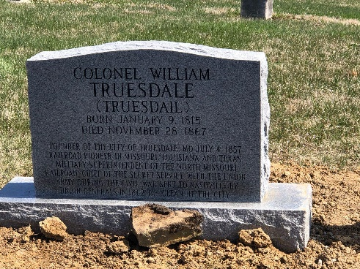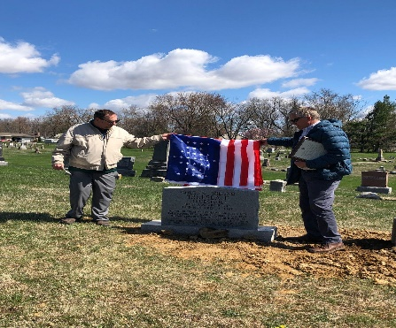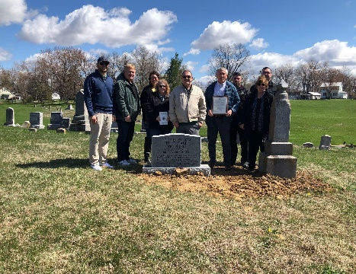

Truesdail’s 932 acre estate has taken on many changes over the years. Most notably, Central Wesleyan College and Orphan Asylum, College United Methodist Church, Katie Jane Nursing Home, and the Niedringhaus Gymnasium were former occupiers. Now it has been transformed into a thriving business district.

Throughout the years Truesdale has been the home to schools, businesses, and churches. From the middle half of the 20th century to the beginning of the 21st century, Truesdale was the home to three famer’s elevators including MFA, and Thornton’s Feed Store. A grocery store and meat locker were located across Highway M from the train depot for nearly a century, and after the three-story red brick building was demolished, is the current location of Green Gardens greenhouse. Truesdale had a post office also located across the street from the depot that was built in 1889, but it was closed in 1979. Truesdale’s oldest business is still in operation after beginning in 1883. Brockfeld’s Gunsmithing has been a pillar in the Truesdale community for 141 years, through five generations, and is a large part of the historic legacy.

Throughout the years, there have been many changes in Truesdale, proving the motto:
“Embracing the Past, Shaping the Future”.

- Current notable companies in Truesdale include Cascades Plastics, Oldcastle Glass, Refresco, and Warrenton Oil Company
- Dining options include Olive’s Bakery and El Tapanco Mexican Restaurant
- Department of Natural Resources Land Grant to establish Bruer Park in the city center
- State Emergency Management Agency grant to build the MaryLou Community Center/Safe Room
- Established the Planning and Zoning Commission in 2022
- Established a transportation sales tax in 2020 for street enhancements
- Annexed approximately 7 acres into the city limits in 2022
- Drug take-back program implemented in 2011
- New city hall built in 2008
- 2024- in cooperation with Warrenton School District, established the School Resource Officer Program at Rebecca Boone elementary school
- Added community events:
- Railroad Days Summerfest held the first Saturday in June- celebrates the heritage of the community with family-friendly activities and concerts
- Truesdale Community Christmas held the first Saturday in December- kicks off the holiday season with a visit from Santa Claus, great food, and prize giveaways

Colonel Truesdail would be proud of the community he founded 167 years ago!

Remainder of page intentionally left blank

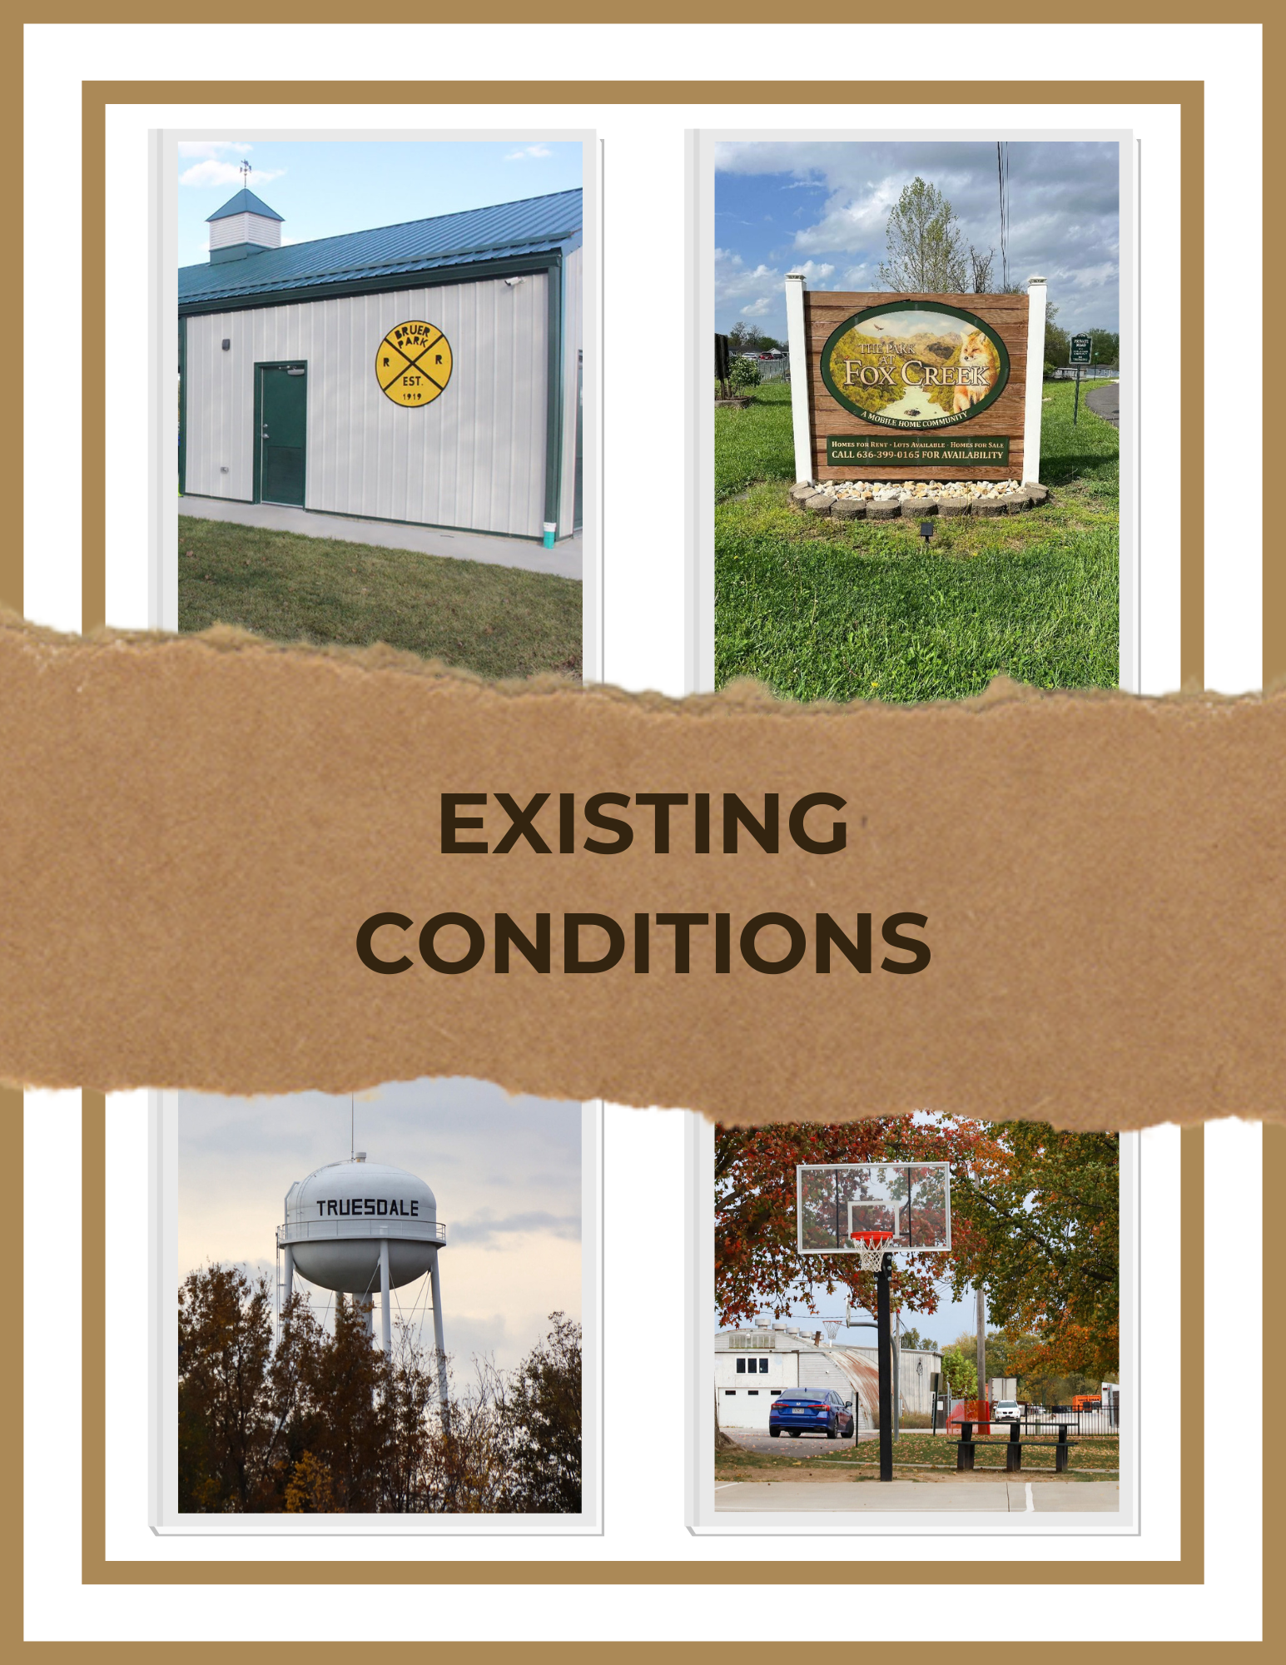

SECTION TWO: EXISTING CONDITIONS
GEOGRAPHY
The city of Truesdale is located in northcentral Warren County, Missouri, in the township of North Elkhorn. According to the United States Census Bureau, the city has a total area of 1.29 square miles, of which 1.27 square miles is land and .02 square miles is water. Truesdale is located along Interstate 70, is 17.7 miles west of the city of Wentzville in St. Charles County, and adjacent to the city of Warrenton to its West. Interstate 70 is the primary access route for Truesdale, with State Route M running east and west directly through the city. The city is separated by railroad tracks running east and west through the city. The city is situated in a rural agricultural area, yet is within the St. Louis Metropolitan Statistical Area and within a 60-minute commuting distance of most major industries in the St. Louis region. The City’s elevation is 860’ above sea level.

CLIMATE
The climate of Truesdale is typified by relatively high temperatures and evenly distributed precipitation throughout the year. Summer months are described as mostly consisting of moist, maritime airflow from the western of the subtropical cells over low-latitude ocean waters. Temperatures are high and may lead to warm, oppressive days with summers usually wetter than winters. The warmest month, on average, is July with an average high temperature of 89° F, and an average of 12.6 days above 90°F. Typically, the month with the most precipitation, on average, is May with 4.4”.

Winter months are usually mild, with the coolest month, on average, being January with an average low temperature of 21° F, and an average of 25.4 days below 32°F. Typically, the month with the least precipitation, on average, is January with 2.0”.

Rainfall averages 3.7” per month March through October, while the average is 2.25” per month November through February. Winter months, November through February, average 3”- 5” of snowfall. Average wind speeds range from 6 miles per hour in July to 9 miles per hour in March. Winter and spring winds are from the west northwest while summer winds blow primarily from the south.

Climate data for Truesdale, Missouri
Month | Jan | Feb | Mar | Apr | May | Jun | Jul | Aug | Sep | Oct | Nov | Dec | Year
Average high F° | (39) | (42) | (53) | (66) | (75) | (84) | (89) | (87) | (80) | (68) | (53) | (41) | (65)
Average low F° | (21) | (23) | (32) | (42) | (51) | (60) | (66) | (64) | (55) | (44) | (33) | (24) | (43)
Average precipitation (inches) | (2.0) | (2.0) | (3.3) | (4.0) | (4.4) | (4.3) | (3.4) | (3.1) | (3.9) | (3.0) | (2.9) | (2.1) | (38.3)
Source: Weatherbase

PHYSIOGRAPHY
According to the Missouri Department of Natural Resources, the topography of Truesdale is “moderately dissected plains”.

GEOLOGY
The geology of the area contains elements from the Paleozoic era. Most of the uplands are underlain by rock of the Mississippian Geologic Age, which consists of cherty limestone, shale and extensive solution limestone. The soils within the area are generally fertile, composed of silty loam. The majority of the geologic formations and soils within the area are suitable for uses such as residential and other development

NATURAL CONSTRAINTS
The city boundaries are surrounded completely on the west and south by the city of Warrenton, and partially to the north and east leaving little land with which to expand the city limits. The topography of the available land is relatively flat with some steeper dissected hills covering some portions. Charette Creek runs south from below the city boundary. Reifsnider Conservation Area lies at the southernmost tip of the area. In some areas, the type of clay locally referred to as “plastic” may cause building constraints. Careful site analysis and preventive building regulations should be included in the city’s codes. Buildable soils in and around Truesdale are suitable for residential development with the exception of steep slopes and possible areas of hydric soils. Hydric soils generally remain too wet to support a building foundation.

MAN-MADE CONSTRAINTS
The city should develop and adopt comprehensive planning and zoning ordinances and statutory elements to impact the development of the community and influence future development. These development ordinances should be outlined in at least the following sections of the ordinance:
- Chapter 415- Floodplain Management
- Chapter 455- Subdivision and Land Development

SOCIOECONOMIC
This section of the plan covers the socioeconomic conditions for the City of Truesdale comparing the 2010 census data to the 2020 census data as compiled from the U.S. Census Bureau. This information demonstrates the growth of the City of Truesdale over the past ten years, comparing comparable growth to other cities in the region, and the State of Missouri. Additional highlights include racial composition, household composition, educational attainment, and employment data.

POPULATION
Population analysis is used to indicate what community services may be needed in the future. The City of Truesdale has seen growth between 2010 and 2020 census counts from 732 people in 2010 to a population of 853 in 2020 resulting in a 8.6% increase.

The population of Warren County grew by 9.3% in the last decade (2010-2020), making it the seventh fastest growing county in the state. Warren County and its cities continue to witness population growth that is both positive and stable. The table below compares the population growth of Truesdale with other communities in the surrounding region and highlights the positive change in the last ten years.

Population projections by the Missouri Office of Administration indicate that Warren County's population is estimated to reach 46,241 by 2030, an 88.5% increase from 2000, ranking it the third largest projected increase in the State. Much of this growth is anticipated to concentrate in the communities along the Interstate 70 corridor, with most of the concentration in and around the established commercial and industrial centers of Warrenton, Truesdale, and Wright City. With the recent allocation of more than $3 billion dollars to be invested in expanding Interstate 70 across the state, the potential is even greater for this region.
In 2000, Missouri was the nation's seventeenth most populous state. By 2020, the state had dropped to nineteenth as a result of lower than average growth.
Projections indicate that Missouri's growth will continue on a downward trend in the coming decades. Overall growth between 2000 and 2030 will average roughly six percent per decade. Census Bureau models predict the nation to grow at about ten percent per decade. Missouri's projected rate of growth through the year 2030 will be less than was seen during the 1960s, 70s and 90s but greater than the 1930s, 40s and 80s. The model projects Missouri's population to grow by roughly 1.2 million people over the next thirty years, a 21 percent increase, for a total population approaching 6.8 million people in 2030.
POPULATION BY AGE
The fastest growing demographic in Truesdale is the population of persons under 5 years old with almost 50% growth over the past ten years going from 67 children in 2010 to 98 in 2020. These numbers may indicate that the city is attracting younger persons who are growing their families in Truesdale.

It is noteworthy that the population of Truesdale citizens who are 65 and older dropped 3.3% from 2010 to 2020 going from 63 individuals to 51 individuals. While these numbers indicate a decline in Truesdale, as this population group continues to grow statewide, the city will need to review programs and services that may better support and encourage this population to remain in Truesdale, and avoid the migration to other cities. These may include such services as senior housing, access to health and social services, transportation/mobility, and recreational opportunities. The upward trend of this population will continue as every day in the United States, 10,000 people turn 65. AARP predicts that the number of older adults will more than double over the next several decades and will represent more than 20% of the population by 2050.

General Population Characteristics
 | Truesdale |  | Missouri
 | 2010 | 2020 | 2010 | 2020
Total Population | 732 | 853 | 5,988,927 | 6,154,913
% Persons under 5 years | 9.1 | 12.3 | 6.5 | 6.0
% Persons 5-20 years | 29.7 | 26.9 | 23.8 | 19.2
% Persons 21-64 years | 51.5 | 54.4 | 55.7 | 58.0
% Persons 65+ | 9.7 | 6.4 | 14.0 | 16.8
% Female | 45.6 | 51.8 | 51.0 | 57.2
% Male | 54.4 | 48.2 | 49.0 | 42.8
Median Age | 27.3 | 31.8 | 36 | 39.2

RACIAL COMPOSITION
The City of Truesdale is not racially diverse with 91% of the population identifying as white, and significantly less racially diverse than the state of Missouri. All other ethnicities make up only 9% of the city’s population which is also significantly less than the state characteristics. The ethnicity of the city is comparable with Warren County where the population identifying as white is 94.3%, and all other ethnicities combined at 5.7%.

Population Racial Characteristics
 | Truesdale |  | Missouri
 | 2010 | 2020 | 2010 | 2020
% White | 87.9 | 91.0 | 80.8 | 78.0
% African-American | 5.6 | 3.8 | 11.6 | 11.4
% American Indian | 0.9 | 0.0 | 0.5 | 0.5
% Asian American | 0.5 | 0.1 | 1.6 | 2.2
% Two or more Races | 3.6 | 2.3 | 2.1 | 2.3
% Some other Race | .1 | 1.4 | 0.1 | 2.0
% Hispanic or Latino | 1.4 | 1.4 | 3.3 | 3.6

HOUSEHOLD COMPOSITION
In addition to the age of the population, the household characteristics of a community may determine the type and quantity of community facilities and services that should be considered to support the needs of the population. The number and type of individuals in a household guides the school system, youth and senior services programs, and the economic development emphasis for the community.

According to the 2020 Census data, there are a total of 270 households in Truesdale of which
- 47.7% are married couple family households
- 20.1% are single family households
- 32.5% are nonfamily households
- 2.96 is the average household size
- 3.58 is the average family size
- 122 households (45.5%) have children under 18 years
- 8.5% of householders living alone are 65 years and over

With more than 45% of the households with children under 18 years may indicate the need to consider the development of more programs for youth, transportation/mobility emphasis to enable the safe and timely access to and from the elementary school in the city. This was addressed in the city’s active transportation plan. A recreation center/community center, additional playgrounds, and park facilities are examples of amenities that could be considered to maintain an active community with children.

Median family income is typically higher than median household income because of the composition of households. Family households tend to have more people, and more of those members are in their prime earning years; as contrasted with members who have lesser incomes
because they are very young or retirement age. Areas with a wide disparity between the two measures have an excess of nonfamily households: single persons or otherwise.

The median home value has risen significantly between 2010- 2020 with the addition/completion of two subdivisions with housing prices starting in the low-mid $200,000s.
The median home value in Truesdale (2020 census) is $134,000. By 2021 this number had risen to $145,300 which is still less than the national average of $244,900. The 2020 homeownership rate in Truesdale is 73.5% which is well above the national average of 64.6%.

As the median home values have risen, so too has the median household income. This can be due to the influx of families/homeowner’s who are moving into the newer, higher-priced homes that have been built in the community over the last ten years.

As per the U.S. Census Bureau, a family consists of two or more people (one of whom is the householder) related by birth, marriage, or adoption residing in the same housing unit. A household consists of all people who occupy a housing unit regardless of relationship. A household may consist of a person living alone or multiple unrelated individuals or families living together.

Over the most recent four years, the city has seen growth in new residential building permits that have been approved. The city has 11 parcels of land, totaling 59.28 acres, that are available for development as of 2024. These prime locations are located along South Spoede Lane, East Veteran’s Memorial Parkway, and a portion of East Highway M.

The number or permits granted the last five years are as follows:
- 2020- 20 permits
- 2021- 5 permits
- 2022- 3 permits
- 2023- 4 permits
- Current- one planned subdivision with 190 lots

Household Characteristics
Truesdale
 | 2010 | 2020
Total Housing Units | 273 | 302
Occupied Housing Units | 267 | 270
% Homeownership Rate | 48.7 | 73.5
Median Home Value | $105,800 | $134,000
Median Household Income | $24,297 | $36,250
Occupancy Characteristics
Married-Couple Family | 76 | 129
Male Household- No Spouse Present | 3 | 14
Female Household- No Spouse Present | 73 | 40
Nonfamily Households | 115 | 87

The city of Truesdale has 302 housing units according to the 2020 Census. Of this total,
- 54.8% are single unit structures (37.8% in 2010)
- 14.8% are two-or-more unit structures (18.7% in 2010)
- 30.4% are mobile homes and all other types of units (43.4% in 2010)
- 73.5% are owner-occupied housing units (48.7% in 2010)
- 26.5% are renter-occupied housing units (51.3% in 2010)

2020 Home Values (Occupied)
Truesdale
Under $50,000 | 42
$50,000- $99,999 | 23
$100,000- $299,999 | 98
$300,000- $499,999 | 11
$500,000 and above | 2
 | 176

The buying power, or personal wealth, of a population influences the socio-economic characteristics of a community. The ability to purchase goods, including housing, is dependent on the income of a community’s population. The income of a community determines the type and quality of housing stock on the market and the availability of retail goods and services of the community. The population’s income and buying capacity also influences the community’s ability, through taxation, to provide public facilities and social services such as transportation infrastructure, medical facilities, educational centers, entertainment venues, and recreational facilities and senior services. Hence, per capita income is used as an economic indicator of a community’s standard of living and wealth.

Between 2010- 2020 the mean income of all households in Truesdale grew from $32,949 in 2010 to $47,047 in 2020, a 43% increase. The median income also saw substantial increases over that same period. In 2010 the median income was $24,297 for all households in Truesdale, and $36,250 by 2020, a 50% increase.

Mean income, or average, is obtained by dividing the total aggregate income of a group of people by the number of people in the group. The median income is the amount that divides the total income distribution in two equal groups, half having income above the median amount, and half having income below that amount.

The chart below compares the growth in median incomes between the larger cities in Lincoln and Warren counties with the fast-growing city of Wentzville in St. Charles County. While all of the cities saw some growth in median income, the cities rank as the following in percent of median growth over the 2010-2020 timeframe with Truesdale showing a 50% increase in median income over the last ten years.

 | 2010 | 2020 | Increase
Warrenton | $45,118 | $47,804 | 6%
Moscow Mills | $43,421 | $47,386 | 9%
Wright City | $44,301 | $57,290 | 29%
Wentzville | $71,933 | $93,602 | 30%
Troy | $49,156 | $68,524 | 39%
Truesdale | $24,297 | $36,250 | 50%

POVERTY NUMBERS
Another measure of a community’s economic health is the Federal Poverty Level, sometimes called the Poverty Line. This is an arbitrary number set each year by the U.S. Department of Health and Human Services for statistical analysis purposes. For 2023, the Federal Poverty Level, or FPL, is set for the 48 contiguous states at $14,580 for individuals, and up to $50,560 for a family of eight. For a family of four, the FPL is $30,000. Note that the condition of a community’s economic health varies inversely to the number of families living under the Federal Poverty Level.

According to the United States Census Bureau (2020 data), an estimated 193 citizens (24.6%) of Truesdale are living below the Federal Poverty Level. Of this number, 82 (42.5%) are female, and 111 (57.5%) are male.
- 30 are children under 5 years
- 47 are children 5 to 17 years
- 54 are adults 18 to 34 years
- 62 are adults 35 to 64 years

Of the estimated 193 citizens living below the FPL, 130 are considered in the civilian labor force (considered as individuals 16 years and over), with:
- 13 (10%) working full-time, year-round in the past 12 months
- 66 (50.8%) working part-time or part-year in the past 12 months
- 51 (39.2%) did not work

It is estimated that 101 households in Truesdale receive food stamps/SNAP with 52.5% of the households having at least 1 child under the age of 18. The median income for these households is $12,639, and 22.4% are households where there has been no worker in the past 12 months.

EDUCATIONAL ATTAINMENT
The city of Truesdale is served by the Warren County R-III School District. The District serves students to Truxton to the north, to the border of the Wright City R-II District to the east including a portion of Innsbrook, to Pinckney and Treloar to the south, and west of Jonesburg. The District serves 3,094 students with 277 certified staff working out of 6 schools. Rebecca Boone Elementary School is located in Truesdale and serves children grades K- 5. Middle school students from Truesdale attend Black Hawk Middle, and all students in the District attend Warrenton High School. The Warren County R-III School District is fully accredited by the Missouri Department of Elementary and Secondary Education.

The educational attainment of a community’s citizens may influence the local economy and affect the income and type of employment opportunities in the region. The percentage of students eligible for free or reduced meals is an indicator of families living near or below the poverty level. Rebecca Boone Elementary has a 68% student free or reduced lunch rate which is the highest of all three elementary schools in the district. Missouri’s rate is 53.2% which ranks it 32nd for the percentage of students on free or reduced lunch.

The table below compares the educational attainment of the population of Truesdale 25 and older against the Missouri statistics. The population of the city has trended up related to educational attainment with 96.1% of the citizens holding a high school degree or higher compared to 73.9% in 2010. This is above the Missouri statistics.

 | Truesdale |  | Missouri
 | 2010 | 2020 | 2010 | 2020
% Graduation Rate |  | 93.7 | 81 | 89.3
Educational Attainment (population 25 yrs. and older)
% High School or Equivalent Degree | 69.2 | 76.2 | 86.8 | 61.3
% Bachelor's Degree or Higher | 4.7 | 19.9 | 9.7 | 30.0
% High School Degree and Higher | 73.9 | 96.1 | 96.5 | 91.3

There is a total of 183 children residing in Truesdale enrolled in school. The high school (grade 9 to grade 12) students are the largest group with 65 (35.5%) of the students, followed by middle school (grade 5 to grade 8) at 59 (32.2%), elementary (grade 1 to grade 4) at 41 (22.4%), and kindergarten with 18 (9.8%) enrolled. There are an additional thirteen children enrolled in preschool.

ECONOMY AND EMPLOYMENT
The city of Truesdale may be described as a “bedroom community” because it is outside of the suburbs or city center, and is located in a more rural, residential, and less industrial area. However, there is an industrial park in the city with additional land available for more light to medium industrial growth, as well as development of new commercial properties. Several companies are headquartered in Truesdale, including Warrenton Oil Company, Gastorf Chevrolet, Cascade’s Plastics, Eagle Activewear, River City Steel, Co., H.T. Hackney Co., and C&S Metal Works. There are multiple small to medium-sized commercial/industrial and retail businesses located within the city. Because of this, the city is well situated to become a more full-service community; there are new residential neighborhoods under construction, Refresco, a major employer in the city, is expanding operations and creating new jobs, and the city is developing planning and zoning ordinances to direct growth in the city.

The labor force of an area is defined as those 16 years of age and older who are employed or actively seeking employment. Labor force and employment data provide evidence of the strength of the local economy. The table below indicates the employment status of individuals in Truesdale. There are 550 people 16 years of age and older in Truesdale

Employment Characteristics
 | Truesdale | Missouri
 | 2020 | 2020
Employment Rate | 70.8% | 60.1%
Unemployment Rate | 4.3% | 5.0%
Average Commuting Time to Work (in minutes) | 19 | 23.7
Class of Worker
% Private Company | 81.3 | 67.6
% Self-employed (incorporated business) | 0 | 3.4
% Not-for- Profit | 0 | 10.2
% Local, state, federal govt. | 14 | 12.9
% Self- employed (not incorporated business) | 4.7 | 5.9
Means of Transportation
% Drove Alone | 95.8 | 75.4
% Carpool | 4.2 | 7.9
% Public Transportation | 0 | 0.8
% Walked | 0 | 1.6
% Bicycle | 0 | 0.2
% Taxi, Motorcycle, or Other Means | 0 | 1.1
% Work from Home | NA | 12.9

OCCUPATION AND INDUSTRY
The chart below indicates the industries where Truesdale citizens are employed. There is a substantial amount of diversification among citizens representing a well-rounded cross section of industry types. 21.2% of the workforce is in the manufacturing industry, making it the highest employment type for citizens of Truesdale. 18.8% are employed in the educational services, healthcare, and social assistance field, with retail trade at 16.8% rounding out the top three.

There have been some recent announcements of industrial projects in the area
which include a 500,000 square-foot facility for the American Foods Group, LLC, which broke ground in September 2022 on an $800,000,000 beef processing facility in the County. This new facility is expected to generate 1,500 new jobs in the area. The proposed Elkhorn Ridge subdivision, with 190 single family home lots, will provide more housing inventory for potential employees who will be coming to the area as industrial growth continues to move further west of the St. Louis metropolitan area.

Refresco Beverages US Inc, a leading global provider of beverage solutions with a facility
in the City, announced in February 2023 that it will expand its operations in the City, investing $22,000,000 and creating 30 new jobs through the installation of an additional production line.

The following table indicates the largest employers located within 15 miles of the City:

Company Name | Product or Service | Number of Employees
American Foods Group, LLC | Meat processing plant | 1300
Warren County R-III School District | Education | 750
Wal-Mart | Retail | 400
Refresco Beverages US Inc. | Soft drink manufacturing | 375
Cascades Plastics | Wood container and pallet manufacturing | 225
Old Castle Glass | Glass product manufacruting | 200
SAF Holland USA | Motor vehicle parts manufacturing | 200
Schnucks Supermarket | Grocery store | 175
Warrenton Oil Co. | Crude petroleum extraction | 175
Agape Ministry of Warren County | Community outreach/food pantry | 150
Source: City of Warrenton.

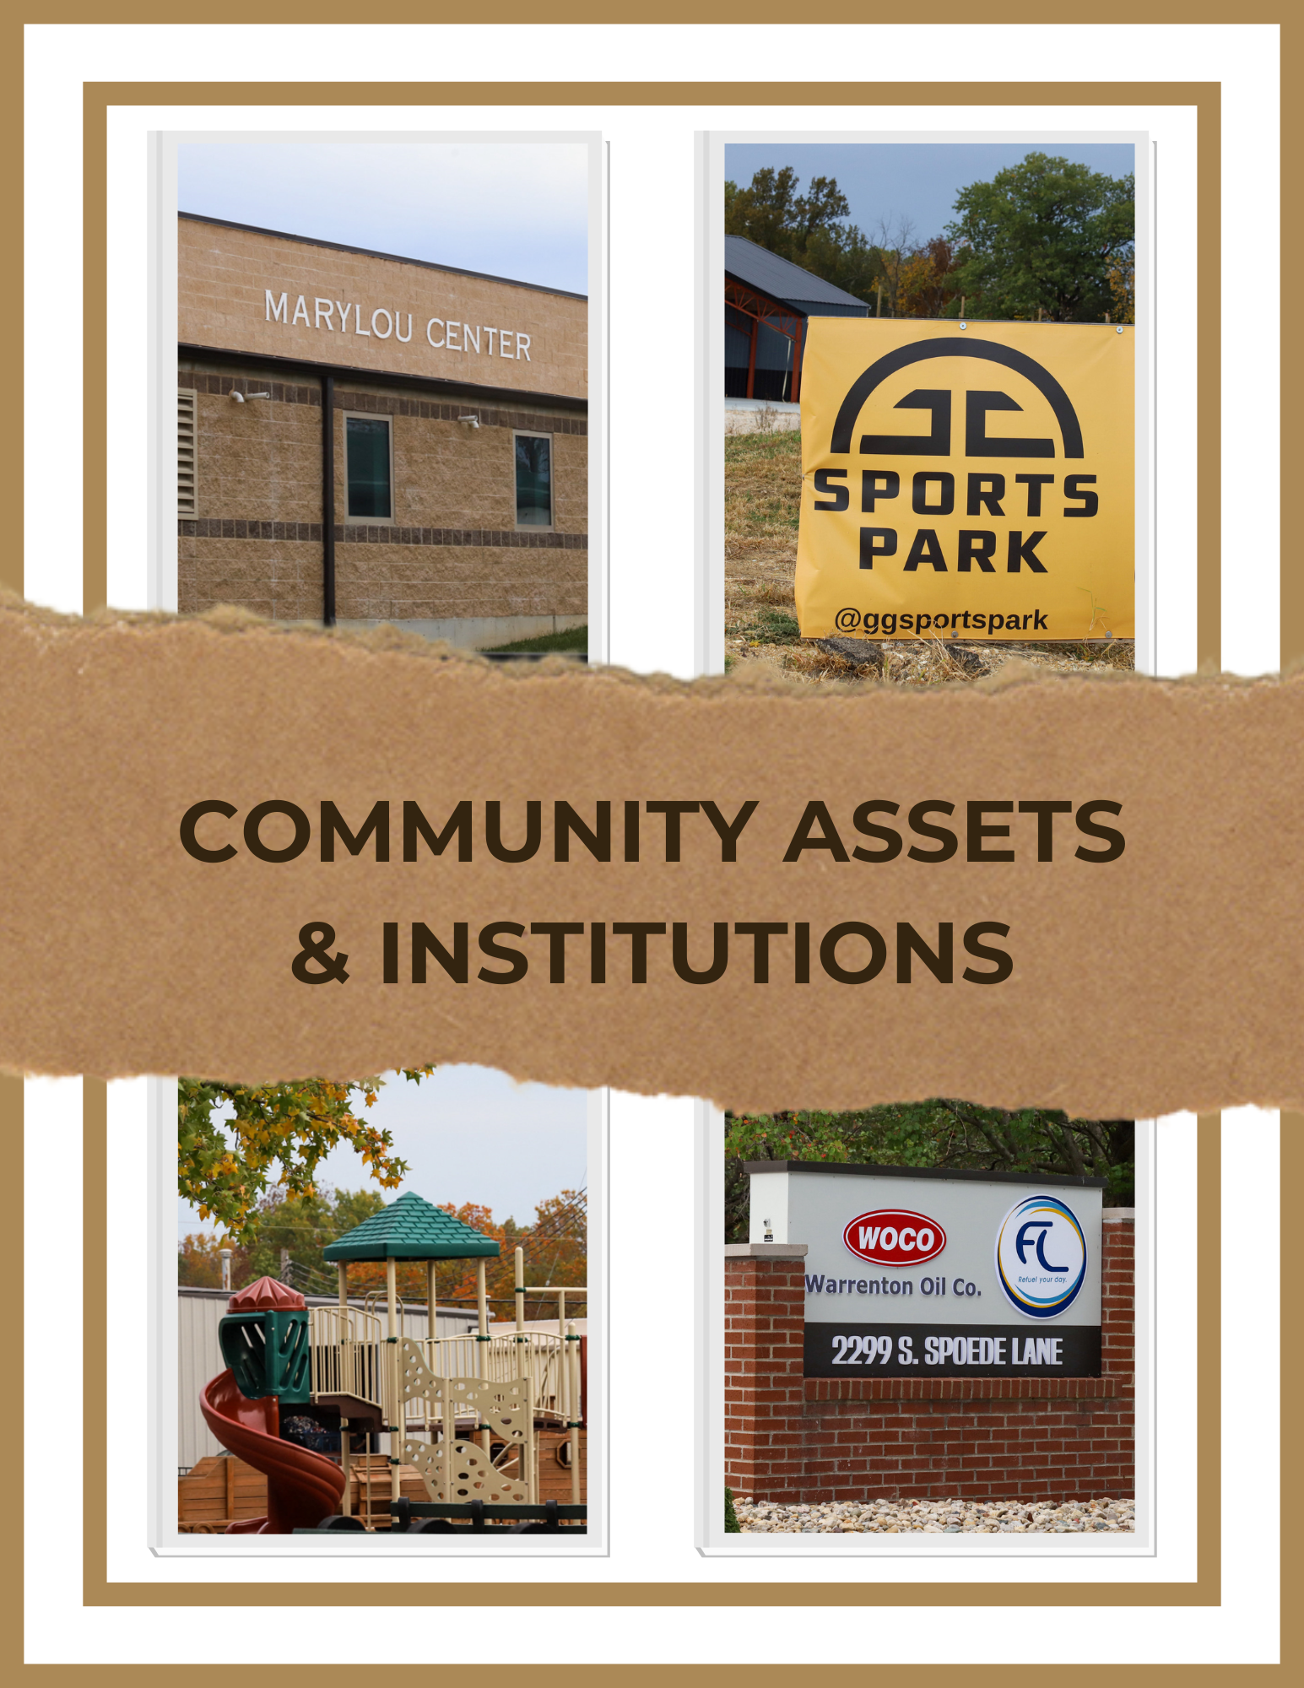

SECTION THREE: COMMUNITY ASSETS AND INSTITUTIONS
One of the signs of a growing community is the availability and diversity of community assets and institutions for City citizens and guests.

CHURCHES
Truesdale has three faith communities that are located within the city providing opportunities for spiritual growth for those who wish to participate. Creekside Place Church, Faith Christian Family Church, and Holy Rosary Catholic Church.

CITY BUILDINGS
Truesdale City Hall is open Monday- Friday and houses the Mayor's office, the Police Department, and the Public Works Department.

CITY GOVERNMENT SERVICES
The city of Truesdale was incorporated in 1857 and is classified as a 4th class city. The city is served by an elected Mayor, an elected four-member Board of Aldermen, and an appointed City Clerk. The Board is responsible for establishing policy direction for the city on behalf of taxpaying citizens and businesses. They introduce and enact ordinances, and oversee the day-to-day budget concerns for the city. The Mayor acts as the head of the Board of Aldermen and enforces the decisions of the Board. The Mayor presides over all meetings, but votes only in case of a tie of the Board of aldermen. Both the Mayor and Board of Aldermen are elected by registered voters to two-year terms.

The Board of Aldermen appoint the City Clerk who assists the Mayor and Board of Aldermen in conducting City business. The City Clerk works with the Mayor and Board of Aldermen in preparing the budget each year.

COMMUNICATIONS
The city is served by Brightspeed, Centurylink, Charter Spectrum, and residents of the City receive St. Louis area radio stations and television channels. Cable television is provided by Spectrum, DirectTV, and Dish Network.

The Scenic Regional Library has a branch in Warrenton, Missouri, just north of the City. An executive board of directors governs the regional library system. The Scenic Regional Library provides access to books, audio visual materials, magazines, preschool story times and other programs to all residents in the area. It was founded to promote literacy and education, thus improving the communities it serves.

EDUCATION
Truesdale is served by the Warrenton R-III School District. Rebecca Boone Elementary is the only District school within the city limits. The school serves students kindergarten through 5th grade. Holy Rosary Catholic School provides educational programs for student’s kindergarten through grade 8.

NONPROFIT ORGANIZATIONS
There are three nonprofit organizations within the city of Truesdale. Righteous Rides operates a cafe', and provides vehicles for international missionaries who are on home assignment. Since 1978, Warren County Sheltered Workshop has been empowering people with disabilities by providing opportunities for meaningful employment. Warren County Pathfinders have a facility in Truesdale providing day program services for adults with disabilities.

PARKS AND RECREATION
Within the city limits of Truesdale is Bruer Park, named for Mayor Murray A. Bruer who passed away on July 1, 2017 during his term as Mayor. The park has a pavilion with grills, restrooms, basketball court, and playground. Truesdale's annual Railroad Days event is held at the park. The park is located near Highway M in the heart of the city. Good Game "GG" Sports Park, located on Veteran's Memorial Parkway, opened in 2022 and is a new paintball, nerf ball, airsoft, and gel blaster action sports complex on 40+ acres. It is available for both public and private play.

PUBLIC SAFETY
Truesdale is served by the Warrenton Fire Protection District headquartered at 606 Fairgrounds Road, with two additional stations within the district’s territory. A Chief and Assistant Chief oversee a staff of nine career firefighters, seven volunteer firefighters, and three field support members.

Becoming fully operational in 1982, the Warren County Ambulance District provides advanced life support, with both EMTs and paramedics on staff. Recent years have seen the district respond to around 4,500 calls annually. The emergency medical service calls, averaging more than 5,000 annually, are covered by a staff of 24 paramedics and eight EMT-B field personnel. The district covers approximately 250 square miles in Warren County with seven Advanced Life Support ambulances, three battalion chiefs, and one mass casualty incident trailer. The District is served by four Bases, two in Warrenton and two in Wright City providing accessibility to Truesdale from the east and west. Medical control is primarily through St. Joseph's Hospital in Lake St. Louis however, patients may be transported to hospitals in Wentzville, Troy, and Washington.

Truesdale operates its own municipal police force paid for out of the city’s budget, led by the Chief of Police, Sergeant, School Resource Officer, and four part-time officers. The Police Department dispatch services are provided from the Warren County Joint Communications 911 Center located in Warrenton.

In December 2021, the Mary Lou Center and Safe Room opened next to the city park. The facility is available for private and public events, and serves as a storm shelter during severe weather, and as an as-needed heating and cooling center for citizens.

TRANSPORTATION
The city is in the MODOT Northeast District which serves 17 counties in Northeast Missouri and maintains approximately 10,000 miles of state roads. Interstate 70 is the main thoroughfare providing access to and from the city. State Route M dissects the city running east and west through the center of the town. Veteran’s Memorial Parkway runs east and west along the northern part of the city. Just outside the city limits providing ancillary access, State Route 47 runs north and south just west of the city. The city maintains a network of local streets.

In 2023, the Missouri Department of Health and Senior Services (DHSS) awarded grant funds to Boonslick Regional Planning Commission to assist with the implementation of DHSS active living strategy in their five-year plan. Truesdale was selected from a list of potential communities, and a Truesdale Community Active Transportation Plan was developed for the long-range goal of providing improved access and mobility within the community for all citizens. The plan outlines and prioritizes the city’s desire to enhance mobility throughout the community by improving pedestrian and bike travel, and guidance for the city to develop a more complete streets and sidewalks plan to better serve the community. The plan is included in this document as Appendix B.

UTILITIES
Ameren Missouri provides the city with electric service and natural gas.

WATER AND WASTEWATER
The city owns and operates a water supply and distribution system primarily to service residential and commercial customers residing within the corporate limits. The City’s existing sewer facility is comprised of a collection system. The city owns the sewer mains within the corporate limits of the City. The City has one lift station. The City contracts with the City of Warrenton for the treatment of sewage.

FINANCIAL RESOURCES
The Board of Aldermen annually engages an independent certified public accountant for the purpose of performing an audit of the books of account, financial records, and transactions of the City. The City prepares its government-wide financial statements on the economic resources measurement focus and the accrual basis of accounting. Revenues are recorded when earned and expenses are recorded when a liability is incurred, regardless of the timing of related cash flows. Real estate taxes are recognized as revenues in the year for which they are levied. Derived tax revenues such as wages, business privilege, and income taxes are recognized when
the underlying exchange transaction has taken place. The City’s fiscal year ends on June 30.

Budget Process
Budgets for the City are prepared and adopted on the cash basis of accounting for all governmental and proprietary funds. The Mayor is authorized to transfer budgeted amounts between departments within any fund; however, any revisions that alter the total expenditures of any fund must be approved by the Board of Aldermen.

As required by State law, the aggregate City budget may not include any expenditure in excess of anticipated revenues plus any unencumbered balances. The fund level constitutes the City’s legal level of budgetary control. Reported budget amounts are as originally adopted or amended by Board of Aldermen resolution. Annual operating budgets are adopted for the General and Proprietary Funds. Appropriations lapse at fiscal year-end but may be appropriated again in the following year. The actual results of operations are presented in comparison to the budget on the statement of revenues, expenditures, and changes in fund balances. The actual results are
presented in accordance with the cash basis of accounting and reconciled to the modified accrual basis of accounting used for governmental-type funds.

Missouri municipalities have a number of means of financing their operations and capital improvements which may include grants, property taxes, sales taxes, special taxes, permits, fines, and fees. The main sources of revenue for the City of Truesdale are from property taxes, sales taxes, permits, fines, and fees.

The city has a current tax structure that generates $0.8766 per $100 of assessed valuation. The city’s current assessed valuation is $33,689,022.

In addition to property taxes, the city is authorized to collect separate sales taxes:
- General Fund- 1.5%
- Transportation Sales Tax- 0.5%
- Capital Improvements- 0.5%

The city uses special funds in order to track special projects and dedicated/restricted non-general revenue fund. These include:
- Transportation Sales Tax
- Water
- Capital Improvements
- Law Enforcement Training
- Street and Motor Fuel

The City derives its revenue from a variety of sources. The following table indicates the primary sources of the City’s total governmental revenue for the 2023 fiscal year:

Revenue Source Revenues Percentage of Revenues Totals
Real estate and personal property $ 366,966 33.85%
Sales taxes 386,620 35.66
Franchise fees 195,442 18.03
Motor and Fuel 39,465 3.64
Charges for services 89,922 8.29
Interest 5,728 0.53
TOTAL $1,084,143 100.00%
Source: Audited Financial Statements of the City for fiscal year ended June 30, 2023

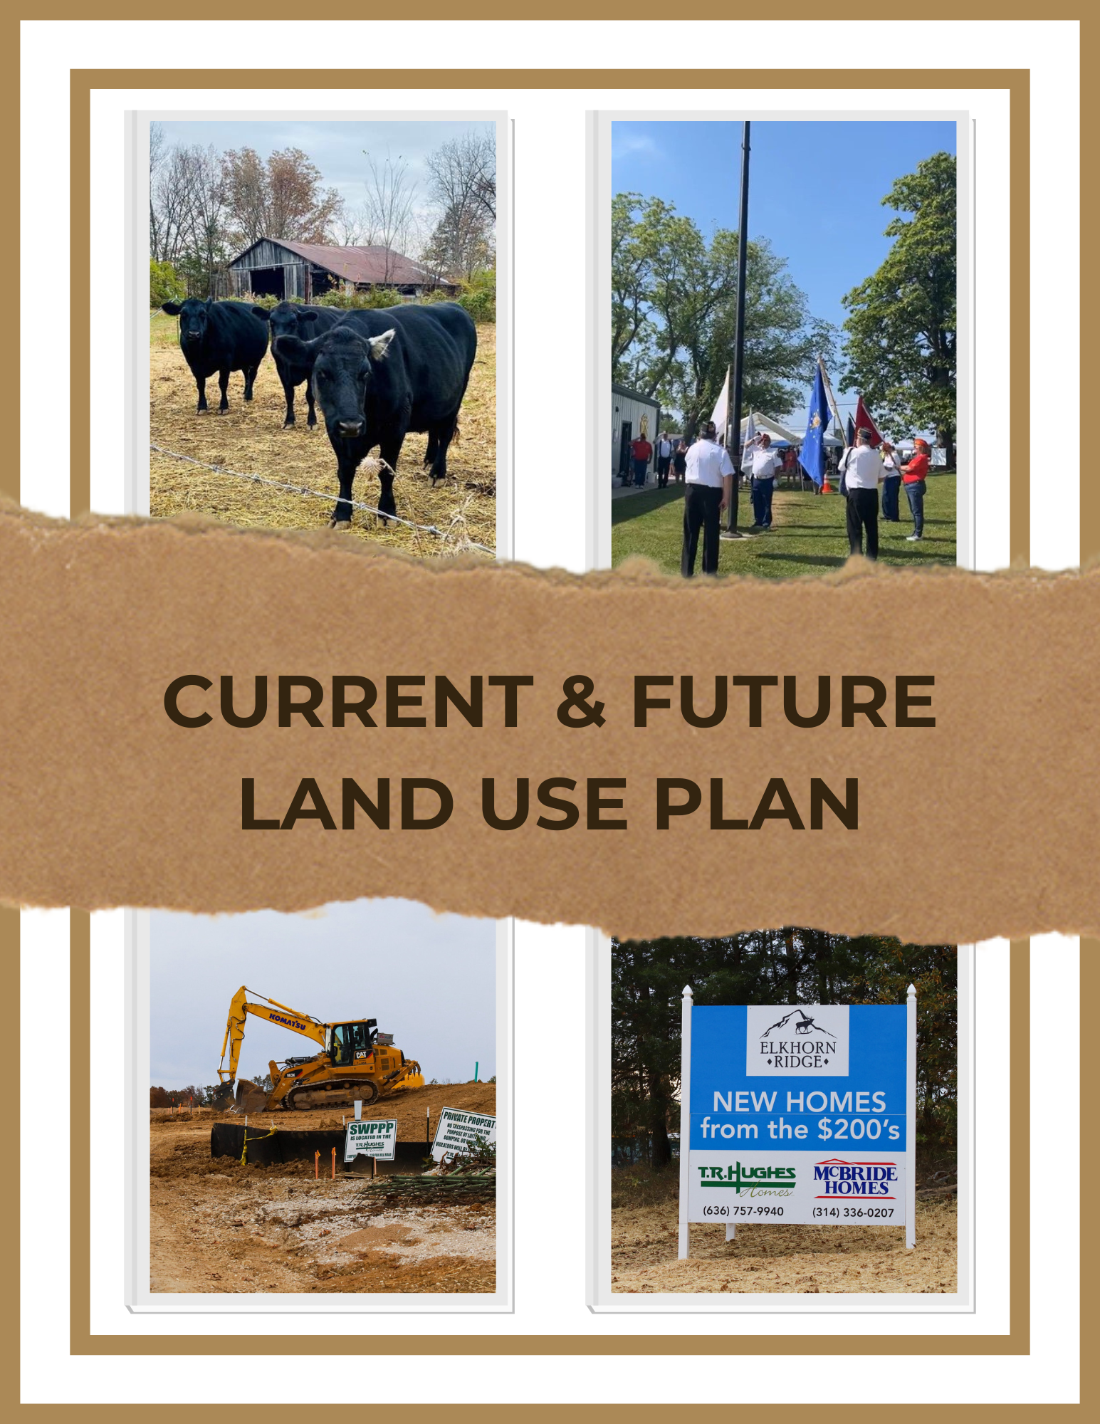

SECTION FOUR: CURRENT AND FUTURE LAND USE PLAN
Land use can be viewed as a shared natural resource, much like air and water, that should be conserved, cared for, and utilized with due regard to its effect on public health, safety and welfare. The key element of comprehensive plan is the land use section which indicates the uses of property.
The existing zoning map identifies land areas in Truesdale that are suitable for various types of activities, such as residential, historic/mixed use, commercial/industrial, parks/open space, institutional and agriculture. The existing land use map was shared with the comprehensive plan taskforce members for feedback on any missing land uses in the city. Further, the taskforce members individually identified future expansion proposals considering the potential for growth around the city.
The composite proposed expansion map for Truesdale can help enhance the economic vitality of the city by collectively assessing and making comprehensive recommendations for allowing various land related activities in the city, keeping in mind the suitability of the area to the function. While planning for the future is an important goal of this element of the comprehensive plan, the existing residential and business area, in addition to areas where future development will occur, must be able to flourish for Truesdale to truly evolve into a quality, economically balanced community. The proposed expansion map was developed to ensure efficient and smarter use of existing infrastructure and deliver timely, well-located additional infrastructure capacity.
The purpose of future land use map in the preparation of a comprehensive plan is to define the scope of work from which goals and actions are developed. It is important for City leaders and the community members/organizations they serve to acknowledge and understand that this planning area for future land use is not only areas currently within the city limits, but also those areas adjacent to the city limits which impact business, growth, or future uses. In order to effectively plan for future needs in terms of capital improvements, investment in City services and areas of impact must be considered. The future land use map shows Truesdale’s general vision for future growth and development within the city and aims to reflect the comprehensive plan guiding principles, while also considering existing development patterns and projected population growth.
The current zoning map (Appendix C) and current land use map (Appendix D) are provided at the end of the document.

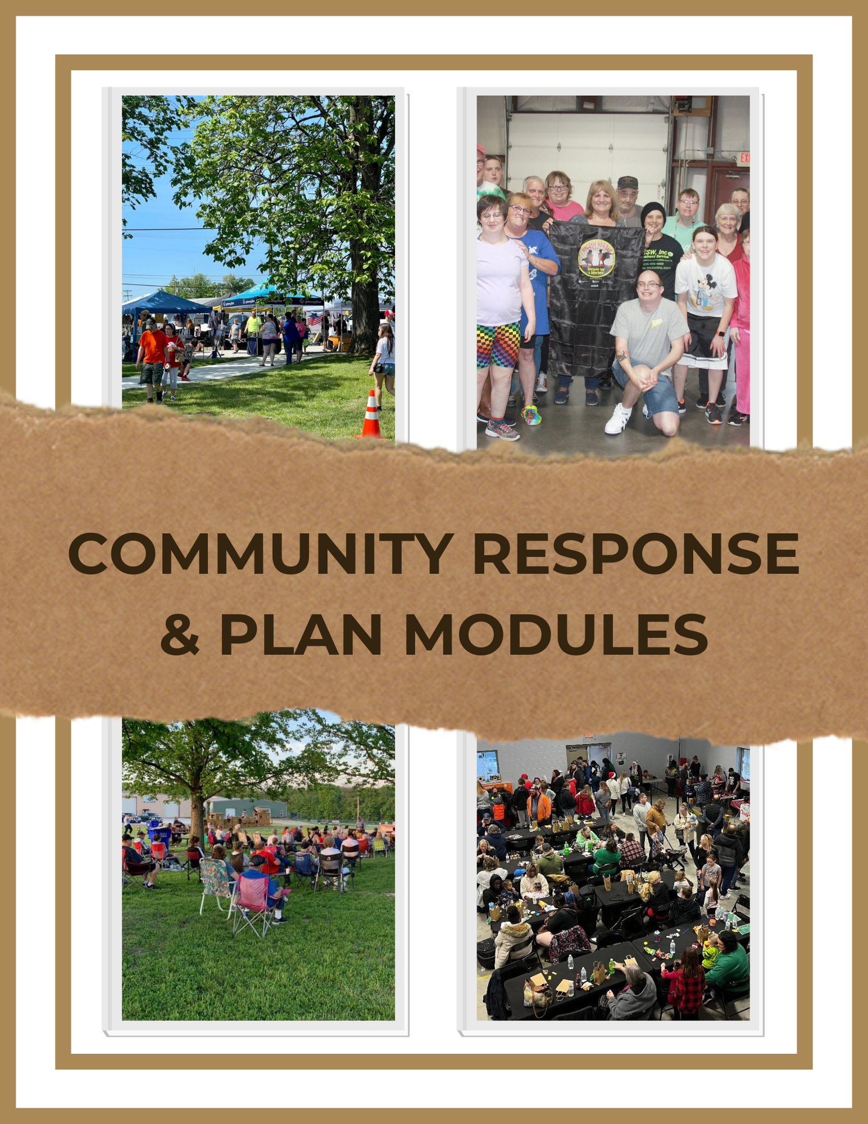

SECTION FIVE: COMMUNITY RESPONSE AND PLAN MODULES
COMMUNITY RESPONSE
One of the main purposes of the comprehensive plan process is for the planning committee and city officials to receive feedback from the community survey in order to identify the key issues, concerns, and opportunities as identified by citizens within the community. Because of the good response of citizens completing the survey and providing valuable input, the committee was able to gain a comprehensive understanding of the strengths, weaknesses, and opportunities for the city. This section summarizes some of the key comments that have come from the engagement process.

Strengths
- Communication is strong between the city and the community
- Pride in the community- beautification
- Small-town feel with managed growth

Weaknesses
- Need a full-time police force
- Would like to see more retail operations- gas station, post office, grocery store

Opportunities
- Continue to preserve the small-town feel of the city while allowing for specific, managed growth
- Provide more regularly scheduled community events
- Trails for walking, biking, etc.

PLAN MODULES
Based on the survey results, community input, and committee discussion, the plan modules outline the overall approach and framework for the longer-range city plans, and form the core of the comprehensive plan.

1. ROBUST ACTIVE LIVING OPPORTUNITIES
2. QUALITY AND DIVERSE HOUSING
3. THRIVING LOCAL ECONOMY
4. TRANSPORTATION AND MOBILITY
5. MUNICIPAL SERVICES AND PUBLIC INFRASTRUCTURE
6. PARKS AND RECREATION

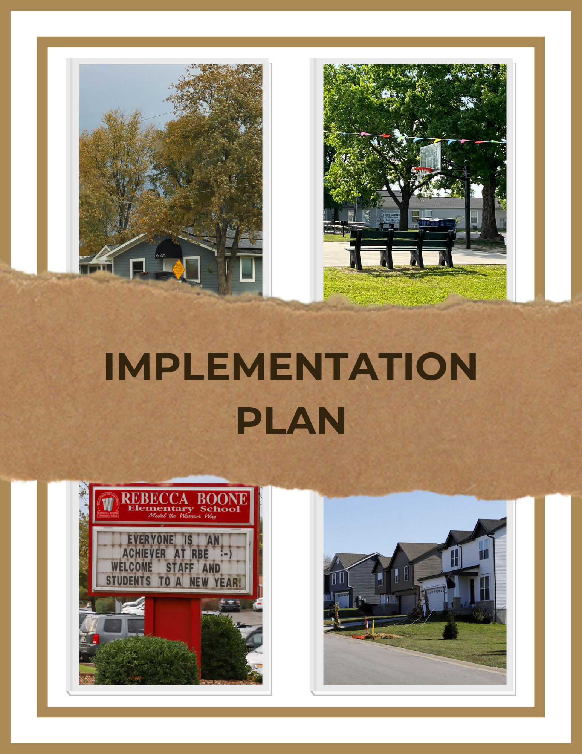

SECTION SIX: IMPLEMENTATION PLAN
Introduction
The implementation plan outlines the goals and objectives the comprehensive plan committee has identified and set in place to guide the future of the city over the next ten years. Implementation of the plan starts with the recommendation of the plan by the Planning and Zoning committee to the Mayor and Board of Alderman. The Mayor and Board of Alderman must officially approve the comprehensive plan and understand and support its role as the guiding document and/or blueprint identifying the specific goals and objectives that will drive the city’s future decisions related to growth and redevelopment.

The comprehensive planning process brought together elected and appointed officials from the city, as well as a cross-section of community leaders. As a result of input gathered through the community survey, listening sessions, and meetings of the comprehensive plan committee, the following is the agreed upon goals, objectives, and timeline for the plan. The timeline represents short-term (1-3 years), mid-term (3-5 years), long-term (5-10 years), and ongoing timeframes.

Responsible entities are those who will have the overall oversight and responsibility for consideration, review, and implementation of the goals. Additional stakeholders may be included as needed for each goal.

Capital Improvement Plan
The Capital Improvement Plan (CIP) provides a longer-term profile of major expenditures the city wants to undertake and should be updated annually. The plan is a guide for identifying and managing current and future scheduling and funding requirements for defined projects. This plan should be seen as a rolling document as older projects drop off when completed and new projects are added each year.

The CIP provides a number of benefits, including:
- Keeping the public informed and focus attention on community objectives
- Coordinating capital needs within the confines of the operating budget
- Promoting and prioritizing project planning
- Uniting local government entities activities to reduce duplication
- Increasing opportunities for obtaining federal and state funding assistance

Current Capital Improvement Plan Project List
1. Smith street upgrade (“Smith Street Project”)
2. Addition of a third patrol vehicle
3. Upgrading the Public Works vehicle

Page intentionally left blank
Plan Module | Goals | Objectives | Timeline/ Responsible Entity
I. Robust Active Living Opportunities | Goal #1- Define and utilize zoning codes to achieve compliance with land use plan and future land development. | Objective #1- Review current zoning to maintain current green space needs/requirements, buffer zones, and corridor growth regulations.  Objective #2- Define housing codes  Objective #3- Define and map historic/downtown area.  Objective #4- Develop an annexation plan for future growth and development. | Short-term/ P & Z  Short-term/ P & Z, City  Long-term/ P & Z, City  Short-term/ P & Z, City, BRPC
I. Robust Active Living Opportunities | Goal #2- Character of the Community | Objective #1- Consider developing a design guide to provide business owners, and property owners with suggestions on architectural layout options that compliment neighborhood character.  Objective #2- Establish and develop the historic district/improvement district and properties that have significance in Truesdale.  Objective #3- Generate design guides that promote strategic and planned rehabilitation techniques and new construction standards in and around the downtown/historic district. | Short-term/P&Z, City  Long-term/P&Z, City  Long-term/P&Z, City
I. Robust Active Living Opportunities | Goal #3- Promote the beautification and livability of neighborhoods through landscaping, sidewalks, and other improvements. | Objective #1- Consider various beautification programs for residential streetscapes. Consult with local Master Gardener program for potential input and assistance.  Objective #2- Develop master plan to coordinate maintaining and adding sidewalks/walkways within neighborhoods that comply with accessibility requirements.  Objective #3- Consistent code enforcement of City ordinances related to maintenance of property. | Mid-term/ City and Extension/Master Gardeners  Short-term/P&Z, City, BRPC (Active Transportation Plan- Appendix E)  Short-term/City
I. Robust Active Living Opportunities | Goal #1: Provide quality municipal services to residents while continuing a modest tax burden. | Objective #1- conduct yearly review of services to determine cost burden to citizens and the City. | Ongoing/City
II. Quality and Diverse Housing | Goal #1: Establish Truesdale as a community of high-quality, diverse housing options. | Objective #1- Control the density of residential developments with defined lot line setback guidelines, and limit overall development densities through the P&Z process.  Objective #2-Encourage proper maintenance, and compliance with local planning and zoning for owner occupied homes, and rental homes.  Objective #3- Initiate a re-occupancy inspection program for rental property. | Short-term/P&Z, City  Short-term/P&Z, City  Long-term/City, BRPC
II. Quality and Diverse Housing | Goal #2- Promote the development of a variety of quality housing while maintaining affordable options. | Objective #1- Encourage larger single-family homes on larger lots.  Objective #2- Continue to approve attached single-family homes (villas) at appropriate locations.  Objective #3- Consider multi-family units of varying densities at appropriate locations within the City.  Objective #4- Consider housing options for various age groups and demographics- young families, senior citizens, etc. | Long-term/P&Z, City  Long-term/P&Z, City  Long-term/P&Z, City  Long-term/P&Z, City
III. Thriving Local Economy | Goal #1- Promote the City as a community that welcomes new businesses. | Objective #1- Compile the necessary community data to ensure that potential businesses can make informed decisions.  Objective #2- Maintain a database of available vacant ground and vacant buildings that are available for business expansion.  Objective #3- Actively pursue funding opportunities that promote the goals of the Comprehensive Plan.  Objective #4- Continue membership and participation with the Greater Warren County Economic Development Council (GWCEDC) and BRPC | Long-term/P&Z, City, BRPC  Long-term/P&Z, City, BRPC  Long-term/City, BRPC  Ongoing/City, GWCEDC, BRPC
III. Thriving Local Economy | Goal #2- Provide for a variety of business and retail space which are convenient and attractive to consumers to strengthen the City’s economy. | Objective #1- Provide oversight in promoting new businesses that will complement current businesses, and community needs.  Objective #2- Approve the overall design of new business space and the remodeling/maintenance of current business space to ensure quality commercial areas that meet current zoning codes and culture of the community area in which it is being built/remodeled.  Objective #3- Maintain code enforcement for the architectural and landscaping zoning requirements for current and new businesses. | Ongoing/P&Z, City, BRPC  Ongoing/P&Z, City  Ongoing/P&Z, City
III. Thriving Local Economy | Goal #3- Develop an economic development strategy that provides sustainability to the Truesdale community. | Objective #1- Foster a pro-business approach in City government that facilitates opportunities for business development and enhancement.  Objective #2- Ensure the balance between the needs of the community for a good quality of life with economic development interests. | Short-term/City, BRPC, EDC  Mid-term/City, BRPC
III. Thriving Local Economy | Goal #4- Provide residents with additional retail shopping opportunities. | Objective #1- Provide new sources of revenue for the City services.  Objective #2- Entice new and/or unique commercial undertakings that are new to the area and/or City. | Long-term/City  Long-term, City
III. Thriving Local Economy | Goal #5- By attracting new business growth, expansion of businesses in the City, provide opportunities to expand employment opportunities which promotes additional sources of revenue for a sustainable and affordable community. | Objective #1- encourage a mix of light industrial, commercial business, and retail development.  Objective #2- Enhance existing business, attract new business, new employment opportunities to strengthen the City’s market position and work toward longer-term economic sustainability. | Long-term/City, BRPC, EDC  Long-term/City, BRPC, EDC
III. Thriving Local Economy | Goal #6- Connect City plans with the Regional Comprehensive Development Strategy (CEDS). | Objective #1- Participate in the ongoing CEDS meetings. | Ongoing/City
IV. Transportation/Mobility | Goal #1- Create a transportation/mobility program which is designed to keep streets and sidewalks safe and adequately maintained. | Objective #1- Complete a street inventory of the streets in Truesdale to assess their condition and develop an aggressive maintenance program to repair damage to public streets and sidewalks.  Objective #2- Complete the active transportation plan for future road and sidewalk needs in the community.  Objective #3- Seek partnerships with Federal, State, County agencies to obtain the maximum funding to support street and sidewalk improvements based upon the priority of needs. | Short-term/City, Public Works  Ongoing/City, BRPC  Ongoing/City, BRPC
IV. Transportation/Mobility | Goal #2- Provide for current and future transportation/mobility needs for the City. | Objective #1- Conduct a transportation study.  Objective #2- Map the current transportation network/corridor for the City to determine if current roadways are in place to meet the needs of citizens.  Objective #3- Develop longer-term transportation/roadway plan for citizen access based on future growth plans. | Mid-term/City, BRPC  Mid-term/City  Long-term/City
V. Municipal Services and Public Infrastructure | Goal #1- Ensure that community services and utilities are in place to adequately serve existing and new neighborhoods and businesses. | Objective #1- Maintain cooperative working relationship with current utility providers.  Objective #2- Communicate future City development opportunities with utility providers in a timely manner to ensure adequate response times. | Ongoing/City  Short-term/City
V. Municipal Services and Public Infrastructure | Goal #2- Ensure that the public safety needs of the City are adequately met. | Objective #1- Develop and maintain an active building maintenance inspection plan to identify unsatisfactory structures, and then coordinate with the responsible parties to then either remove or improve the structure(s) in order to maintain safety standards for the community.  Objective #2- Continue work with local fire, police, medical first responders and other emergency responders to provide adequate and timely safety services to the community.  Objective #3- Publicize the availability of the local Warren County Recycling Center and encourage citizens to use those services to cut down on materials that could cause hazards to the community. | Ongoing/Building Inspector, City, Chief of police, Public Works  Ongoing/City, Public Works  Short-term/City
V. Municipal Services and Public Infrastructure | Goal #3- Pursue the feasibility of adding additional police officers for the City. | Objective #1- Research opportunities through cognizant authorities.  Objective #2- Discuss possible sharing with other local providers, and develop costs and framework for a plan.  Objective#3- Research grants and funding opportunities. | Short-term/City, Chief of Police  Ongoing/City, School Resource Officers, Chief of Police  Long-term/City, School District, BRPC
VI. Parks and Recreation | Goal #1- Continue to maintain and further improve the existing park in Truesdale. | Objective #1- Within land constraints of the park, consider any additional improvements and/or amenities to be added to maintain usage. | Ongoing/city, P&Z
VI. Parks and Recreation | Goal #2- Evaluate current land for potential recreational and entertainment opportunities for the City. | Objective #1- Undertake a survey to determine residents perceived needs for recreational and entertainment resources.  Objective #2- Determine where deficiencies exist and develop long-term strategy to meet the needs.  Objective #3- Explore public/private funding opportunities to expand recreational and entertainment resources. | Mid-term/City, P&Z, Businesses  Mid-term/City, P&Z  Mid-term/City, P&Z
VI. Parks and Recreation | Goal #3- Explore the development of a new park facility to serve Truesdale residents. | Objective #1- Inventory existing available land and identify potential location(s) for placement of an additional park. | Long-term/City, P&Z

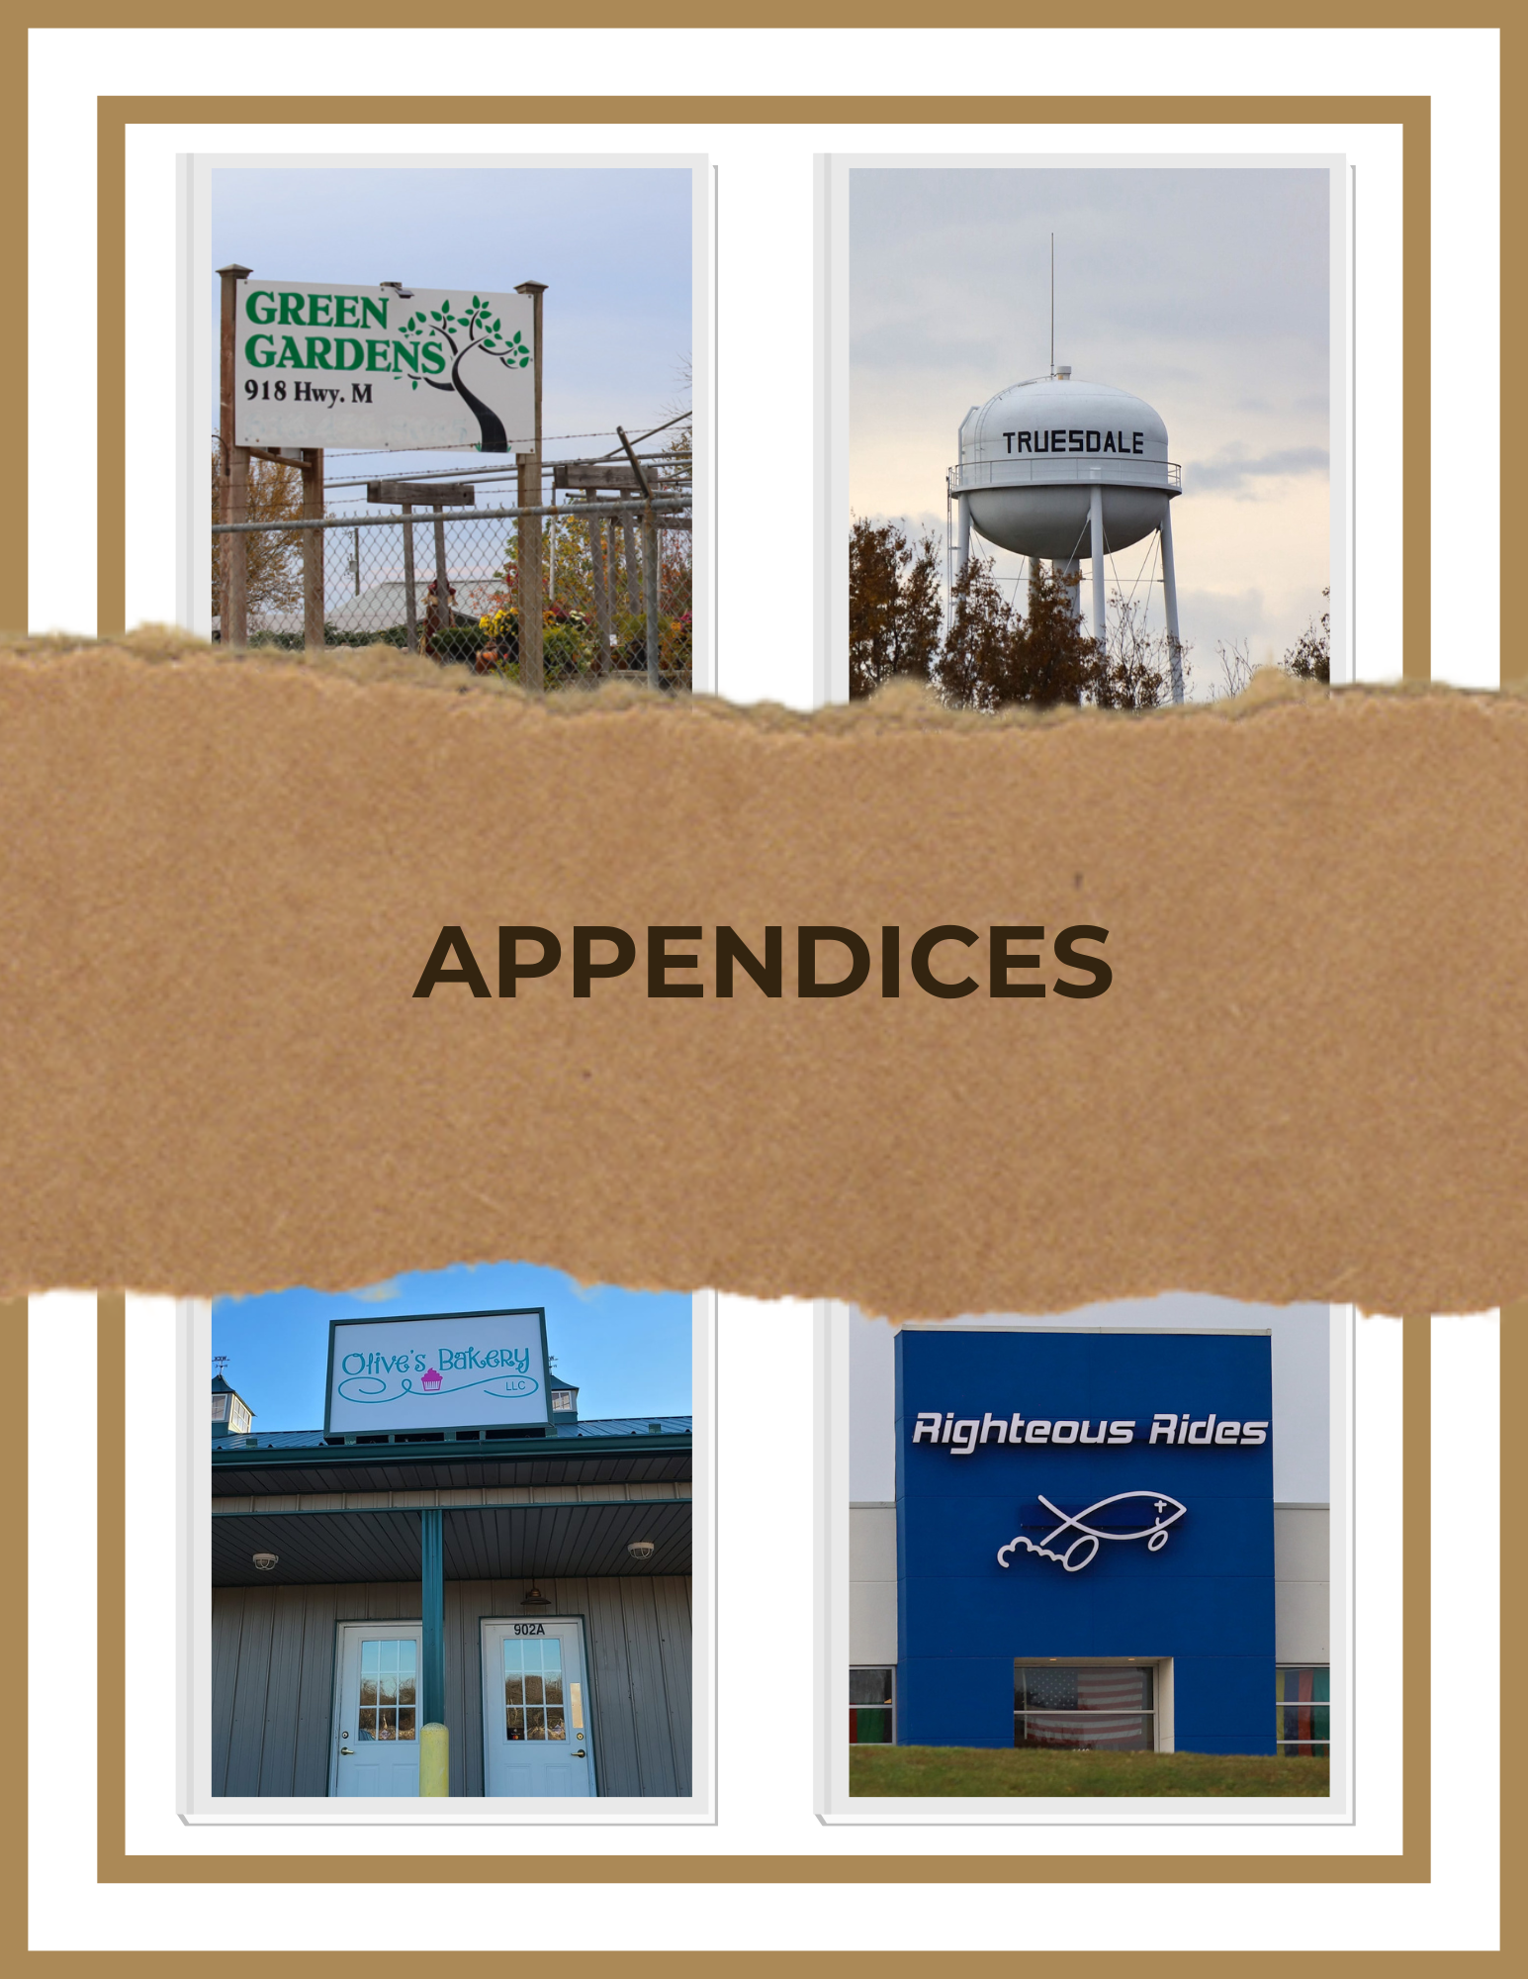
SECTION SEVEN: APPENDICES
Appendix A: Community Survey Results
As part of the comprehensive planning process, citizens were asked to complete a community survey and share their thoughts about the current and future direction of the city. 70 surveys were completed as part of this exercise. The online survey was available through a third-party system offered by SurveyMonkey and administered by BRPC. Surveys were available through the city website, the city Facebook page, hard copies available at the city offices, and links sent in resident water bills for three months.

The survey provides a point-in-time snapshot of the opinions of those providing input to the survey. In some cases, respondents may have had considerable knowledge or insights about a subject of a question while, in other cases, respondents may have had little or no prior familiarity with a topic. This disparity should be considered when reviewing the results.

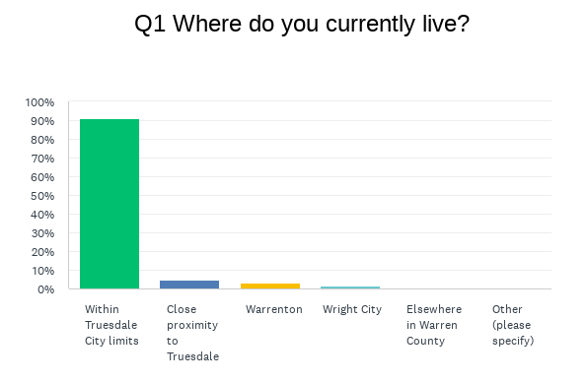
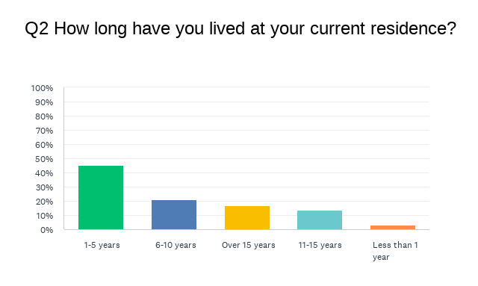
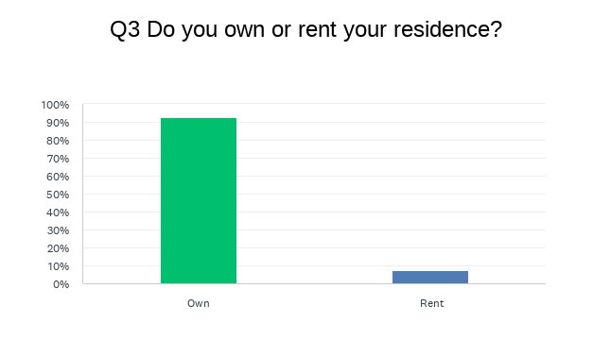

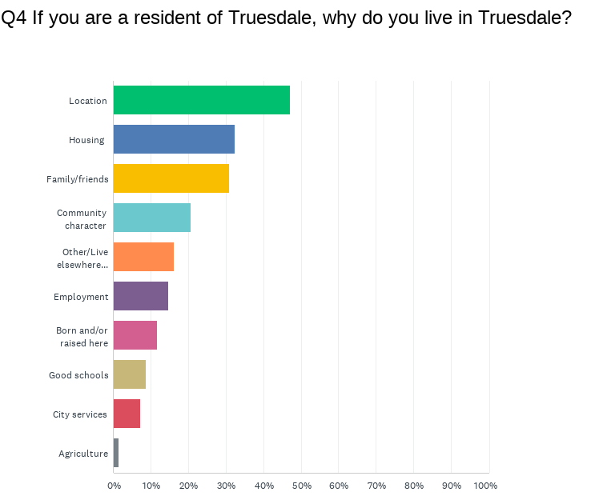

Q5 How many people are in your household?
- Under Age 5- 45.6% (31 people)
- Ages 5-18- 51.4% (35 people)
- Ages 19-64- 86.7% (59 people)
- Ages 65+- 44.1% (30 people)

Q6 Please mark the number of people in your household based on his/her location of employment.
- Outside Warren County- 61.8% (42 people)
- City of Truesdale- 45.6% (31 people)
- Retired/Not Working- 30.9% (21 people)
- Warrenton- 22.0% (15 people)
- Close proximity to Truesdale- 20.6%- (14 people)
- Elsewhere in Warren County- 19.1% (13 people)
- Wright City- 14.7% (10 people)

Q7 Please rate the following community characteristics in the City of Truesdale. 1= Very poor, 2= Poor, 3= Neutral, 4= Good, 5= Very Good
- Sense of Community- 3.96
- Overall City Services-3.84
- Safe Environment- 3.82
- Preserving Heritage/History- 3.76
- Housing/Property Values- 3.71
- Education/Schools-3.4
- Proximity to Healthcare Services- 3.27
- Employment Opportunities-2.93
- Recreational Facilities-2.88
- Economic/Business Opportunities- 2.77
- Transportation/Road System- 2.66
- Shopping/Retail Opportunities- 2.37
- Arts/Cultural Opportunities- 2.24
- Food/Dining Choices- 2.22
- Entertainment Opportunities- 2.08
- Public Transportation- 1.8

Q8 Please rate the following local community services in the City of Truesdale. 1= Very poor, 2= Poor, 3= Neutral, 4= Good, 5= Very Good
- City Trash Collection- 4.17
- High Speed Internet- 3.94
- City Police- 3.92
- Parks and Recreation- 3.85
- Sewer- 3.75
- Water- 3.65
- City Street Maintenance- 3.63
- Services to Those with Disabilities- 3.33
- Services to Seniors- 3.21
- Animal Control- 2.98

Q9 Please rate the availability of the housing categories in the City of Truesdale. 1= Very poor, 2= Poor, 3= Neutral, 4= Good, 5= Very Good
- Mid-level Single Family Homes- 3.56
- New Home Sites- 3.52
- Starter Homes- 3.31
- Apartment Homes- 2.79
- Luxury Single Family Homes- 2.67
- 55+ Senior Community- 2.55
- Villas- 2.52
- Multi-unit Condominium Homes- 2.46

Q10 Please rate your opinion of the existing road/transportation areas in the City of Truesdale. 1= Very poor, 2= Poor, 3= Neutral, 4= Good, 5= Very Good
- Traffic Congestion- 3.54
- Roadway Safety- 3.42
- Traffic Signals, Signage, Etc.- 3.35
- Maintenance/Repair Timeliness- 3.21
- Condition of Roads- 3.1
- Sidewalks- 2.77
- Pedestrian/Bicycle Facilities- 2.62
- Public Transportation- 2.04

Q11 Please rate how relevant each topic is to you. 1= Very low, 2= Low, 3= Medium, 4= High, 5= Very High
- City Should Attract/Retain Small Businesses- 3.94
- City Should Preserve Historic Downtown Business District- 3.81
- City Should Promote Entrepreneurial Activities- 3.7
- City Should Preserve the Agricultural Base- 3.58
- City Should Continue Residential Development- 3.48
- City Should Attract Industrial/Manufacturing- 3.27
- City Should Attract High-tech/Research Firms- 3.19
- City Should Attract Big-box Retail Business- 3.10

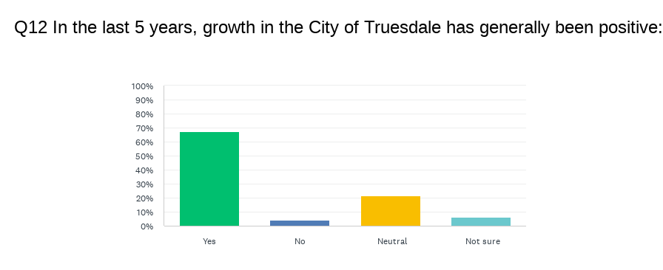

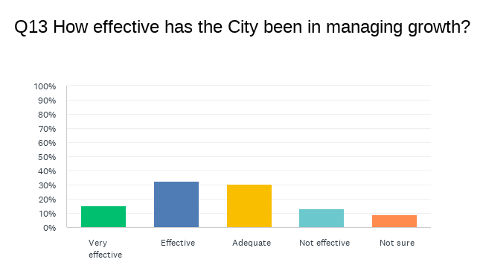

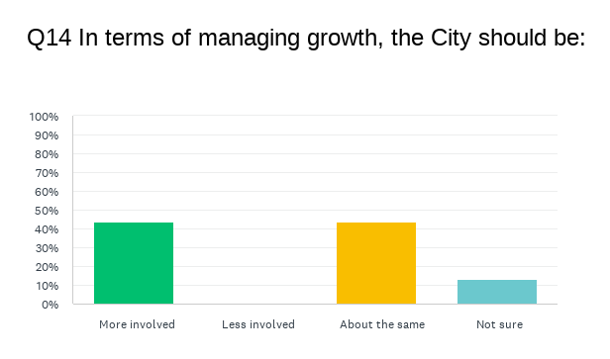

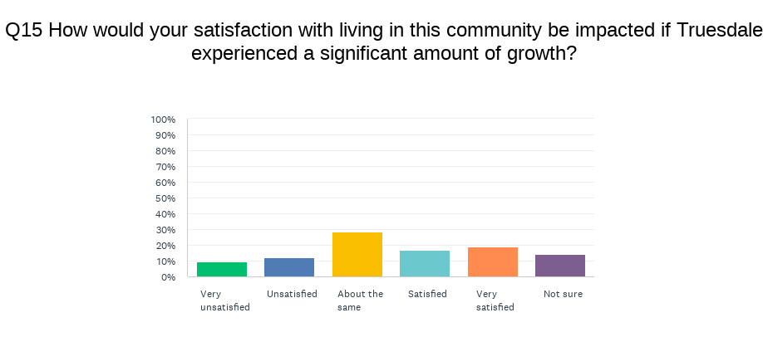
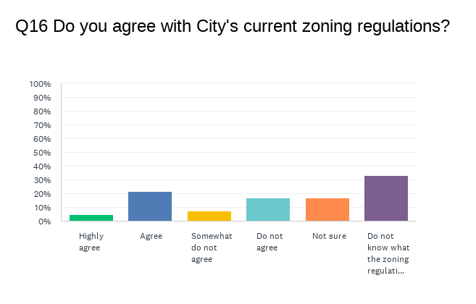
Q17 Please explain how you would like to see the City of Truesdale develop. Please note that there may have been multiple similar responses, and similar responses have been combined in some instances.
- Allow growth but don't let it run down the appeal of this town. No weed factories, stinky or loud industrial, stick with good businesses, family friendly avenues, and things that people find pleasant.
- Full service community.
- Bedroom community for commuters, just the way it is.
- Keep going the way you are. You are all growing nicely.
- Mixed use and industrial growth to allow growth in the tax base to better fund services.
- I would like to see Truesdale develop itself with more people coming in and better roads. I think we should have nicely paved roads and good schools. Good fencing too, not the chain link that you see falling apart on 70. I think we should take pride of the town. Also, businesses help bring more people and more money to do those things. Maybe a really nice park too.
- Just the way it is.
- Local small business shopping mall/district would be great and more public parks for kids to play.
- I would like to see more restaurants and little retail stores, but it's just right.
- Just do not approve the micro-lot housing (i.e. what is happening next to Heritage Hills). It's not a good look and we fear it will bring down property values.
- Truesdale has potential to be a nice residential area. We don’t need more industrial buildings or trailers. Single family starter to midsize homes would make us a nice residential town.
- More opportunities for tiny homes and retirement communities.
- Mixed use community with a focus on children's safety, growth for industry and residential, and agriculture.
- The community needs to stay residential. Our growth should be family oriented, not business. Fix the roads, fund public services (police and fire), and keep the citizens safe.
- Restaurants and retail.
- Less giant subdivisions. I like the small town feel here. The schools and roads can’t handle the drastic growth. There needs to be more rules with what goes where as well which is why you’re doing this.
- No more trailer parks.
- Growth is good but must remember the citizens that have lived here for years. The city is more than subdivisions.
- Planning and zoning.

Q18 Rank these indicators from 1-10 with 1 being the most important and 10 being the least important.

Q19 If you selected “Other” above, please indicate what other areas are important to you.
- Safety
- Preserving Town Character
- Water management/housing construction screening
- Appearances, enforcing codes
- Food

Q20 Based on what you have seen in other communities, are there any facilities, services, amenities, etc. you would like the City of Truesdale to consider?
- Gas stations, post offices, grocery store.
- Laws to be enforced more like running stop signs. Bad habit.
- Let's keep things the way they are. Too much growth brings crime and congestion.
- Outdoor swimming pool.
- Wentzville does a nice job in having high standards for buildings and they are built with looking nice. I think we should take pride in our town and make it look nice.
- I would love recycling options for paper/cardboard, plastic, and/or glass. I have to drive to O’Fallon to use their recycling bins/drop off site
- Online billing makeover, City Hall, shrubs, flowers, landscaping.
- Public pool.
- Automatic bill pay WITHOUT service fee. Free recycling.
- Better drainage of the water and sewers.
- Community events more regularly. Perhaps movies in the park, or live shows in the park (of different genres).
- Avoid being overran by rental properties & storage facilities.
- Better parks.
- Shopping, restaurants, movie theaters/entertainment.
- Animal shelter.
- Cleanliness, trash service, trashy yards, appearance. More patrolling.
- If Chic Fil A or Raising Canes is interested in coming to town let them know the community welcomes them with open arms!
- Uber
- Trails for walking, biking, golf carts, etc.
- Have a full-time police department on duty.
- Sewer treatment plant.

Q21 Please share any other comments you have.
- I have been very pleased with the care and service provided by our city clerk (Elsa), our police chief and officers, and receptionist. They are always very pleasant and friendly.
- I think we, as a community, should stop competing with Warrenton, Wentzville, and O'Fallon, and make what we have better.
- The city does a great job of communicating to citizens and working with special needs/disabilities!
- Upgrade to City Hall landscaping.
- Have your police officers give out tickets for running stop signs.
- Would like to preserve a small-town feel.

Appendix B: Active Transportation Plan
Appendix C: Current Zoning Map
Appendix D: Current Land Use Map

