**Central Missouri Railroad Association**

Train Show & Swap Meet: October 3rd @ 10:00 am to 4:00 pm

**Rebecca Boone Elementary** 836 South Street, Truesdale, MO 63380

**FREE ADMISSION WITH A DONATED ITEM: *Non-Perishable Food, Personal Care Item, Coats*

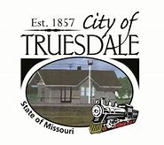

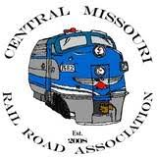

Opening Ceremony: 10:00 am

Caricaturist Artist: Bax Illistration 10:00 am – 2:00 pm

National Night Out: 10:00 am – 2:00 pm

Live Music:George Portz & The Friends of Bluegrass Noon – 2 pm

Vendors, Raffles, Scavenger Hunts *(with a chance to win Polar Express tickets!*), Bounce Houses and more!

Food Available for purchase.

**October 3, 2020 10:00 am -5:00 pm**

**Bruer Park**

**800 Smith Street, Truesdale, MO 63380**

**one day**

**two events**

**4th Annual Railroad Days**

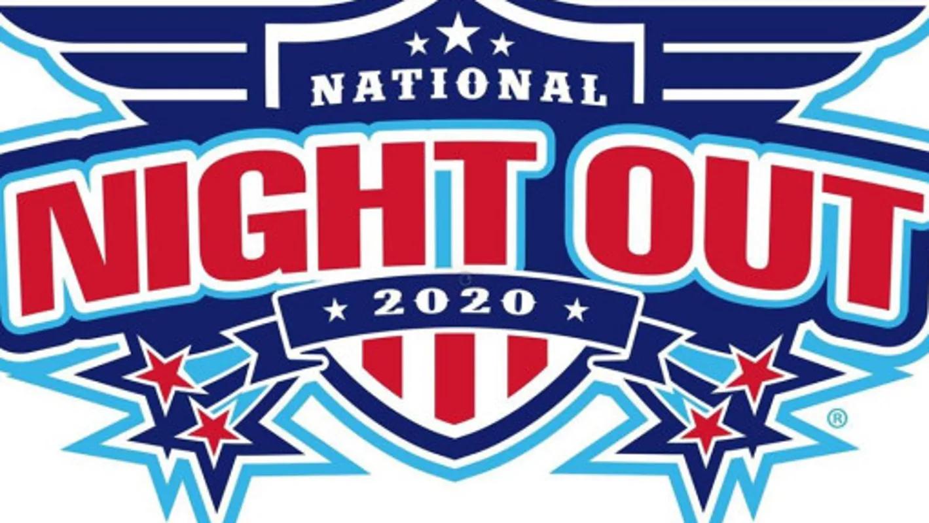

**Bruer Park**

**Free Event**  Truesdale, MO

**10am to 2 pm**

**Join us for a day of family fun as we celebrate**

**WARREN COUNTY NATIONAL NIGHT OUT 2020!**

Promoting **police-community partnerships** and **neighborhood camaraderie**

Meet your local first responders!

*Popcorn & Snow Cones * Games * Face painting * Children’s Activities & SO MUCH MORE!!

Hosted by the Truesdale Police Department