4th Annual Warren County National Night Out
October 3, 2020
10:00 am – 2:00 pm
Bruer Park, Truesdale MO
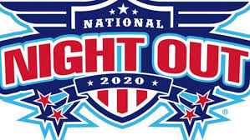

Name of Agency or Organization: ____________________________________________________________
Contact Name:____________________________________________________________________________
Phone #:___________________________ Email:________________________________________________

Display/Booth Information – Outdoor space only
Will you be present for the entire event (10 am -2 pm)? ________________
If not, what is the time frame you will be attending? _____________________________________

How much Space will you need for your set up? _______________________________________
- For example: 10 x 10 area
Is there anything specific that you will need (e.g. street parking, electricity) for your setup? ____________________________________________________________________________________________________________________________________________________________________________________________________
Please list items that will be displayed / services that will be offered: ____________________________________________________________________________________________________________________________________________________________________________________________________________________________________________________________________________________________________________________________________________________________________________________________________________________________________________________________________________________________________________________________________________________________________________________________________________

Will you have a “carnival” game? If so, please describe: ____________________________________________________________________________________________________________________________________________________________________________________________________

