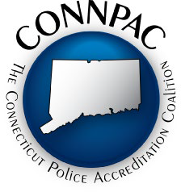

**CONN-PAC INVOICE ANNUAL MEMBERSHIP DUES**

**For Fiscal Year**

**AMOUNT DUE $100.00**

**Make Checks Payable to:** Connecticut Police Accreditation Coalition (CONN-PAC)

**Purchase Order:**

**RETURN TO:** Juliette M. Parker

CONNPAC Treasurer

City of Groton Police Department 295 Meridian Street

Groton, CT 06340

Reminder that CONN-PAC Meetings are generally held the 1st Thursday of every other month at 10:00 a.m. at a location to be determined.

Visit the CONN-PAC website for meeting dates, agendas and minutes