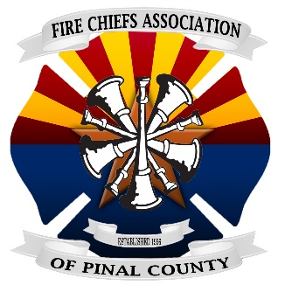 **FIRE CHIEFS ASSOCIATION OF PINAL COUNTY**

**MEETING AGENDA**

P. O. Box 10446 ■ Casa Grande, Arizona 85130

(480) 982-4440 ■ Fax: (480) 982-0183

**President Vice President Secretary/Treasurer Chief at Large Chief at Large**

**Dave Kean Kelly Weddle Barb Elliott Brian Gilbert****Morey Morris**

**AFCA PC Region Rep. AFCA PC Fire Resource Coordinators AFCA PC Training Rep.**

**Kelly Weddle Kelly Weddle & Vacant & Vacant Brian Gilbert**

**Date:** Wednesday, February 26, 2020

**Time:** 1300 Hrs (1:00 PM)

**Host:** Pinal County Office of Emergency Management

**Location:** 135 N. Pinal St, Florence, AZ 85132 (Old Courthouse building) Room: Ironwood

**Contact:** Chuck Kmet

**Phone:** 520-251-2394

**CONFERENCE CALL IN: 1-877-820-7831**

**Passcode: 411782#**

* Call to Order & Introduction – Dave Kean
* Legislative Presentation –
* Presentation – Lindsay Mathieson & Ryan Zavala with American Red Cross
  + Resources
* Presentation – Braden Briggs with Empowerment Systems, Inc.
  + Fire & First Responder water drive for Pinal County
* Review and Approval of Minutes from November 12, 2019
* Secretary/Treasurer Report – Barb Elliott
  + VFIS Insurance Renewed
  + Dues for 2019 / 2020
  + Updated Rosters, contact information
* Board Correspondence –
* Board Appointments –
* Board Presentations –
* Legislative Updates – Morey Morris
* Grant Updates
  + FEMA SAFER Grant –
    - FEMA AFG Grant –
    - FEMA FP&S Grant –
    - VFA Grant –
    - AZDOHS Misc. Grants –
    - GOHS Grant –
    - AEMS Misc. Grants –
    - SAEMS Provider Grant –
    - Fireman’s Fund Grant –
    - Gila River Prop 202 (semi-annual) –

Page 1 of 2

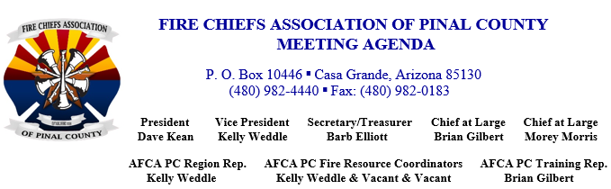

* Grant Updates (con’t)
  + - Tohono O’Odham Prop 202 (annual) –
    - Ak-Chin Prop 202 (annual) –
    - Pinal County Emerg. Mgt. Haz-Mat (annual) –
* New Business
  + Pinal County Emergency Management Update – Chuck Kmet
  + Pinal County Public Health Update – Kore Redden
  + AZ Department of Forestry and Fire Management Update –
  + AFCA – Pinal Co. Region Reports – Kelly Weddle
  + AFDA Update –
  + FCAPC Safety Trailer Update –
  + Training Committee Report – Brian Gilbert
  + Fire Investigation Task Force Update –
  + FCAPC Golf Tournament & Scholarship Report – Scott Miller
* Agency Roundtable – Brief updates

Next Meeting: TBD

On Deck: TBD

* Adjournment

Page 2 of 2