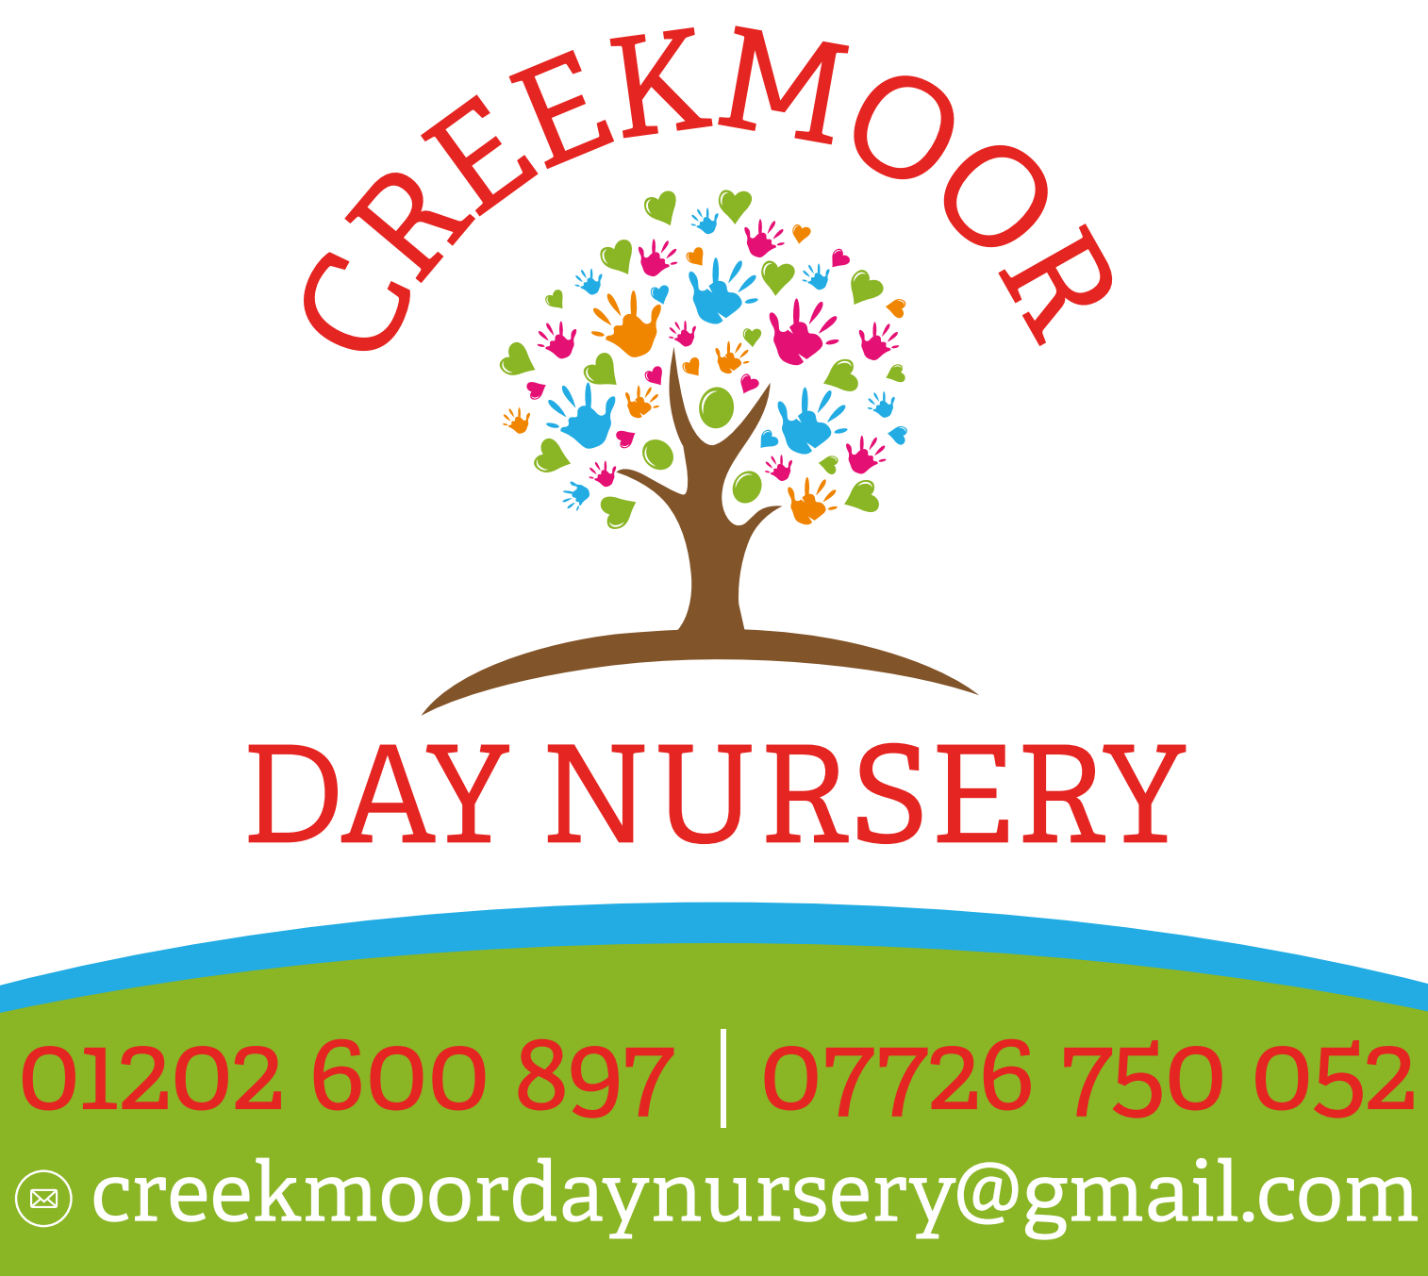
Equipment and resources policy.
At Creekmoor day nursery LTD we organise the premises and equipment to meet the needs of all the children. We provide a wide range of high quality equipment and resources to support the delivery of our early years curriculum. We take reasonable steps to ensure the safety of children and ensure they are not exposed to risks.

To ensure this occurs within the nursery, including in our outdoor areas, we provide:
- Play equipment and resources which are safe and, where applicable, conform to the European Standards for Playground Equipment: EN 1176 and EN 1177, BS EN safety standards or Toys (Safety) Regulation (1995)
- A sufficient quantity of equipment and resources for the number of children registered in the nursery
- High quality resources to meet children’s individual needs and interests and promote all areas of children’s learning and development
- Opportunities to involve the children in decision making about new resources and equipment, where possible
- A wide range of books, equipment and resources which promote positive images of people of all races, cultures, ages, gender and abilities, are non-discriminatory and do not stereotype
- Play equipment and resources which promote continuity and progression and sufficient challenge
- Sufficient storage so resources and equipment can be displayed for children to independently choose and/or stored away safely and then rotated
- Appropriate risk assessments and checks on all resources and equipment before first use to identify any potential risks and again at the beginning and end of every session.

Cleaning and maintaining of all resources and equipment
We repair or replace any unsafe, worn out, dirty or damaged equipment whenever required. We maintain an inventory of resources and equipment, recording the date on which each item was purchased and the price paid for it. We carry out an evaluation of the effectiveness of the resources including the children’s opinions and interests. Adults role model and discuss how to use and look after equipment and resources.

We encourage children to put resources back where they belong after use. We will often use silhouettes or pictures to support the children to do this.

This policy was adopted on | Signed on behalf of the nursery | Date for review
February 2025

