Preparation and Materials needed | - Materials needed for this session: Long balloons for the balloon dogs, deck of cards, paper plates, scissors, markers, paint, string, tissue, hand size soft balls, disposable cups, 9 in balloons, straws, painters tape, dowel rods or water bottle, large disposable round table cloth, sponges, and prizes for the games.  - Set up the room open as possible for the scouts to set up the carnival games.  - Have scout booklet open to the shaped balloon page instructions and balloons set out so the scouts can start immediately.  - Have the attendance sheet out and ready  - Review the session to be prepared to lead the discussion. Do not read it to the scouts other than the lone wolf cub story, be prepared ahead of time to smoothly lead the session.
Gathering | Shaping balloons – Instructions in the Cub Scout Booklet
Opening | - Pick 2 scouts to hold the flag, 1 scout to lead the Oath, and 1 scout to lead the Law.  - Ensure all of the scouts are focused and ready to begin
Talk Time | Grin and Bear it
Activity | Enjoy the carnival
Closing | - Point out positive behaviors and activities shown during this session.  - Tell the scouts what next session will be.  - Have the scouts clean up the room
After the meeting | - Enter the advancements per rank.  - Lion – Lion’s Honor 4  - Tiger – Games Tigers Play 1, 2, 3  - Wolf – Running With the Pack 1, 4  - Bear – Grin and Bear it 2-5  - Webelos – Game Design (elective) 4  - Arrow of Light – Game Design (elective) 4  - Enter attendance  - Turn in any needed documents into the district/council  - Call, text, or e-mail 2 parents to share something positive about their scout. Make sure every scout has a positive comment before you return to these scouts.
Carnival
Talk Time: Grin and Bear it
Sometimes we should just stop, smile, and enjoy a good laugh. The last session and this session is all about enjoying each other and having a good time. Today we are going to create our own little carnival. Carnivals have jokes, tricks, and games.
Activity: The Carnival
- Select several scouts to work together as teams to set up and run the different games
- Select a few scouts to entertain and distract the Pack while the games are being set up. They are distracting them with jokes.
- Give the people setting up games the instruction sheets and supplies to set up around the room.
- Make sure the individual scouts can read and say their jokes.
- The leader is the ring master of the carnival. After the games are all played, bring all of the scouts together to reflect what went well, what can be done to improve, what they enjoyed, what they want to do again at home.
- This can be stretched into two sessions if need be.
- Leaders are encouraged to help the scouts make up their own carnival games and jokes beyond what is provided.
Sponge Toss

Needed:
- 1 large disposable table clothe
- Permeant marker
- Several hand size sponges
- Masking tape

Set-up:
- Spread the table cloth on the ground.
- Use the marker to draw a central circle on the table cloth. Draw several rings around the central circle. This is the bull’s eye for the game.
- Use the masking tape to indicate a toss line and leave the sponges there.

To Play:
- Players toss the sponges onto the bullseye.
- If they sponge lands on the center circle they get a prize.
- Note…The sponges can be either dry (for indoor games) or wet (for outdoor games)

Balloon Races

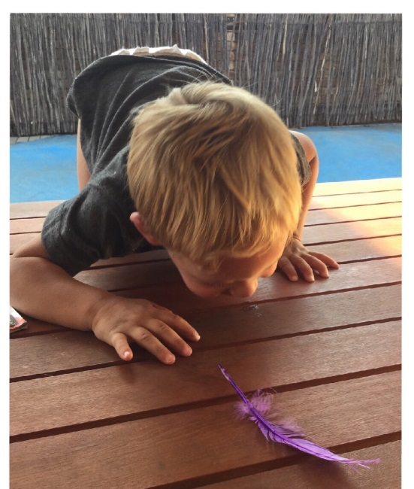
Needed:
- Several balloons approximately the same size.
- Several straws (will need 1 per player)
- Painters tape

Set up:
- Use the painters tape to indicate the start and end line. Should be approximately 6 feet apart.
- Place the balloons on the start line.

To Play:
- 2-4 players line up behind their chosen balloon.
- Each player is given a straw.
- At the start players blow through the straw to move the balloon.
- The winner is the first player to blow the balloon across the end line.

Balloon Rockets
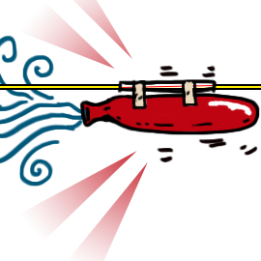
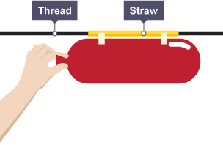
Needed:
- Several 9” Balloons (1 for all players)
- 4 strings 6-8 feet long
- 4 straws wide enough for the string to pass through it
- Painters tape
- 4-8 chairs or some other structure to attach the strings to create the race track

Set Up:
- Slide 1 straw on each string. Make sure the straw moves easily across the length of the string.
- Attach the straw to the chairs or structure used. Separate the structures to make the string taunt

To Play:
- 2-4 players blow up their own balloon. DO NOT KNOW THE BALLOON!!!!!
- While holding the balloon closed tape the balloon to the straw.
- At the start the players let go of the balloon and the air coming out will move the balloon.
- The winner is the first balloon to make it to the end of the string or the balloon that goes to the furthest.

Ring Toss

Needed:
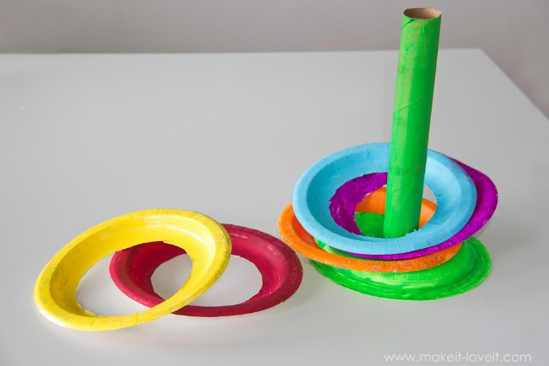
- Several paper plates.
- A dowel rod or water bottle
- Optional – paint or markers
- Optional – Food Coloring if using water bottles
- Scissors
- Making tape

Set Up:
- Use the scissors and cut the centers out of several of the paper plates leaving the outside ring of the plate.
- Optional – paint or color the paper plate rings to decorate
- Poke a hole out of a couple paper plates to push the dowel rod through it and tape it in place.
- Tape the dowel rod and plate to a surface with the rod standing up and steady.
- Or place water bottles instead of the dowel rods. Optional – put food color in the water for decorations.
- Use the tape to mark a toss line

To Play:
- Players stand at the toss line and throw to the dowel rod or bottle.
- Players win when the paper plate ring lands around the rod or bottle.
Tissue Toss

Needed:

- 4 Paper plates
- Scissors
- String
- Tape
- A box of tissue or roll of toilet paper
- Optional – paint or markers

Set Up:
- Use the scissors to cut the center out of the paper plates leaving the outside ring.
- Optional – paint or color the paper plate rings for decorations
- Tie or tape one end of the string to the paper plate rings and attach them from the ceiling (or tree branch if outside) making the rings dangle different heights.
- Use the tape to mark a toss line

To Play:
- Players are given either squares of toilet paper or individual pieces of tissue.
- When standing at the toss line the players try to throw the tissue through the paper plate rings.
- Players win if their tissue goes through a ring.
- Optional – If outside the tissue can be wet
Cup Alley or Toss

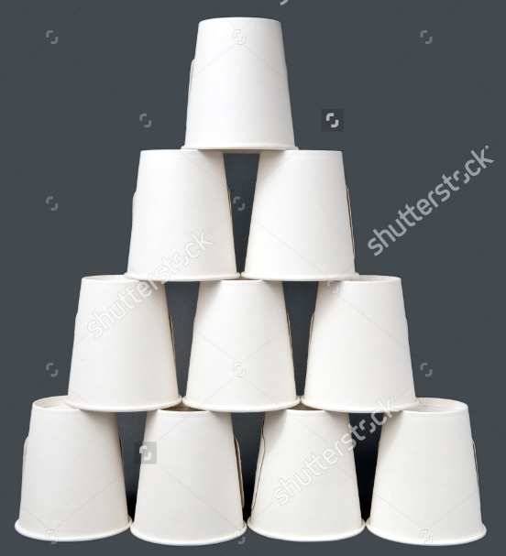
Needed:
- 10 disposable cups (10 per set)
- A hand ball
- Masking tape

Set Up:
- Stack the cups in a pyramid (as shown in the picture)
- Use the tape to mark a toss line

To Play:
- Player is given the hand ball
- Player must stand behind the toss line.
- The player either throws or rolls the ball toward the cups
- The player wins if they knock down the cups

