Mulwala Preschool (Riverina Murray Preschool Alliance member)

SECTION: 4 – Staffing Arrangements
POLICY NO: 4.3.4
POLICY: Code of Conduct (Incl. Ethical Conduct)
REVIEW DATE: 29/10/2025

CODE OF CONDUCT POLICY
We believe in maintaining an inclusive and welcoming environment and workplace that motivates and facilitates personal growth and development for staff and educators. The values that underpin our work ethic include equality, respect, integrity, and responsibility. Our Service is committed to adhere to the ECA Code of Ethics (2016) which is based on the principles of the United Nations Convention on the Rights of the Child (1991) and provides a framework for the reflection about the ethical responsibilities of early childhood professionals.

NATIONAL QUALITY STANDARD (NQS)
QUALITY AREA 4: STAFFING ARRANGEMENTS
4.1 | Staffing arrangements | Staffing arrangements enhance children's learning and development.
4.1.2 | Continuity of staff | Every effort is made for children to experience continuity of educators at the service.
4.2 | Professionalism | Management, educators and staff are collaborative, respectful and ethical.
4.2.1 | Professional collaboration | Management, educators and staff work with mutual respect and collaboratively, and challenge and learn from each other, recognising each other’s strengths and skills.
4.2.2 | Professional Standards | Professional standards guide practice, interactions and relationships.
QUALITY AREA 7: GOVERNANCE AND LEADERSHIP
7.1.1 | Service philosophy and purpose | A statement of philosophy guides all aspects of the service’s operations.
7.1.3 | Roles and responsibilities | Roles and responsibilities are clearly defined, and understood, and support effective decision-making and operation of the service.

EDUCATION AND CARE SERVICES NATIONAL LAW AND NATIONAL REGULATIONS
S. 162A | Child protection training
S. 165 | Offence to inadequately supervise children
S. 167 | Offence relating to protection of children from harm and hazards
82 | Environment to be free from tobacco, vaping devices, vaping substances, drugs and alcohol
83 | Staff members and family day care educators not to be affected by alcohol or drugs
84 | Awareness of child protection law
155 | Interactions with children
168 | Education and care services must have policies and procedures
170 | Policies and procedures to be followed
171 | Policies and procedures to be kept available
172 | Notification of change to policies or procedures

RELATED POLICIES
Bullying, Discrimination and Harassment Policy  Child Protection Policy  Child Safe Environment Policy  Child Safety and Wellbeing Policy (VIC services)  Dealing with Complaints Policy  Interactions with Children, Family and Staff Policy  Privacy and Confidentiality Policy  Professional Development Policy | Record Keeping and Retention Policy  Recruitment Policy  Respect for Children Policy  Responsible Person Policy  Safe Use of Digital Technologies and Online  Environments Policy  Staffing Arrangements Policy  Social Media Policy  Tobacco, Drug and Alcohol-Free Policy  Work Health and Safety Policy

PURPOSE
We aim to establish a common understanding of workplace standards and ethics expected of all employees of the Service. We aim to ensure positive working relationships are formed between all educators and management, promoting dignity and respect by avoiding behaviour, which is or may be perceived as harassing, bullying or intimidating. Educators and management will at all times conduct themselves in an ethical manner and strive to ensure that all interactions are positive and respectful and are in accordance with the Service’s philosophy.

Our Service takes every reasonable effort to accommodate the diversity of all children into our organisation and service operations embedding the National Child Safe Principles New South Wales into our organisation and service operations. We are committed to the safety and wellbeing of children and young people. We recognise the importance of and responsibility for, ensuring our Service provides a safe and supportive environment which respects and fosters the rights and wellbeing of children in our care. We are dedicated in promoting cultural safety for Aboriginal children, cultural safety for children from culturally and/or linguistically diverse backgrounds and to providing a safe environment for children with a disability.

SCOPE
This policy applies to staff, educators, management, approved provider, nominated supervisor, students,
families, children, volunteers and visitors of the Service.

IMPLEMENTATION
The approved provider, nominated supervisor, educators, staff, volunteers, and students will adhere to the Early Childhood Australian Code of Ethics, Education and Care Services National Regulations and National Quality Standard, National Child Safe Principles New South Wales and Service policies and procedures at all times, promoting positive interactions both within the Service and the local community. Our Service adopts and aligns with the National Model Code and guidelines for taking images or videos of children to ensure safe physical and online environments.

RESPECT FOR PEOPLE AND THE SERVICE
- Employees, educators, staff and management are committed to the Service philosophy and values, inclusive of best practice in early childhood education and building positive partnership with children, families and staff
- Our Service has developed a Statement of Commitment to Child Safety and Wellbeing to demonstrate a strong culture of child safety within the Service
- Employees, educators, staff and management must adhere to our child safe policies including Child Safe Environment Policy, Child Protection Policy, Safe Use of Digital Technologies and Online Environments Policy and take all reasonable steps at all times to protect children from abuse and harm
- Employees, educators, staff and management understand that child safety is everyone’s responsibility
- Effective, open, and respectful reciprocal communication and feedback between employees, children, families, and management is conveyed
- It is important to treat colleagues, children, and families with respect. Bullying or insulting behaviour, including verbal and non-verbal aggression, abusive, threatening, or derogatory language or intimidation towards other employees, educators, staff, management, children, visitors, or families is unacceptable and will not be tolerated
- Employees, educators, staff and management are committed to valuing and promoting the safety, health, and wellbeing of employees, volunteers, children, and families
- Employees, educators, staff and management promote the cultural safety, participation and empowerment of Aboriginal and Torres Strait Islander children to express their culture and enjoy their cultural rights
- Employees, educators, staff and management promote the safety, participation and empowerment of children with culturally and/or linguistically diverse backgrounds to support children to express their culture and enjoy their cultural rights
- Employees, educators, staff and management promote the safety, participation and empowerment of children with a disability
- Employees, educators, staff and management are committed to an equal opportunity workplace and culture which values the knowledge, experience, and professionalism of all employees, team members, and managers, and the diverse heritage of our families and children
- Employees, educators, staff and management respect the privacy of children and their families by keeping all information about child protection concerns confidential and only share information to promote child wellbeing or safety and /or manage risk of family violence with other Information Sharing Entities (IES) as per NSW.
- Our Service will conduct a comprehensive probation and induction orientation program for all new employees, volunteers and students to include awareness of their roles and responsibilities in relation to child safe practices and child protection reporting obligations
- Policies and procedures will be developed to ensure employees, educators, staff, students, visitors and families are aware of the standards of behaviour that is expected within the Service
- Employees, educators, staff and management are informed that inappropriate behaviour, including bullying, sexual harassment, discrimination and harassment will not be tolerated
- It is important employees, educators, staff and management listen and respond to the views and concerns of children particularly if they are telling you that they or another child has been abused or they are worried about their safety or the safety of another.

EXPECTATIONS OF EMPLOYEES
EMPLOYEES WILL:
- adhere to the Code of Conduct Policy
- ensure their Working with Children Check (WWCC) is valid and current
- ensure their work is carried out proficiently, harmoniously, and effectively
- act in a professional and respectful manner at all times whilst at work
- demonstrate and maintain professional boundaries that foster trust, dignity and mutual respect in their interactions with children, families, colleagues and members of the community
- not be in the possession of a personal electronic device that can take images or videos or personal storage and file transfer media when providing education and care and working directly with children- National Model Code
- act honestly and exercise attentiveness in all Service operations
- carry out all lawful directions, retaining the right to question any direction which they consider to be
unethical. If uncertain they can seek advice from the nominated supervisor, approved provider or the
Ombudsman
- uphold the rights of children and always prioritise their needs
- treat all children and young people with respect
- promote the wellbeing and safety of children and take all reasonable steps to protect children from abuse
- provide active and adequate supervision of children at all times
- understand their legislative responsibility as mandatory reporters to report any allegation of child abuse, neglect or possible risk of harm to management or Child Protection authority
- understand their legislative responsibility to report any inappropriate action of any other employee that involves children or young people to management as part of the Reportable Conduct Scheme
- participate in all mandatory training, including update of Child Protection Law training and reporting process every 12-24 months.
- follow and comply with the Dealing with Complaints Policy when matters are raised regarding child safety and wellbeing
- have a solid understanding of the Service’s policies and procedures, National Principles for Child Safe Organisations and the ECA Code of Ethics. If uncertain about the content of any policy or procedure with which they must comply, employees should seek clarification from the nominated supervisor or approved provider
- work collaboratively with colleagues and management families and members of the community with courtesy, respect and recognise and value diversity
- be mindful of their duty of care towards themselves and others
- be positive role models for children at all times
- ensure compliance with a zero tolerance of racism within the Service
- report any incidents or bullying, discrimination or harassment, including sexual harassment they have experienced or witnessed
- not be under the influence of drugs or alcohol while working; bring alcohol or drugs onto the premises
- not smoke or vape in or on surrounding areas of the Service [see Tobacco, Drugs and Alcohol-Free Policy]
- respect the confidential nature of information gained about each child enrolled in our Service
- engage in critical reflection to inform individual and collective decision making and ensure continual improvement, including a review of child safe policies and procedures
- report to management and decline any bribe or gift, including money, received by a family that may influence or appear to influence a decision or action
- report any instances of suspected corrupt conduct, mismanagement of government funds or other serious allegation to the Department of Education via their Online contact form. For more information visit the Department of Education website: Reporting fraud via a tip-off.

EMPLOYEES MUST NOT:
- use abusive, derogatory or offensive language
- engage in conduct that is detrimental to the professional standing of our Service, is improper or unethical, is an abuse of power, or harasses, discriminates against, victimises, humiliates, intimidates, or threatens other educators, staff members, volunteers, or visitors at the Service, either directly or indirectly via information technology such as email, text or social media. Additionally, they must never support or encourage this behaviour in others.
- condone or participate in illegal, unsafe or abusive behaviour towards children, including physical, sexual or psychological abuse, ill-treatment, neglect or grooming
- exaggerate or trivialise child abuse issues
- fail to report information to the approved provider if they know a child has been abused
- engage in unwarranted and inappropriate touching involving a child
- persistently criticise and/or denigrate a child
- verbally assault a child or create a climate of fear
- encourage a child to communicate with an adult in a private setting
- share details of sexual experiences with a child
- use sexual language or gestures in the presence of children
- discriminate against any child, because of culture, race, ethnicity or disability
- put children at risk of abuse- refusing food/play, making threats, exposing children to inappropriate language or material (movies, internet, photos)
- show preferential behaviour towards any child
- accept an offer of money, regardless of the amount
- seek or accept a bribe
- acquire personal profit or advantage because of their position (e.g., through the use of Service information)
- exchange any property of the Service for own use unless properly authorised
- approach other employees, managers or visitors directly on individual matters that are irrelevant to them
- exchange large gifts or money to, or from, an individual child or family that may be seen as favouritism
- engage in any action in breach of our Privacy and Confidentiality Policy, including but not limited to disclosure of confidential Service or customer information, or the improper or illegal use of that confidential information. Authorised persons will only access confidential information for the purpose intended.
- engage in or support any action in breach of Service policies and/or procedures.

EXPECTATIONS OF LEADERS AND MANAGEMENT
In addition to the above responsibilities, leaders and management are expected to:
- model child safe values in daily practices and decision-making
- monitor and review compliance with Child Safe Standards, mandatory reporting, National Law and Regulations
- promote a collaborative and interconnected workplace by developing a positive working
environment where all employees can contribute to the ongoing continuous improvement of the Service
- promote leadership by working with employees and providing opportunities for professional development and growth
- provide flexible opportunities to ensure all employees can participate in staff meetings and professional development
- promote open and effective communication with all staff regarding Right to Disconnect provisions under Fair Work Act- including out of hours emergency contact and expectations of staff
- provide ongoing support and feedback to employees
- keep employees informed about essential information and any relevant changes and make all documents readily accessible to them
- ensure copies of the ECA Code of Ethics and National Child Safe Principles are available to staff and families.
- model professional behaviour at all times whilst at the Service
- implement supportive and effective communication systems, consulting employees in appropriate decision making
- take appropriate action if a breach of the code of conduct occurs
- share skills and knowledge with employees
- give encouragement and constructive feedback to employees, respecting the value of different professional approaches
- follow recruitment policies and procedures to ensure all potential candidates undergo appropriate background checks, including Working with Children Checks
- model and provide guidance to educators and staff to ensure compliance with a zero tolerance of child abuse, racism and bullying within the Service.

REPORTING A BREACH OF THE CODE OF CONDUCT
Our Service aims to foster a culture of transparency and accountability while supporting employees to report any reasonable suspicion of reportable matters of improper, illegal or misconduct within the Service to management including, but not limited to:
- breaches of the Code of Conduct or other Service policies
- breaches of Education and Care Services National Law or Regulations
- breaches of legislation or law
- criminal activity
- corruption
- conduct that poses a danger or harm to any person/s
- harassment or discrimination
- improper or misleading financial practices

Raising any concern, or breach of the Code of Conduct is a professional responsibility. Reports can be made verbally, in writing, and may be anonymous. Our Service will implement protective practices to ensure that, where applicable, employees identity is not compromised or disclosed following a report of a reportable matter. All reports will be handled professionally and confidentially including storage of documents in a secure and confidential manner and ensuring access to confidential documents is restricted to authorised personnel only. Once a report has been made the matter may be investigated through a formal investigation.
Reporting responsibilities
- as mandatory reporters, all employees, students and volunteers must report possible risk of harm to children or young persons to management and/or Child Protection authority, police (see Child Protection Policy)
- the approved provider/management will report any allegations or child related misconduct as per their legislative requirements (this may include reporting the matter to the Police, Department of Communities and Justice and the Office of the Children’s Guardian in NSW.
- employees will report any concerns they may have about inappropriate actions of any other
employee that involves children or young people to the approved provider as per the Reportable
Conduct Scheme
- if employees become aware of a serious crime committed by another employee, they are required to report it to management
- all prospective employees are required to complete a prohibition notice declaration on the Employment Application Form to acknowledge they do not hold any prohibition notices that would prevent them from working with children
- employees are required to notify management immediately of any enforcement actions issued to them during their course of employment.

MANAGING CONFLICT IN THE WORKPLACE
MANAGEMENT WILL:
- adhere to the Dealing with Complaints Policy
- remain objective and impartial when managing conflict in the workplace
- be responsive and address a possible breach of the code of conduct by any employee as soon as they aware of the breach
- investigate all allegations which may result in remedial action, or disciplinary action ranging from a caution to dismissal
- consider all relevant facts and make decisions or take actions fairly, ethically, consistently, and with transparency. If they are uncertain about the appropriateness of a decision or action they will consider:
- whether the decision or conduct is lawful
- whether the decision or conduct is consistent with Service policies and objectives
- whether there will be an actual, potential, or perceived conflict of interest involving obligations that could influence the business relationship or conflict with business duties.

ADHERING TO SERVICE CONFIDENTIALITY
- Unless authorised to do so by legislation, employees must not disclose or use any confidential
information without appropriate approval (including written approval as required)
- Lawful sharing of information with other parties must be to promote the wellbeing or safety of children and adhere to guidelines under Child and Family Information Sharing Schemes (e.g., CISS, FVISS and MARAM in Victoria)
- All employees are to ensure that confidential information is not accessed by unauthorised people
- Employees will adhere to the Service’s Privacy and Confidentiality Policy.

BABYSITTING
- Our Service does not provide babysitting services outside normal operating hours
- Should employees undertake private babysitting arrangements with families, our Service takes no responsibility for any private arrangements between staff members and the family. However, we do expect staff to inform the Service if they are babysitting or caring for a child that attends the Service.
- Employees are not to undertake private babysitting arrangement with families in our service. All staff are bound by contract to the Service’s Privacy and Confidentiality Policy, where they are unable to discuss any issues regarding the Service, other staff members, parents/families, or other children.

RECORD KEEPING
- Employees and management will maintain full, accurate, and honest records as required by the Education and Care Services National Regulations
- The approved provider has a responsibility to ensure that employees comply with their record keeping obligation outlined in the Record Keeping and Retention Policy
- Employees must not destroy records without permission from management
- Records must be retained and stored securely as per our Record Keeping and Retention Policy.

DUTY OF CARE
- Duty of Care refers to the legal obligation of the approved provider, nominated supervisors and
educators to take all reasonable steps to protect children from harm, injury, infection and hazards, ensuring their overall health, safety and wellbeing are maintained at all times.
- This obligation includes providing adequate supervision, a safe environment and appropriate responses to incidents, all in line with the requirements of the National Quality Framework
- All staff and educators have a responsibility to take reasonable care for the health and safety of themselves and others at the workplace to enable compliance with the work health and safety legislation outlined in the Work Health and Safety Policy
- Duty of Care relates to both physical and psychological wellbeing of individuals

APPROPRIATE USE OF COMMUNICATION AND SOCIAL NETWORKING SITES
SOCIAL MEDIA
- As a Child Safe Organisation, our Service has the responsibility to ensure children and educators are protected from harm when they engage in with digital technology including social media
- Strict guidelines for the use of social media are outlined in our Social Media Policy
- The Service offers its current enrolled families and staff members a Facebook page as a communication tool. The administrator of the account is the Service’s Room Leader/supervisor. The administrator controls the content on the page and ensures that the postings are relevant and respectful of the Service, the children, the staff, families, and greater community.
- Staff members are not permitted to post any negative comments relating to the Service, children, colleagues, or families on any personal social media account
- If they choose to ‘like’ the Service’s page they have a responsibility to ensure that their profile picture is an appropriate representation of an early childhood educator. If it is not, we request that they do not ‘like’ the page.
- Staff members are to use their own personal discretion when adding a family of the Service as a ‘friend’ on Facebook. The Service does not recommend staff to add families of the Service as they will be seen still as a representative of the Service and held to the Service’s Code of Conduct on all posts on their private ‘wall’ if families have access.
- Families are advised in our Social Media Policy to respect that staff may have a personal policy on adding families due to their professional philosophy and that the Service does not recommend staff to have families as friends on their private account.

NATIONAL MODEL CODE AND GUIDELINES
We are mindful that educators have a duty of care to ensure children are protected from potential risk of harm. It is imperative that all employees of the Service provide children with their full attention, ensuring supervision is maintained and remains on the children at all times.
Our Service adopts and aligns with the National Model Code and Guidelines for taking images or videos of children. only service-issued/approved devices are to be used when taking images or video of children
- personal electronic devices that can take images or videos (such as tablets, phones, digital cameras, smart watches) and personal storage and file transfer media (such as SD cards, USB drives, hard drives and cloud storage) should not be in the possession of any person while providing education and care and working directly with children
- authorisation is only provided for a staff member or educator to use a personal electronic device for essential purposes (personal health requirement, disability, family necessity, local emergency event, technology failure). Exemptions need to be provided for in writing by the approved provider.
- a register of all electronic devices purchased for and used within the Service is developed and maintained by the approved provider/nominated supervisor
- strict protocols are implemented for appropriate storage and retention of images and videos of children.

PERSONAL PHONE CALLS/MOBILE PHONES/SMART WATCHES
- employees are not authorised to use the Service’s phones for personal reasons unless in the case of an emergency or with permission from management
- no personal mail or deliveries should be directed to the Service unless prior approval has been granted by the nominated supervisor/management
- employees are not to contact families or children of the Service for personal reasons
- if, for personal reasons an employee needs to remain contactable from someone outside the Service they should ensure that the situation is explained to management and that the service’s primary contact details are passed on to the persons/family outside the Service
- children are at no time to be given access to service issued or personal mobile phones
- personal electronic devices can only be accessed by staff/educators when they are not working directly with children or providing education and care- taking a scheduled break, during planning time or administrative activities
- smart watches may only be worn if they do not have camera/recording functionality

SERVICE EMAIL
- Email is to be used only for company usage, not for private communications
- Passwords and access privileges are strictly confidential and to be used only by the educator issued with that access, or persons delegated to know and use that access in the normal course of operation
- It is the responsibility of the authorised user to take fair and reasonable steps to ensure the passwords and other forms of access are held safe
- Employees are to be aware that their Service email account may be accessed by management at any time.

USE OF ALCOHOL, DRUGS, VAPING AND TOBACCO
- Smoking or vaping is NOT permitted in or on surrounding areas of the Service
- Educators, staff, visitors and volunteers must not carry or use vaping substances or vaping devices on the Service premises while education and care is provided to children
- It is expected that the odour of cigarette smoke will not be detected on an employee’s clothing. If an employee is found smoking/vaping on the premises, that employee’s employment may be terminated. Our Service supports the Smoke Free Environment Act 2000. The Service and its employees will follow all conditions outlined in this act.
- Our Service is bound by the Education and Care Services National Regulations. Alcohol, drugs, or other substance abuse by employees can have serious adverse effects on their own health and the safety of others. As such, all employees must not:
  - consume alcohol nor be under the influence of alcohol while working
  - use or possess illegal drugs at any workplace
  - drive a vehicle, having consumed alcohol or suffering from the effects of illegal substances, or
  - bring alcohol, vaping devices or any illegal drugs onto the premises.
- If a co-worker suspects a colleague to be affected by drugs, alcohol or observes them vaping or smoking, they must inform the nominated supervisor immediately. No employee will be allowed to work under the influence of drugs or alcohol. (See: Tobacco, Drugs and Alcohol-Free Policy)
- Employees undergoing prescribed medical treatment with a controlled substance that may affect the safe performance of their duties are required to report this to the nominated supervisor. Consideration will be given as to whether the particular medication affects the person’s capacity to provide education and care to children.
- All issues pertaining to these matters shall be kept strictly confidential. A breach of this policy may initiate appropriate action including the termination of employment.
DRESS CODE
- All employees must adhere to our uniform/dress code supplied during induction.
- Enclosed shoes must be worn at all times (strictly no high heels, thongs, or wedges).
- Clothes must be suitable for free movement, active play, and messy play.
- No offensive logos or political statements are to be displayed on clothing.
- Jewellery – one (1) earring per ear (small studs).

PERSONAL HYGIENE
All employees are to adhere to the following standards:
- long hair is to be clean and neatly tied back. Ensure hair does not hang in your eyes
- makeup is to be light and natural
- fingernails are to be clean and well groomed
- nail polish (if worn) cannot be chipped
- employees will follow appropriate oral hygiene practices
- an appropriate deodorant/antiperspirant will be worn
- strong perfumes will not be worn as they may cause allergic reactions in children.

BREACH OF THE CODE OF CONDUCT
All employees are made fully aware that the following breaches of the Code of Conduct and role
responsibilities may result in disciplinary action which may lead to performance management or termination of employment:
- reporting to work under the influence of alcohol or drugs
- refusal to complete mandated professional training
- possessing or selling drugs at the Service
- immoral, immature, or indecent conduct while at the Service
- inappropriate use of company equipment and/or resources
- refusing to work as reasonably directed
- possessing a dangerous weapon whilst at the Service
- bringing disrepute to the Service
- causing disruption or discontent in the relationship between a family and the Service
- disclosure of confidential information
- stealing, abusing, defacing, or destroying company property
- interfering with work schedules
- falsification of reports, documents, or wages information
- failure to report for work without notice or unauthorised absence
- walking off the job
- failure to follow policies and procedures
- vulgarity or disrespectful conduct to families, management or colleagues
- making or publishing false, vicious, or malicious statements about any employee of the Service, or the Service itself
- failure to hand in lost property (this is regarded as stealing): Lost property is to be handed to the nominated supervisor
- unable to maintain or hold a current Working with Children Check/Clearance New South Wales
- having personal visitors whilst on shift
- continued personal phone calls
- carrying a personal mobile phone/ electronic device whilst on shift-NMC
- using a personal mobile phone or device to take photographs or video of children-NMC
- unauthorised solicitation or distribution of money or materials
- consistent or ongoing poor work standard
- carelessness in the performance of duties
- consistent or ongoing low level of enthusiasm
- lack of personal cleanliness and hygiene
- taking excessive breaks
- failure to report health, fire or safety hazards
- repeated tardiness.

CONTINUOUS IMPROVEMENT/REFLECTION
The Code of Conduct Policy will be evaluated and reviewed on an annual basis or earlier if there are changes to legislation, ACECQA guidance or any incident related to our policy. Feedback will be requested from children, families, staff, educators and management and notification of any change to policies will be made to families within 14 days.

RELATED RESOURCES
Code of Conduct – Staff Acknowledgement Form
SOURCES

Australian Children’s Education & Care Quality Authority. (2025). Guide to the National Quality Framework
Australian Children’s Education & Care Quality Authority. (2024). National Model Code for Early Childhood Education and Care.
Anti-Discrimination Act: See https://raisingchildren.net.au/disability/disability-rights-the-law/law/anti-discrimination-laws for Acts for specific Australian states and territories.
Australian Human Rights Commission https://www.humanrights.gov.au/our-work/childrens-rights
Early Childhood Australia Code of Ethics. (2016).
Australian Government. Fair Work Ombudsman. (2024). Hiring employees
Government of South Australia Human Services Child safe environments
National Principles for Child Safe Organisations
NSW Government Office of the Children’s Guardian Code of Conduct- a guide to developing child safe Codes of Conduct. (2020).
Ombudsman Act 2001 (Cth).
Privacy and Personal Information Protection Act 1998 (Cth).
Victoria State Government. (2021). Family Violence Multi-Agency Risk Assessment and Management Framework.
Victoria State Government. (2022). Families, Fairness and Housing. Resources for Child Safe Standards
Work Health and Safety Act 2011 (Cth).
Workplace Relations Act 1996 (Cth).

REVIEW
POLICY REVIEWED BY: | Vicki Martin | Director |  | 29/10/2025
POLICY REVIEWED | SEPTEMBER 2025 | NEXT REVIEW DATE | DECEMBER 2026
VERSION NUMBER | V29.10.25
MODIFICATIONS | - policy reviewed out of regular calendar review due to legislation changes for child safety- National Model Code (NMC)  - added reference to new mandatory policy- Safe Use of Digital Technologies and Online Environments Policy  - updated changs to vaping ban  - minor edits within policy  - sources checked for currency and updated as required  - policy adopted from Child care desktop

Mulwala Preschool (Riverina Murray Preschool Alliance member)

SECTION: 4 – Staffing Arrangements
POLICY NO: 4.3.4
POLICY: Code of Conduct (Incl. Ethical Conduct) The child’s View.
REVIEW DATE: 26/3/2025
Our Preschool Promise
At our preschool, we have special rules to help everyone be kind, safe, and happy. These rules help teachers and friends make good choices every day!

What We Do
👩‍🏫 Our teachers and helpers always try to do the right thing.
🧒 We listen to kids, families, and our community to make sure we are doing a great job.
🤗 Everyone here – teachers, children, and families – follows our kindness rules.

Our Kindness Rules
✔️ We take care of each other.
✔️ We keep each other safe. ✔️ No Pinching
✔️ We are fair and include everyone. ✔️ No Biting
✔️ We play, learn, and have fun together! ✔️ No Hitting

Our Big Ideas
✨ Every child is special and can do amazing things.
🌎 Every child has a right to be happy, safe, and respected.
🤝 Families and teachers work together to help children grow.
🎨 Play is super important for learning and having fun!
Our teachers always think about the best way to help children. They talk to each other and families to make sure we all feel safe and cared for.
At our preschool, we work as a team so that everyone feels happy and welcome! 🎉

This is what we think a code of conduct is.

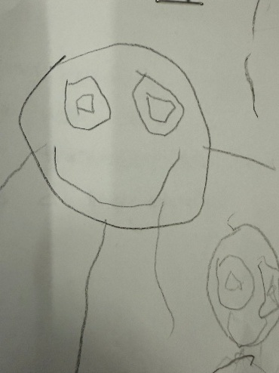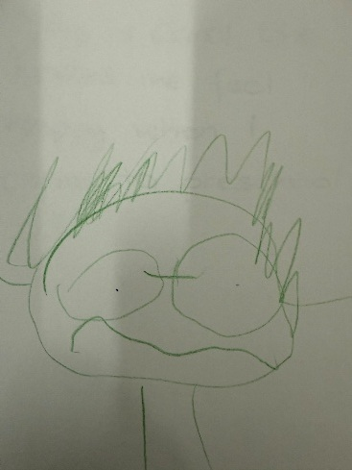
This is my teacher Carol she makes me feel happy and safe when I come to preschool
This is a friend who has hurt themselves and needs a band aid. I am helping them.

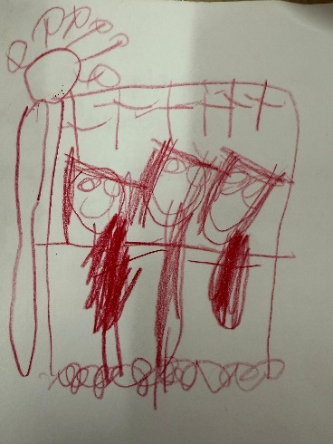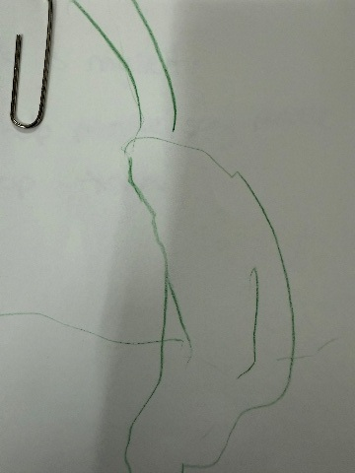
This is myself I help people say Stop and please
This is my friends on the monkey bars playing. We look out for each other.

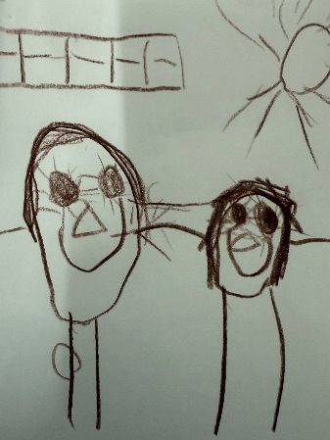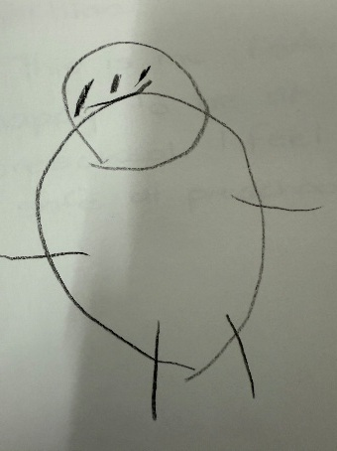
This is me I am happy to be at preschool. I feel safe at preschool.
I’m helping my friend she has hurt her knee. I’m giving her a cuddle.

