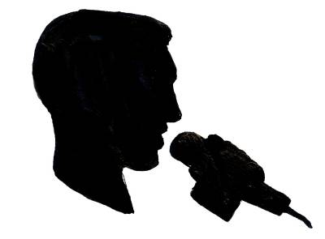 | MC. J. Wiz Production  DJ Services  James B. Strutchen Jr  529 Roserush Lane  Jacksonville, Florida 32225  (904)-318-8942  http://www.mcjwizproduction.com  jstrutchen@mcjwizproduction.com  strutchjr1@bellsouth.net | 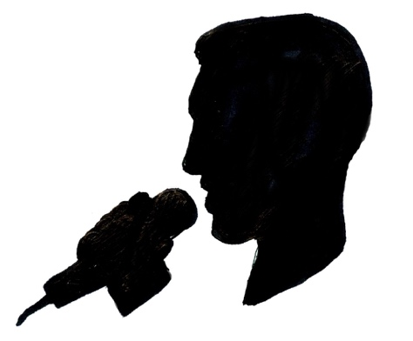
Agreement
1, James B. Strutchen agrees to provide a professional sound system, wireless microphones, and clean, radio edit or explicit online music library for your special event. This event is for ____________________________ (client) at the _______________________________________(location) on the _____day of __________ in the year of _______ between the hours of _______ to _______ for services rendered in the amount of _________ for ______ hours of musical entertainment. Once the designated time has expired, an additional charge of $100.00 per hour or any portion of an hour will be added to the negotiated amount. Entertainment fees must be paid at least one week in advance of the event. A $100.00 retainer/deposit must be paid within 10 days of your inquiry to reserve date the requested. If you cancel or change the date of the scheduled event, your retainer/deposit will not be refunded. A new contract and retainer/deposit must be submitted to request a new date. The retainer/deposit of current or new contract will be subtracted from the agreed upon price. If I cancel my services to your event, your retainer/deposit will be returned. If an emergency happens in my family and I can’t physically be at your event, I will refund all funds paid to my service and assist you, finding another DJ/MC to work the event to the best of my ability.
Services Rendered
2. I will provide a variety of music or your requested music list, professional stereo sound system, one wireless microphone, one hardwire microphone, digital music, and one lavaliere. I will also play any music supplied by the guests, which has been approved by the responsible party. For specific requests, a list must be provided two weeks in advance. (recommended for customer satisfaction).
Disclaimer Statement
3. LIABILITY. If for any reason the Company or Performer is unable to perform any condition of this contract, the company’s liability shall be exclusively limited to no more than a refund of all monies paid pertaining to the events or items not performed, in all cases not to exceed the full amount of this contract.

Additional Services
Yes | No | Item # | Description | Unit Price | Line Total
Yes | No | 6 | Up Lighting | Included $100.00 | Included  $100.00
Yes | No | 6 | Up Lighting | $20.00
Yes | No | 1 | Projector/DVD Player | $100.00
Yes | No | 1 | Screen 6 X 6 feet Tripod | $25.00
Yes | No | 1 | Toshiba 43” Screen TV and Laptop | $100.00
Yes | No | 1 | Gobo Projector Rotating GOBO Projector IR | $100.00
Yes | No | 1 | Gobo Projector Nonrotating ADJ IKON Profile WW GOBO | $75.00
Yes | No |  | Gobo image ordered | $39.00 to $75.00
Yes | No |  | Under 50 miles round trip from home office | Included | Included
Yes | No |  | Over 50 miles round trip from home office or $50.00 under 100 or .54 per mile) | $50.00
Yes | No |  | ($.54 per mile round trip from home office, if over 100 miles) | Various
Yes | No | 1 | Karaoke | 75.00
Yes | No | 1 | Ceremony Setup, ((2) JBL speaker, (1) wireless microphone and stand, (1) wireless lavalier, (1) 12 channel Yamaha mixer, your choice of music, and 1Ipad | Included  $250.00 | Included
Yes | No | 1 | Generator | $75.00
Yes | No | 1 | 4 Lighting multi-colors | Included $100.00 | Included
Yes | No | 1 | Liability Insurance | Included $50.00 | Included
Yes | No | 1 | Luau Poles setups, 2 stands and 1 pole | $25.00
Yes | No | 20 | Hula Hoops | $25.00
Yes | No | 1 | Disco Mirror Ball | $35.00
Yes | No | 1 | Starburst LED Ball | $35.00
Yes | No | 2 | 2 Low Laying Fog Machines | $75.00
Yes | No | 1 | ADJ BUBBLETRON Bubble Machine and Liquid | $35.00
Yes | No |  | Back drop Setup for selfies or group photos, green screen, gray screen, black screen or your own backdrop | $100.00
 |  |  |  | Subtotal
 |  |  |  | Sales Tax
 |  |  |  | Total
Requirements
4. I will need the following items;
a) 1 table at least 6 feet long and two chairs. (If not available I will use my own table and black table cloth)
b) Reliable electrical power source (Venue)
c) 2 hours setup time (I will arrive two hours before event start time)
d) Point of Contact: Name: ______________________________
e) All music provided must be clearly marked and labeled, if you bring your own music.

5. I am requesting permission to use the pictures I take during your event on my website and add them to my portfolio. A copy will be share with you via Dropbox to the provided email address listed below! Please initial below. _____ Yes, I agree
_____ No, I disagree

6. Please provide your address and venue information.
Client Information
Address:
City:
State:
Zip Code:
Cellular:
Cellular:
E-mail address 1
E-mail address 2
Venue Information
Name of Venue:
Address:
City, State & Zip Code:
Point of Contact:
Main Phone:
Cellular:
E-mail address:
Comments
7. I believe in customer satisfaction, and I believe the best way to reach that goal is via the customer’s input to their own party. The more information you provide, such as a music list, schedule of events, and all surprises provided to me at least two weeks prior to your party will give you the best results. I want to provide you the best DJ Services possible with your participation. Remember, it’s your party. Let’s make your party the best ever.
Note: IF MY EQUIPMENT IS MALICIOUSLY DAMAGED EXCEEDING $50.00 BY THE GUESTS OF THE RESPONSIBLE PARTY, I RESERVE THE RIGHT TO RECOVER COST OF DAMAGED EQUIPMENT THROUGH LEGAL MEANS.

8. Amendments: _________________________________________________________________________
________________________________________________________________________________________
________________________________________________________________________________________
________________________________________________________________________________________

9. Payment:
Deposit: _______ Date: _______________________
Balance: _______ Date: _______________________
Final Payment: _________ Date: ____________________________

10. I _______________________________ the responsible party of the event, agree to the terms stated above on, ______________________________(Date).

______________________________________ James B. Strutchen Jr.
Client Signature Owner Signature James B. Strutchen Jr.

