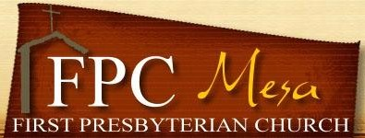
2019 - 2020 Wednesday WRAP
Adult Mandatory Health & Consent Form

Name of Participant__________________________________________________________

Phone:_______________________________________ Email:__________________________________

Home Address _______________________________________________________________________

City______________________________State______Zip_______________

Phone________________________Email___________________________________________________

Name of Participant___________________________________________________________

Phone__________________________Email_________________________________________________

Emergency Contact Person
Name________________________________________________________________________________
Address ____________________________________________Phone_____________________________

Health & Allergies
Any medical conditions you want to share:__________________________________________________

Any allergies? _________________________________________________________________________

Dietary Restrictions? ___________________________________________________________________

Liability Release and Consent

I understand all reasonable safety precautions will be taken at all times by the First Presbyterian Church of Mesa (FPC) and its agents during the events and activities. I understand the possibility of unforeseen hazards and know the inherent possibility of risk. I agree not to hold FPC, its leaders, employees and volunteer staff liable for damages, losses, diseases or injuries incurred by the subject of this form.

In the event of illness or injury, I give permission for any medical treatment for myself deemed necessary for my health and safety. I certify that the medical information contained on this form is complete and correct to the best of my knowledge. I also give consent for myself to be photographed during FPC activities and for those photos to be used in church publications, websites/webpages.

Signature___________________________________________________________ Date ___________

