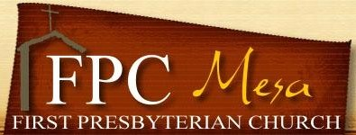
2019 - 2020 Wednesday WRAP
Children & Youth Mandatory Health & Consent Form

1. Name of Participant____________________________Date of birth __________Age ____Grade_____

Address______________________________City__________________State______Zip______________

Phone________________________Email___________________________________________________

2. Name of Participant___________________________Date of birth ________ Age ____Grade_______

3. Name of Participant___________________________ Date of birth ________ Age ____Grade_______

4. Name of Participant___________________________Date of birth ________ Age ____Grade_______

Emergency Contact Person
Parent/Guardian Name_____________________________ Phone _____________________________

Health & Allergies
Any medical conditions you want to share:__________________________________________________

Any allergies? _________________________________________________________________________

Dietary Restrictions? ___________________________________________________________________

Liability Release and Consent
My child(ren)has my permission to participate in authorized events of FPC. I understand that in the event medical intervention is needed, every attempt will be made to contact immediately the persons listed on this form. In the event I cannot be reached in an emergency during the activity dates shown on this form, I hereby give permission to the physician or dentist selected by the activity leader to hospitalize, to secure medical treatment and/or order an injection, anesthesia, or surgery for my child as deemed necessary.
I understand all reasonable safety precautions will be taken at all times by the First Presbyterian Church of Mesa (FPC) and its agents during the events and activities. I understand the possibility of unforeseen hazards and know the inherent possibility of risk. I agree not to hold FPC, its leaders, employees and volunteer staff liable for damages, losses, diseases or injuries incurred by the subject of this form. I also give consent for my child to be photographed during FPC activities and for those photos to be used in church publications, websites/webpages.

Parent/Guardian Signature_________________________________________ Date ___________

