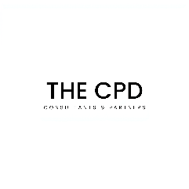

Licensed & Approved Products Clause
Mandatory for All Trusted & Accredited Academies
All Trusted Academies, Accredited Academies, tutors, assessors, and practitioners operating under The CPD Consultants & Partners must use ONLY licensed, legally compliant, and appropriately regulated products during any treatment, training, demonstration, or assessment.
This includes the mandatory use of:
- FDA-approved products (where applicable)
- CE-marked products for use within the UK & EU
- Licensed medical devices and consumables
- Legitimate, traceable products sourced from authorised suppliers
- Products that meet UK regulatory and safety standards
Strict Prohibition
The following are strictly prohibited under CPD accreditation:
- Unlicensed, counterfeit, or black-market products
- Products without CE marking or equivalent regulatory approval
- Products purchased from unauthorised or unverifiable suppliers
- Products with removed, altered, or missing batch numbers
- Any injectable, device, or cosmetic product not compliant with UK law
Accreditation Consequences
Any academy or practitioner found using unlicensed, non-approved, or unsafe products will face immediate compliance action, including:
- Suspension of accreditation
- Removal from the Trusted Academy Register
- Permanent revocation of CPD accreditation
- Public removal from all CPD directories
- Referral to relevant regulatory or enforcement bodies where required
This clause protects learners, clients, practitioners, and the integrity of the aesthetics industry.

