APPETIZERS
Chicken Tenders 6pc……………..……………...…………….10.50
Premium all-white chicken breast tenders breaded then oven baked to a crispy golden brown with your choice of one dressing
Bone in Wings…………………..6pc 9.50 / 12pc 18.00 / 18pc 26.50
Oven baked to perfection with your choice of Buffalo, BBQ, Garlic Parmesan or Lemon Pepper flavor sauce. Each order comes with a dressing of your choice Ranch, Honey Mustard or Blue Cheese
(6pc 1 dressing, 12pc 2 dressings and 18pc 3 dressings)
Meatball Duo…………………………………………………………..………8.50
Two 4oz meatballs, marinara sauce, basil leaves and toasted french bread
Caprese Salad………………………… …………………………….…..8.50
fresh sliced roma tomatoes, fresh basil and sliced fresh mozzarella and french bread
Roasted Garlic …………………………….9.25
roasted bulb of garlic served with goat cheese and
toasted french bread
Baked Goat Cheese ………………………………….9.50
baked goat cheese served with olive oil, rosemary, sun-dried tomatoes and toasted french bread
Pizza Bread (with pepperoni or bacon add 1.50)………….6.00
French Bread…. ………………….………………3.50
Herb and Olive Oil with French Bread………………..………….5.50
Garlic Bread …………………………………..4.50
Garlic Bread with Cheese …………………………………..6.50
Baby Potatoes …………………………………..5.00
Bread Sticks with Marinara …………………………………..5.50
Side of Marinara with your appetizer……………..…..…………1.50
Side of Salad Dressing…………………………………….…..………..1.50
Side of Alfredo Sauce or Pesto………………………………………3.00

EXTRA LARGE SALADS
Served with Bread Sticks or by request with French Bread and your choice of any of our housemade dressings:
Blue Cheese, Honey Mustard, Ranch, House Italian, Balsamic Vinaigrette Drizzle or Roasted Red Pepper Vinaigrette
Caesar……………………………...45.00
Dinner………………………………45.00
Greek .…………………..…………50.00
Chelsea………………..…………..50.00
Spinach…………………………….50.00

ORDER ONLINE @ starpizzacinco.com
DESSERTS
Cheesecakes and Cakes (assorted flavors) 6.75
Brownies (contains walnuts)………………………………… ..…….3.50
Homemade Chocolate Chip Cookies (each)……………………1.75
Apple Cinnamon Pizza……………...see PIZZA MENU for pricing

BEVERAGES
Cans: Coke, Diet Coke, Sprite, Root Beer, Dr. Pepper,
Coke Zero, Diet Dr. Pepper
Soft Drinks (12 oz. can)………………………………………………….2.00
Soft Drinks (12 oz 6 Pack cans)………………..…………..……..…8.00
Mexi-Coca Cola (16.9 oz. bottle) 2.95
Mexi-Coca Cola (12.5 oz. bottle) 2.50
Apple Juice 2.50
Topo Chico Mineral Water 2.75
Bottle of Water …………………….………...………………….…………..1.95
Two Liter Coke, Diet Coke, Sprite or Orange Fanta…….….3.50

BEER TO GO!
(Also available for Delivery)

Shiner Bock, Miller Lite, Bud Light, Michelob Ultra
Bottle 4.50 6-Pack 14.00

Lawnmower, Art Car IPA, Blue Moon, 1980 Kolsh,
Modelo Especial, Dos XX, Birra Moretti, Peroni, Corona,
Crush City IPA, Cloud 8 IPA
Bottle/Can 5.00 6-Pack 16.00

WINE TO GO!
(Also available for Delivery)
14 Hands Cabernet, Washington……….….…………..20.95 Bottle
Robert Mondavi PS Merlot, California..…………….20.95 Bottle
Banfi Chianti Classico, Italy..………………….………….21.95 Bottle
Ecco Domani Pinot Grigio, Italy………….……………..20.95 Bottle
Robert Mondavi PS Chardonnay, California..……20.95 Bottle

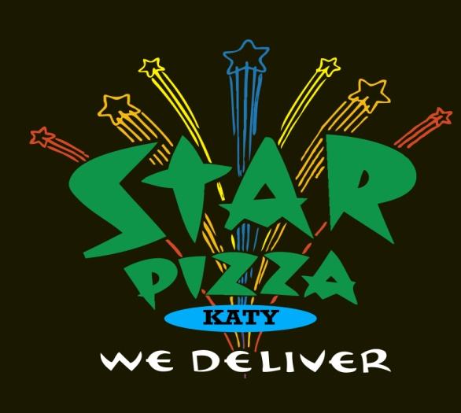
ORDER ONLINE @
www.starpizzacinco.com
Minimum purchase for delivery $15.00
Delivery Drivers Work For Tips. 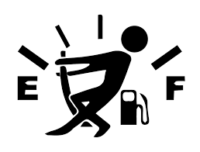

STAR PIZZA 3
24210 Westheimer Pkwy. Ste. 100
Katy, TX 77494
(281) 665-7768

Follow us on Facebook @starpizza3

We honor American Express - Visa - Mastercard - Discover.
NO CHECKS ACCEPTED
All of our pizzas are made to order, using only the finest, freshest ingredients: The pizza sauce is made from scratch with our own special blend of herbs and spices. The dough is made fresh every day, using only unbleached, untreated flour. Our pizzas take a little longer to prepare properly, so please be patient and you will be rewarded with the best pizza you have ever eaten.

OUR DELIVERY AREA:
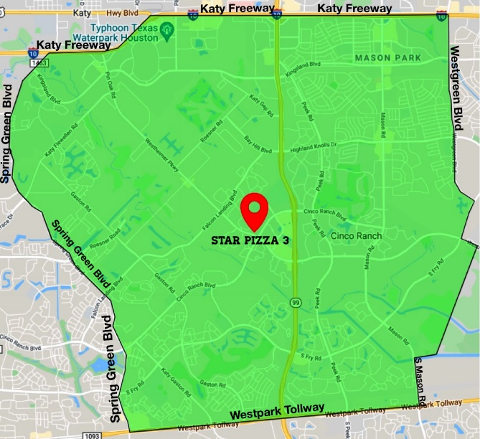

VISIT US ALSO AT:

STAR PIZZA 1
2111 NORFOLK ST
HOUSTON, TX. 77098

STAR PIZZA 2
77 HARVARD ST.
HOUSTON, TX. 77007

Oct 2022

TRY OUR SPECIALTY PIZZAS
All New York Style and Chicago Style Pizzas are available on White or Whole Wheat Crust
-No Substitutions-
Personal Personal New York Style Chicago Style
Size Gluten Free Hand Tossed Deep Dish
6" Chicago/8” New York 8” 12" 14” 16" 10” 12” 14”
Starburst………………………….8.75/9.75……………………….13.00………………..16.00 19.50 23.00……..17.00 21.00 25.00
pizza sauce, cheese, ground beef, italian sausage, pepperoni, onions, mushrooms and green peppers
Salsa Verde………………………8.75/9.75…………….……..…..13.00………………..16.00 19.50 23.00…..…17.00 21.00 25.00
spicy tomatillo sauce, cheese, topped with roasted poblano peppers, pan-fried garlic and feta cheese
Ben's…………………….………….8.75/9.75……………..…………13.00………………..16.00 19.50 23.00..….…17.00 21.00 25.00
pizza sauce, cheese, ground beef, italian sausage, pepperoni and ham
Marilyn's……………….…………8.75/9.75…………………….….13.00………………..16.00 19.50 23.00..….…17.00 21.00 25.00
pizza sauce, cheese, canadian bacon, pepperoni and onions
Veggie……………..……….………8.75/9.75……..…………………13.00………………..16.00 19.50 23.00………17.00 21.00 25.00
pizza sauce, cheese mushrooms, onions, green peppers, broccoli, cauliflower, zucchini and sprouts
Hank's…………………… .……....8.75/9.75……….…….…………13.00………………..16.00 19.50 23.00………17.00 21.00 25.00
pizza sauce, cheese, italian sausage, mushrooms, and black olives
Joe's…………………………………8.75/9.75……..…………………13.00………………..16.00 19.50 23.00………17.00 21.00 25.00
pizza sauce, cheese, sautéed spinach and fresh garlic
Margherita…………….…..….…8.75/9.75….……………………13.00……..…………16.00 19.50 23.00…..…..17.00 21.00 25.00
olive oil base, cheese, roma tomatoes, garlic, fresh basil and parmesan cheese
Chicken Alfredo……………….8.75/9.75……….………………13.00…………..……16.00 19.50 23.00………17.00 21.00 25.00
alfredo sauce base, cheese, chicken, gorgonzola, sautéed mushrooms, sautéed onions and fresh basil
Gorgonzola & Pesto…………8.75/9.75……..…………….…..13.00………………..16.00 19.50 23.00…..…..17.00 21.00 25.00
homemade pesto sauce base, crumbled gorgonzola and roma tomatoes
Portofino…………………………8.75/9.75………………………..13.00………………..16.00 19.50 23.00…..…..17.00 21.00 25.00
olive oil base, kalamata olives, feta cheese, artichoke hearts, red onions, roma tomatoes and fresh basil
Cheese………………………….….7.00/8.00…..……..……………...9.00………….…..….10.00 13.00 16.00………11.00 14.50 18.00
pizza sauce and cheese
Apple Cinnamon Pizza……..n/a/9.00…..…………….………10.00……..…………10.00 13.00 16.00…....……n/a n/a n/a
Caramel sauce base, seasoned apples in cinnamon, toasted walnuts and chocolate sauce topped with powdered sugar

ADD ROSEMARY & GARLIC GRILLED CHICKEN BREAST TO YOUR PIZZA
Personal & Gluten Free 2.00 Small 2.50 Medium 3.00 Large 3.50

Create your own Star Pizza! Additional ingredients are extra.
STEP 1: Start with your choice of size of our CHEESE pizza • STEP 2: pick your CRUST: WHITE OR WHOLE WHEAT, and then choose
NEW YORK or CHICAGO style • STEP 3: choose your INGREDIENTS from the list below • STEP 4: EAT and ENJOY!

ADDITIONAL INGREDIENTS FOR PIZZAS
Personal & Gluten Free 1.50 Small 2.00 Medium 2.50 Large 3.00
Alfalfa sprouts, alfredo sauce, anchovies, artichoke hearts, avocado, bacon, black olives, broccoli, BBQ sauce, Buffalo sauce, canadian bacon, carrots, cauliflower, extra cheese, extra pizza sauce, feta cheese, fresh basil, fresh garlic, fresh jalapeños, fresh mozzarella, fresh spinach, goat cheese, gorgonzola cheese, green peppers, green olives, ground beef, ham, italian sausage, kalamata olives, marinated jalapeños, meatballs, mushrooms, olive oil, onions, pepperoni, pesto sauce, pineapple, poblano peppers, potatoes, red onions, red peppers, ricotta cheese, roasted garlic, roasted red peppers,
roma tomatoes, salami, sautéed spinach in garlic, sun dried tomatoes, tomatillo sauce, zucchini.

PIZZA BY THE SLICE SANDWICHES
(1/6 of a Large 16" Pizza) Sandwiches are available on white or wheat hoagie
NEW YORK STYLE WHITE CRUST and comes with Dinner or Caesar Salad
Cheese……………………….…….……………..…..4.50 Chicken, avocado & bacon…….…10.25
Each Additional Topping…..……..…25 cents parsley garlic aioli with rosemary
(Up to 3 Toppings for Proper Bake) chicken, sliced avocado, bacon,
NY Joes Slice….……….…………..….…..……..…5.00 melted cheese.
NY Hanks Slice……….…..….….…………..….…5.00 Seth's Meatball………………………….9.50
NY Margherita Slice……………..…..…………5.00 hearty meatballs, sauced with our
NY Marilyns Slice…….….………..….……….…5.00 homemade marinara, topped with
Add Grilled Chicken to a slice………..….….….....1.75 melted cheese and fresh basil

SALADS
Served with Bread Sticks or by request with French Bread and your choice of any of our housemade dressings:
Blue Cheese, Honey Mustard, Ranch, House Italian, Balsamic Vinaigrette Drizzle or Roasted Red Pepper Vinaigrette
Small Medium Large
Dinner Salad………………………….…….…5.00…….…………..…………..……….7.25..………………………………………10.00
lettuce, roma tomatoes, carrots, cucumbers and homemade croutons
Caesar Salad…………………………….……..5.00……………………………………..7.25………………………………………..10.00
romaine lettuce, homemade croutons, parmesan cheese and kalamata olives tossed with our classic caesar
dressing
Spinach Salad……………………………….…6.25…………………………………….8.25………………………………….…….11.00
spinach, red onions, egg, bacon bits, roma tomatoes, mushrooms and cucumbers
Greek Salad……………………….….…………6.25…………………….……..…….….8.25….…………….…….…….…………..11.00
field greens, artichoke hearts, capers, feta, roma tomatoes, red onions and kalamata olives
Chelsea Salad……………………….…………..6.25….………..…….…….……………8.25…...………..…………....…………….11.00
mixed lettuces, crumbled gorgonzola, toasted walnuts and sun-dried tomatoes
Antipasto Salad…………..…………….……..6.25…………..…………..……………..8.25……………….………………….……11.00
lettuce, roma tomatoes, red onions, cucumbers, green peppers, black olives, mozzarella cheese, pepperoni and anchovies

Add additional ingredients for salads ……………………………… SM 1.00 MD 1.50 LG 2.00
Add Rosemary & Garlic Grilled Chicken to a salad………..……..3.00

PASTA ENTREES
All Pasta Dishes come with a Dinner Salad or Caesar Salad and
Bread Sticks, French Bread or Garlic Bread served upon request
Small Salad Medium Salad
Meat Lasagna ………………………………………………………………………………………14.75……………………16.50
layers of our homemade lasagna filled with ground beef, Italian sausage, ricotta cheese,
sautéed mushrooms and your choice of marinara, alfredo sauce or a mix of both
Chicken Cannelloni………………………….………………….…………….…………..……14.75……….……………16.50
homemade cannelloni, filled with rosemary garlic grilled chicken, our own blend of cheeses, spices & herbs,
spinach, mushrooms and your choice of marinara, alfredo sauce or a mix of both
Spaghetti…………………………………………………………………………………..…………13.50…………………….15.25
Spaghetti with Meatballs…………………………………………………………………….15.00…………………….16.75
Child Spaghetti (only pasta)……………………………………………………………………….………………….…….7.50
Child Spaghetti with Meatball (only pasta)…………………………...……………………..……………..……….9.00

