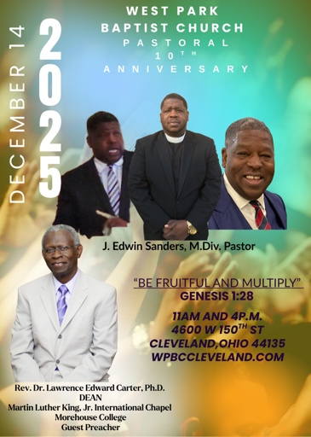

Donations For 10th Anniversary
So Far…..
$300 and Above$
Jason Lucas
$200 and Above$
Dennis C. Francis, Esq. Vincent Denson Rev. Jerome Hamilton Demetrius A. Green Sr. MD Calvin Johnson MD Eugene Felton, Esq.
$100 and Above$
John Monds Benjamin Skyles Meran Metters Jeff Goebel
Dr. Timothy Boddie
$50 and Above$
Eric Richardson Audrey Tidmore Emmanuel McGirt
$25 and Above$
Craig Barkley
$5 and Above$
Wil Bradford

