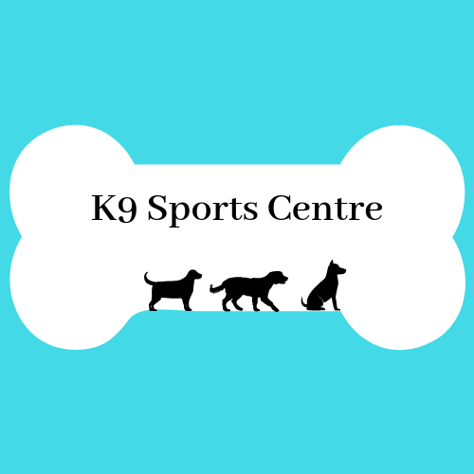
Waiver
I acknowledge that there is an element of risk in participating in any event at a dog training facility.
K9 Sports Centre, it’s owners, the building owners and their affiliates will not be held responsible for any loss, damages, injury or theft to myself, my pet(s) or any of my property.
I agree to be responsible for any cost incurred to the K9 Sports Centre for any property damages due to the actions of myself or my dog(s).
To the best of my knowledge, I certify that my dog(s) is in good health and of good temperament.
I agree to provide up to date vaccination records for my dog(s).

Dog name(s): ________________________ _______________________________

Owner name: _______________________

Owner signature: ____________________ Date: ___________________

