** Mendon Basketball Boosters**

**We are contacting you on behalf of the Pittsford Mendon Varsity Boys Basketball Team to ask that you consider advertising on our team calendar this year.**

**Your donations would support the following program items: purchase of warmups, training equipment, team awards, banquet costs and filming of varsity games. Our team calendar will be posted at many local businesses and we will also acknowledge your sponsorship at all varsity home games. (Each sponsor also receives a poster)**

**We recognize that you receive many requests for community sponsorship but hope you will consider sponsoring the Mendon Boys Basketball Team.** 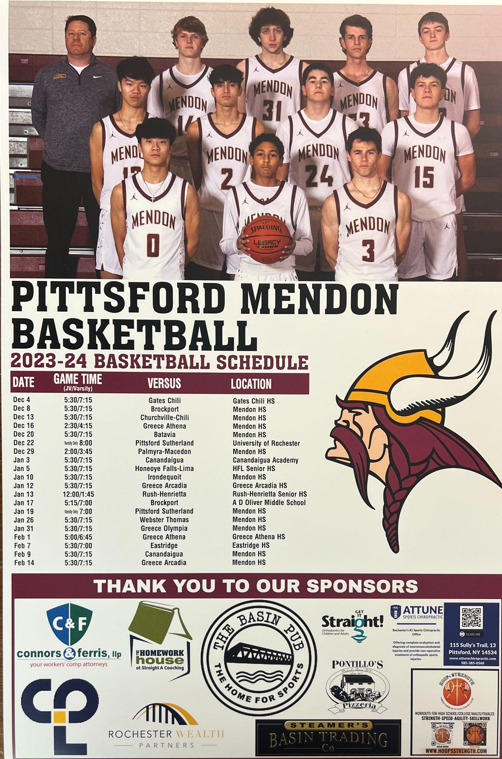

**If you are interested, please provide your information below and include either a business card or artwork to be displayed on the calendar.**

**Thank you in advance!**

**The boys really appreciate it! GO VIKINGS!!!**

**Mendon Basketball Booster Club**

**Contact for information:**

**Karen Shadders**

**karenshadders@gmail.com 585-330-5482**

**Becky Nally**

**Beckynally@gmail.com 585-746-9336**

**Emily Lewis**

**eghlewis@gmail.com 585-733-5950**

**PITTSFORD MENDON BASKETBALL BOOSTERS ADVERSTISEMENT**

Name of Sponsoring Company: _____________________________________________

Contact Person for Sponsoring Company: _____________________________________

Phone Number for Contact Person: ________________________

PLEASE EMAIL BUSINESS LOGO OR ARTWORK TO [Beckynally@gmail.com](mailto:Beckynally@gmail.com)

Checks in the amount of *$250.00* should be made out to *Pittsford Mendon Basketball Boosters* and can be mailed to Becky Nally, 8 Lands End Rise, Pittsford, NY 14534

**THANKS SO MUCH FOR YOUR SUPPORT!!**