Activity 4: Do it yourself!

*Hola, Soy Nicolas Montero, en esta oportunidad te voy a orientar en la ultima actividad de la experiencia 8.*

LEAD IN!

**Look at** pictures and write three verbs for their preparation. (Look at pictures and write three verbs for their preparation)

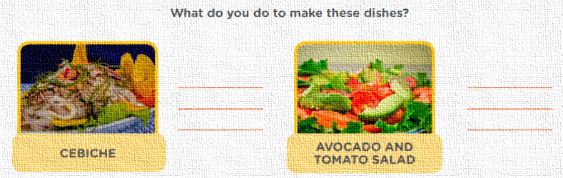

Los verbos son fáciles de usar en una receta, en el cebiche lo básico: LAVAR, CORTAR Y COCINAR, eso son los verbos.

CUT

PUT

MIX

WASH

CUT

COOK

LET’S CREATE!

TU RETO: Elabora una receta saludable de un plato para promover el cuidado de nuestra salud y una mejor condición física que podría ser publicada en Healthy Eating Research.

Step 1: Write the name of the dishes and select one.

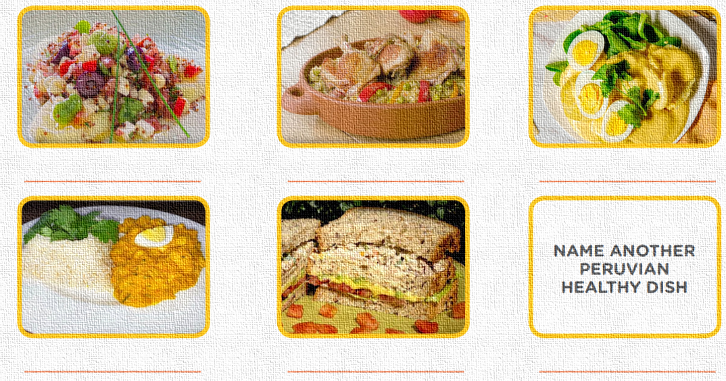

EXPLICACIÓN: Ehh , aquí colocamos los nombres de las comidas abajo, en la parte final debemos colocar otro plato peruano saludable, puede ser uno que se consume en tu comunidad o provincia.

POTATO AJIACO

HAMBURGER

CHICKPEAS SAUCE WITH CHICKEN AND VEGETABLES

CHICKEN CHILI

CHICKEN RICE

VEGETABLE SALAD

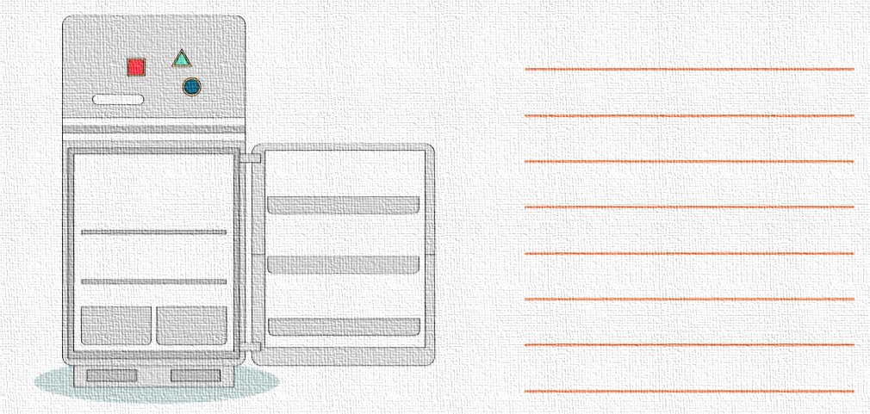Step 2: Look at the picture and choose the ingredients you need to make your dish.

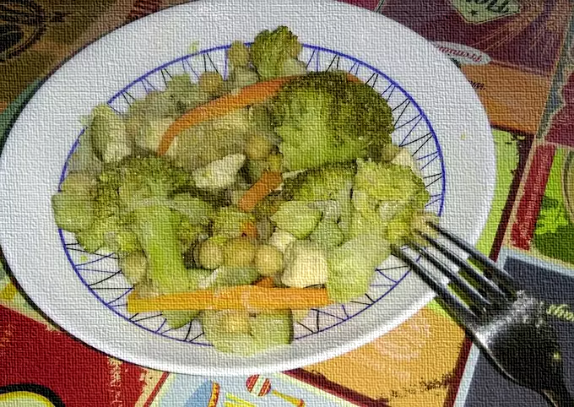

* 400 G OF COOKED CHICKPEAS
* 1 SMALL BROCCOLI
* 1/2 ZUCCHINI
* 1 CARROT
* 1 CHICKEN BREAST
* 1 ONION
* 1 CLOVE GARLIC
* OLIVE OIL
* WHITE PEPPER

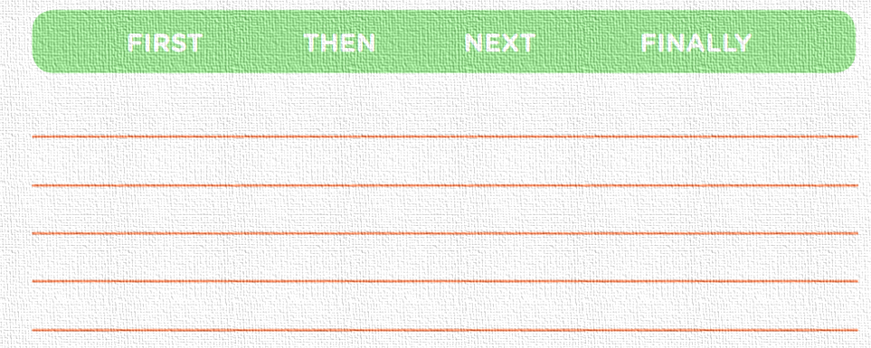Step 3: Write the sequence of your recipe. Use sequencers.

First, the chicken We cut it into cubes (without skin or bones) and put it to marinate with a minced garlic clove and a couple of tablespoons of oi. Then the carrot is cleaned, "peeled" and cut into sticks, the broccoli is separated into small trees and the zucchini is cleaned and diced with skin, in addition to the onion, we peel it and cut it into julienne. Next, in a frying pan we sauté the chicken until golden brown, we reserve it. Add the onion in the same pan, two minutes later the rest of the vegetables and sauté for another ten minutes, and Add the chicken and chickpeas and stir, mixing and sautéing at the same time for another ten minutes. finally, add the pepper to taste, and ready

Nuestro reto es hacer una receta saludable, en el paso 4 puedes realizar otra receta, pero sea creada por ti, bueno eso depende de cómo lo realice tu profe, te dejare 2 ejemplos de recetas, tu eliges cual mas te convenga para guiarte:’) (La segunda receta esta más god), emm tu receta debe contener: FIRST, THEN, NEXT,FINALLY. Solo eso porque son palabras que se deben usar en una receta, debes usar los conectores: AND y por ultimo debes usar verbos para la preparación.

Step 4: Make a creative recipe. (HAZ UNA RECETA CREATIVA)

CHICKPEAS SAUCE WITH CHICKEN AND VEGETABLES

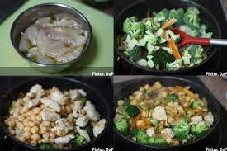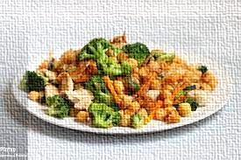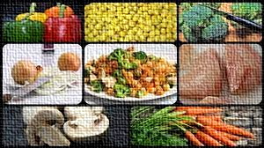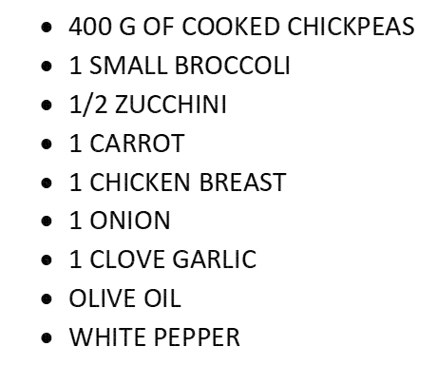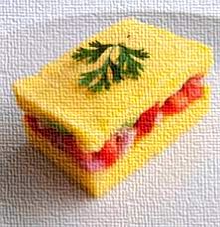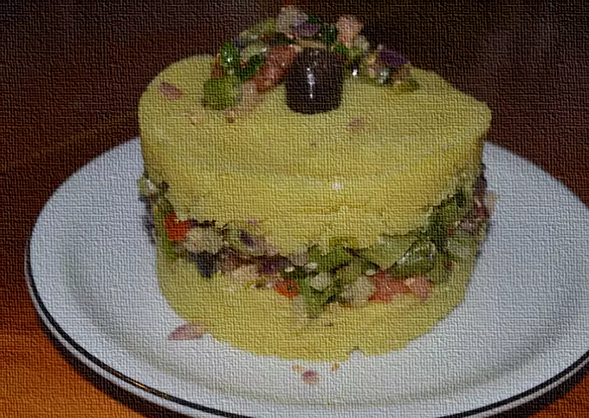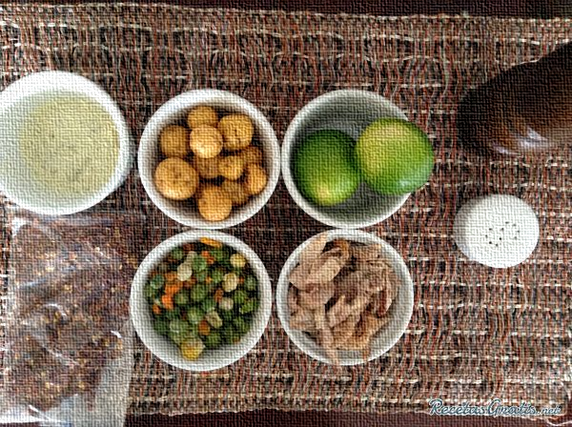

HEALTHY AND RICH!

4

3

FINALLY, add the pepper to taste, and ready

2

1

THEN, the carrot is cleaned, "peeled" and cut into sticks, the broccoli is separated into small trees and the zucchini is cleaned and diced with skin, in addition to the onion, we peel it and cut it into julienne.

NEXT, in a frying pan we sauté the chicken until golden brown, we reserve it. Add the onion in the same pan, two minutes later the rest of the vegetables and sauté for another ten minutes, and Add the chicken and chickpeas and stir, mixing and sautéing at the same time for another ten minutes.

FIRST, the chicken We cut it into cubes (without skin or bones) and put it to marinate with a minced garlic clove and a couple of tablespoons of oi.

HOW TO MAKE

INGREDIENTS

HEALTHY AND RICH!

2

3

4

1

FINALLY, Decorate with a black olive and half a tablespoon of filling, if you want to drizzle with a little olive oil, eat it at room temperature.

NEXT Raise the mold, and make a layer with the filling, pressing slightly, raise the mold a little more, and make a layer of puree.

Place a mold on a plate and fill it with the puree.

THEN Remove from the heat and add the tomato, olives, and small beans, season, add the tablespoons of seed mix, mix well and reserve.

In a frying pan, sauté the green onion, bell pepper and celery, finely chopped.

Make a puree adding a little olive oil, and reserve.

Strain, place in a bowl, add the lemon juice, pepper and salt.

FIRST Cut the sweet potato or sweet potato into small cubes, boil in plenty of water with a tablespoon of curry, until well cooked.

* kg sweet potato or sweet potato
* 1 lemon
* 1 red onion
* 1/2 green bell pepper
* 1 stick celery
* 1 green onion
* 8 black olives
* 1 tomato perita
* 100 gr fine boiled bean
* 2 tablespoons seed mix
* 1 tablespoon curry
* Pepper
* sea ​​salt

CAUSE OF VEGETABLES

k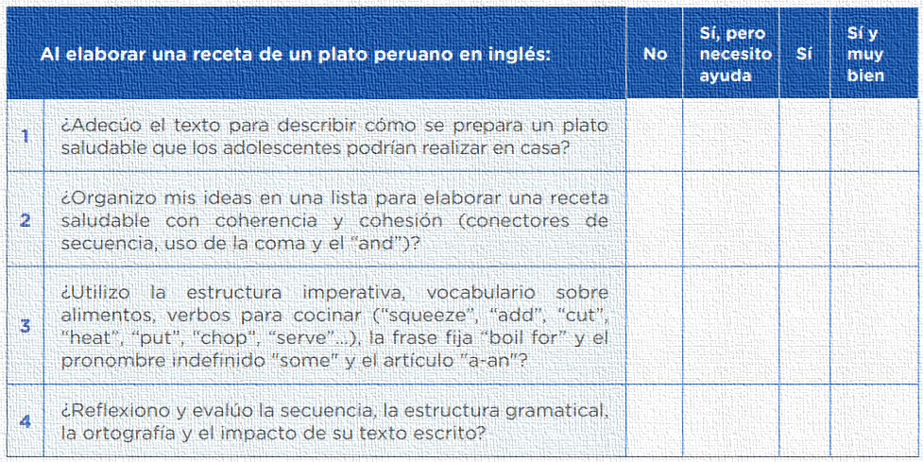

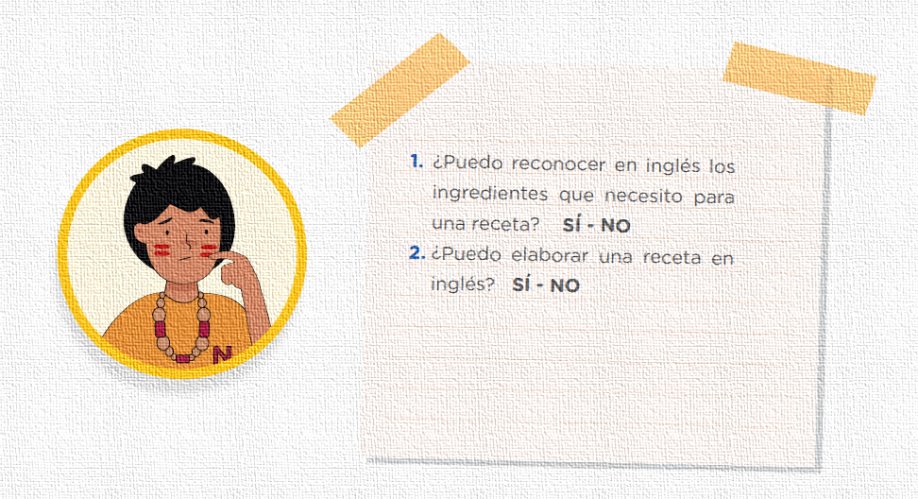

Eso seria todo por esta actividad, si gustas me puedes seguir en INSTAGRAM y CANAL DE YOUTUBE, también subo tareas resueltas para todos los grados de secundaria.

LINK DE MI INSTAGRAM:

<https://www.instagram.com/p/CU2-UPALhfA/?utm_source=ig_web_copy_link>

LINK DE MI CANAL DE YUTU**: (YA SUBI ACTIVIDAD 4- EXPERIENCIA 8. EPT- 5TO**

[**https://youtu.be/8YHGGeG8Vp4**](https://youtu.be/8YHGGeG8Vp4)

NICOLAS MONTERO