

Code of conduct: young archers

Responsible for review of policy | Responsible for review of procedures
Chief Executive | Head of Ethics and Integrity

Change History
Version | By | Date of approval | Next review date
OPP-06b-02cm | Board | February 2019 | January 2021

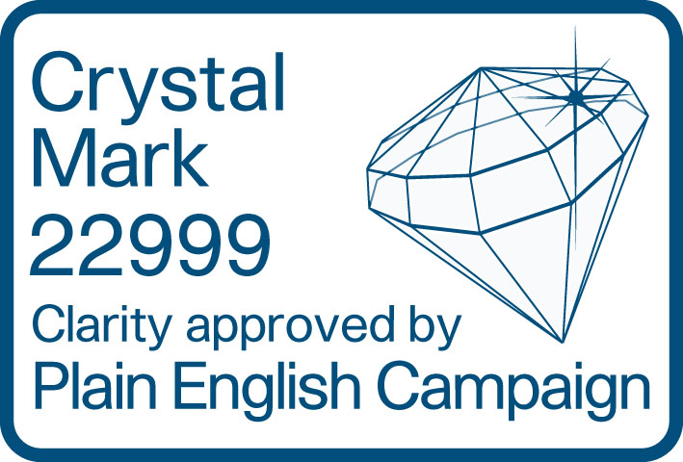

Young archers
This code of conduct applies to all our members under the age of 18 when they are taking part in or involved in the sport of archery. Other codes of conduct may also apply, for example for Archery GB team member agreements. In those circumstances, this code of conduct will also still apply.

To protect our reputation, the code also applies to those associated with Archery GB who are involved in archery while outside the UK.

Having fun, a positive attitude and good sportsmanship are the most important things for young archers.

Expected minimum standards of behaviour and conduct
As a young archer, I will do the following.
- Respect my sport
I will:
  - be on time and be polite;
  - try my hardest and do my best;
  - play fairly – I won’t cheat;
  - accept success and failure with dignity; and
  - respect archery facilities and equipment.
- Respect others
I will:
  - listen and respond to my coach;
  - respect the decisions of officials;
  - control my emotions – verbal or physical abuse is not acceptable;
  - never bully, spread rumours or tell lies (including on social media);
  - protect other archers from abuse and bullying;
  - welcome new young people; and
  - make sure I tell my coach or parents if I think another person needs helps.
- Have self-respect
I will:
  - take responsibility for my actions;
  - never smoke, vape, drink alcohol or take drugs (other than prescription drugs);
  - never use inappropriate language or gestures; and
  - tell someone I trust if the behaviour of others makes me feel uncomfortable.

Breaking the code of conduct
By joining Archery GB, you are agreeing to stick to this code of conduct and all of our policies, rules, regulations and procedures. If you break the code of conduct, we may tell your parents and we may investigate your behaviour and take disciplinary action.

If you feel someone is breaking this code of conduct at your club, you should report it to your club committee. If you feel someone is breaking this code of conduct at an event away from your club, you should report it to the event organiser.

Archery GB is the trading name of the Grand National Archery Society, a company limited by guarantee number 1342150 Registered in England.

