

Code of conduct: adult archers

Responsible for review of policy | Responsible for review of procedures
Chief Executive | Head of Ethics and Integrity

Change History
Version | By | Date of approval | Next review date
OPP-06a-02cm | Board | February 2019 | January 2021

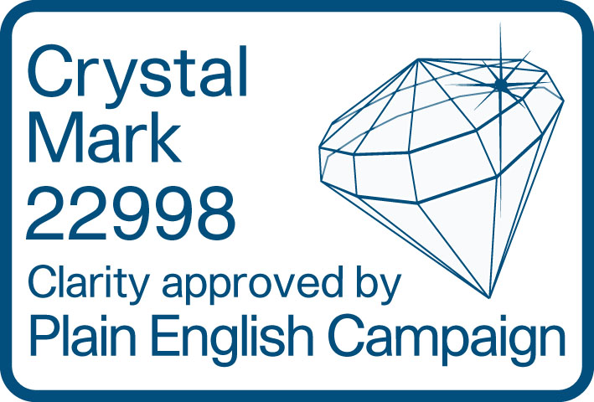

Adult archers
This code of conduct applies to all our members aged 18 and over when they are taking part in or involved in the sport of archery.

Other codes of conduct may also apply, for example for Archery GB team member agreements. In those circumstances, this code of conduct will also still apply.

To protect our reputation, the code also applies to those associated with Archery GB who are involved in archery while outside the UK.

We all have a responsibility to promote high standards of behaviour in archery.

As an archer, you have a big part to play. That is why we are asking every archer to follow a code of conduct.

Expected minimum standards of behaviour and conduct
As an adult archer, I will do the following.
- Respect the spirit of fair play in archery
I will:
  - keep to the rules of shooting and the spirit of archery;
  - display and promote high standards of behaviour;
  - promote fair play – I won’t cheat, complain or waste time;
  - do my best to make sure the sport is enjoyable for everyone;
  - accept success and failure with dignity;
  - be on time for training, competitions and events; and
  - never take part in or accept public criticism of fellow archers, coaches or officials.
- Respect the rights, dignity and worth of my fellow archers
I will:
  - speak to my fellow archers, coaches, judges and officials with respect;
  - remember that everyone makes mistakes;
  - always respect the confidentiality of other archers;
  - treat other people’s information in line with the requirements of the General Data Protection Regulation (GDPR); and
  - always have the best interests of my fellow archers at heart.
- Do my best to ensure my own safety and the safety of others
I will:
  - never take part in archery when under the influence of alcohol or drugs; and
  - place the well-being, safety and enjoyment of each archer above everything, including standards of performance.
- Protect others involved in archery from verbal or physical abuse and threatening or intimidating behaviour
I will:
  - never use or accept offensive, insulting or abusive language or behaviour;
  - never take part in or accept bullying, intimidation or harassment; and
  - never use or accept the use of social media to bully, intimidate or harass anyone.
- I will keep to your rules and policies including:
  - safeguarding policies
  - equality policy
  - anti-doping rules
  - bribery policy
- Take personal responsibility
I will:
  - tell you about any changes to my personal information.

Breaking the code of conduct
By joining Archery GB, you are agreeing to keep to this code of conduct, and all of our policies, rules, regulations and procedures.

We have the right to investigate and take disciplinary action (in line with our disciplinary policy, regulations and procedures) against any alleged break of this code of conduct or our policies, rules, regulations and procedures which may affect our reputation.

If you feel someone is breaking this code of conduct at your club, you should report it to your club committee. If you feel someone is breaking this code of conduct at an event away from your club, you should report it to the event organiser.

Archery GB is the trading name of the Grand National Archery Society, a company limited by guarantee number 1342150 Registered in England.

