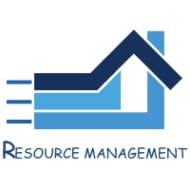
Resource Management, LLC
1101 Sheffield Ave, Dyer, IN 46311
219-865-2104 office 219-865-2148 fax

ACH AUTO PAY AUTHORIZATION FORM

First Name_______________ MI_______ Last Name________________

Address: ____________________________________________________

City: ________________________ State: ___ Zip: ____________________

Email Address: ________________________________

Home Phone: _________________________________

Cell Phone: ___________________________________

I hereby authorize Resource Management LLC, acting as the management company for Wildwood of Munster Condominium Association, to originate an electronic debit transaction to my bank account for HOA dues on a quarterly basis, January, April, July, and October. This transaction will be originated no earlier than the 5th of the month. This authority is to remain in full force and effect until Resource Management, LLC receives written notice of its termination. A fee of $40 will be charged if the ACH is returned.

Bank: _______________________

Routing# _________________________

Account# ____________________________

Type of account: _____checking ______savings

Signature________________________________

Date: ___________________ Date to Begin ACH: ________________________

PLEASE ATTACH A VOIDED CHECK TO THIS FORM

