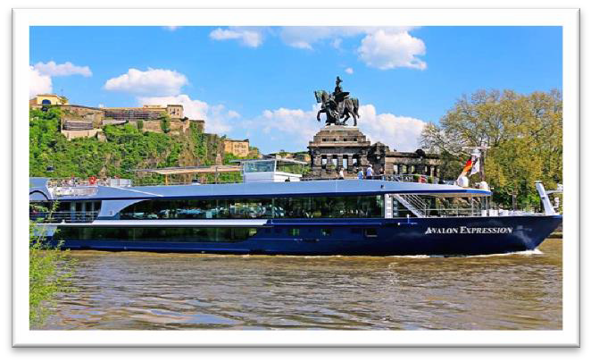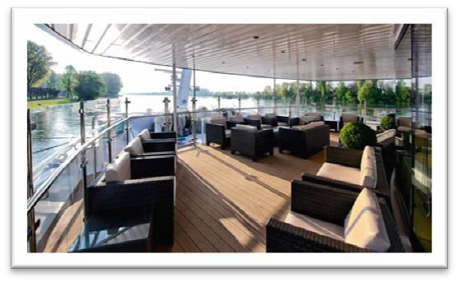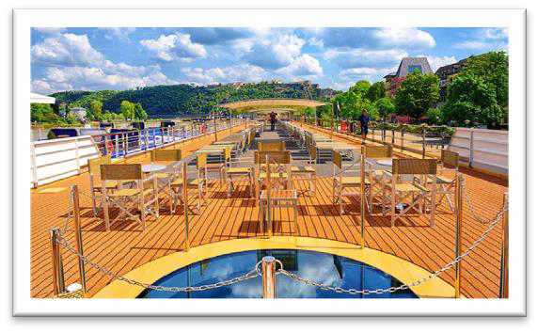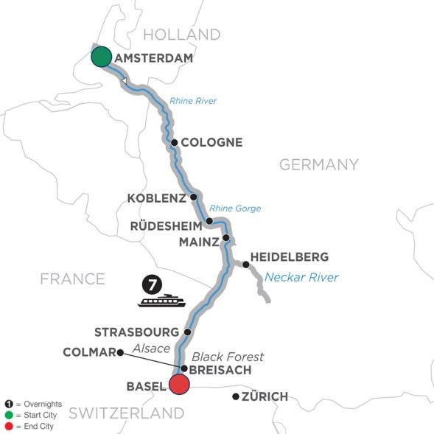
Beer and Wine included with lunch and dinner
Gratuities and Excursions included
(Air Not Included at this time)
Romantic Rhine
River Cruise
April 2 – 9, 2019
French Balcony Stateroom
Cat. “A” Fares….$3,930 pp
Cat. “P” Fares … $4,030 pp (Including taxes & fees, based on double occupancy)
∗ Deposit of only $250pp For more information or To Book, Call…
Pam Ryland
∗ Insurance of $349pp Pensacola Ski Club Trip Leader
Pre night in Amsterdam available Phone (850) 982-0960
for …. $132 pp pryland@bellsouth.net
(Hotel price based on double occupancy) Bunny Muter
Post Nights in Switzerland (954) 351-7070
available upon request Full Service Travel
Agent Mobile (727) 642-4188
Bmuter@CruisePlanners.com
Bmuter@CruisePlanners.com

