NORTHSTAR, Lake Tahoe, CA
Feb 1-8, 2025
Saturday to Saturday
NORTHSTAR Resort is somewhat northwest of Lake Tahoe which can be seen from select points on Mt. Pluto, the peak of the resort.

Cost
Full package (no lift)
Two bedroom condo
pp $2270
Ground only deduct $615

OPTIONAL
EPIC PASS Lift Ticket
Adult 5-day
Now $393, but going up
Single supplement $1210

Number of People
64

Lodging
The Village
Walk-in/Walk-out

Trip Leader
Susan Naile
1704 E Bobe Street
Pensacola, FL 32503
naile2464@gmail.com
(850)261-0300

Co Leader
Fitz Miller
1914 LodgepoleDr
Milton, FL 32583
fitzmiller@yahoo.com
(850)417-3821

Assistant Leader
Scott Hand
scotthand63@gmail.com
‭(850) 686-2496

The ski area is 3170 acres, 20 lifts, 350 inches snowfall/year, 100 trails, 13% Green, 60% Blue, 27% Black.

https://www.northstarcalifornia.com/

The Northstar Village has a small footprint because all the buildings are 4 or 5 stories tall with the upper levels being residential. The condos are all modern, well appointed/equipped, and many have balconies. We will be lodged in several buildings all very close together and all within a 3 minute walk to the main gondola, some literally across the pedestrian walkway from the gondola. All have an elevator, and ski lockers on the ground floor. Mostly we have 2 bedrooms, some 3 bedrooms, and one 4 bedroom. We have a one bedroom but it is much more expensive than the other choices. No “kiddie” rooms - the bedrooms with two twin beds are small, but sized for ADULTS! The number of single pillow beds is limited to 24 so get your trip apps in early if you do not want a bed-mate.
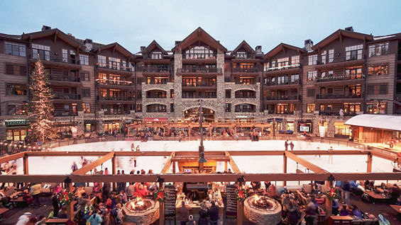

You will be sleeping at 6354 feet and the top of the mountain is 8616 feet, so minimal altitude issues.
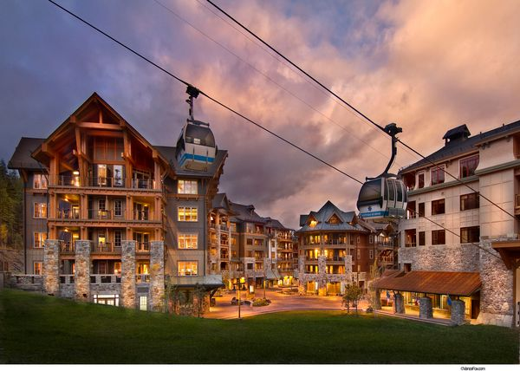

All of the mountain is below the tree line so lots of tree glades to ski and lots of really sweet blues and a few greens. They groom a lot, even some of the blacks.

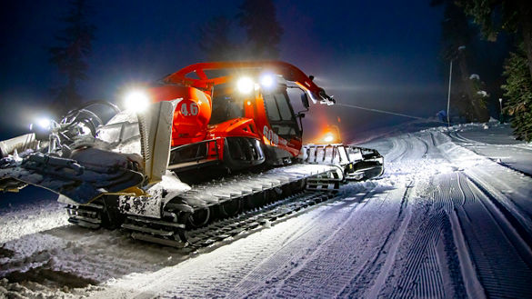

There will be portage upon arrival and departure.

Early signups will have some choice. This lodging list cannot be expanded.

PACKAGE INCLUDES:
- Round trip airfare Pensacola (PNS) to Reno, Nevada (RNO)
two legs connecting in Houston on United Airlines
- Round trip ground transportation
- Grocery/Liquor stop
- Arrival reception hosted by Resort
- 7 nights accommodations in Village
- Walk-in/Walk out – 5 minutes max to gondola
- Pre-trip party
- Apres ski
- Group dinner on the shore of Lake Tahoe
- Friday left-overs and Pizza Party
- Discounted rental options

OPTIONS:
EPIC PASS on your own, purchase through:
www.sportsamerica.com/epic-pensacola
Pick the tab: EPIC DAY LIMITED PASS - holidays excluded

What we know now is that a Northstar specific Epic Pass looks to be:

Adult 13+ Child 5-12
5-day $376 5-day $193
6-day $440 6-day $225
This is an EPIC PASS mountain so retired military and active duty military lift tickets will be $172 and those folks should make their purchase directly with EPIC PASS.
https://www.epicpass.com/pass-results/military.aspx

Note:
Your membership must be current the week of the trip.
Note that our membership year is now July 1 to June 30.
Make checks payable to:
PENSACOLA SKI & TRAVEL CLUB
(on memo line, add 2025 NORTHSTAR)
And mail to:

Susan Naile
1704 East Bobe St
Pensacola, FL 32503

Deposit with Trip App $500 per person
September 1 - $500 per person
October 1 - $500 per person
November 1 - $500 per person (skip if no air)
December 1 - remaining balance

Trip application
https://img1.wsimg.com/blobby/go/033a62b7-6f77-41de-b32f-d7c9c8eac796/downloads/Trip%20Application%20Fillable.pdf?ver=1710978030973

Membership Application
https://img1.wsimg.com/blobby/go/033a62b7-6f77-41de-b32f-d7c9c8eac796/downloads/PSTC%20Member%20Application%20updated.pdf?ver=1710978030973

