SNOWMASS, CO
JANUARY 26 – FEBRUARY 2, 2024
Friday to Friday

Cost
Full package
STANDARD $2600
DELUXE $2805
PREMEIR $2999
Ground only deduct $645

Number of People
60

Lodging
The Crestwood
Slope side

Trip Leader
Susan Naile
1704 E Bobe Street
Pensacola, FL 32503
nailes@bellsouth.net
(850)261-0300

Co Leader
Fitz Miller
1914 Lodgepole Dr
Milton, FL 32583
fitzmiller@yahoo.com
(850)417-3821

SNOWMASS is one of four mountains available to ski on one lift ticket: SNOWMASS 3300 acres, Buttermilk 435 acres, Aspen Highlands 1010 acres, Aspen 673 acres. All connected by a free bus system.

Our lodging is The Crestwood located slope side next to the Snowmass Base Village, the Village Express Lift, and the Elk Camp Gondola. There is a ski concierge for skis and boots. Out the lobby door is a heated Village Shuttle Bus stop. Note that The Crestwood has no elevators and is 3 stories high. There will be portage upon arrival and departure.
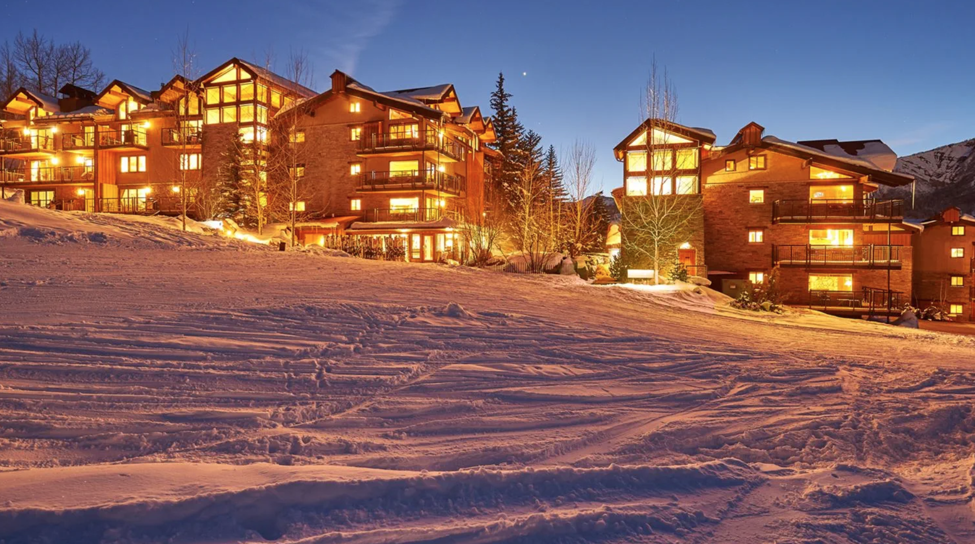
The Crestwood is offering three levels of condo units: Standard, Deluxe, and Premium. These are mostly 2 bedroom, two units of 2 bedroom plus loft, and 3 Premier 3 bedroom units. The differences can be studied here:

https://www.thecrestwood.com/snowmass-condos-rentals/unit-rating-categories/

Early signups will have some choice. This lodging list cannot be expanded.

PACKAGE INCLUDES:
- Round trip airfare Pensacola (PNS) to Eagle County Regional Airport (EGE)
- Round trip ground transportation
- Grocery/Liquor stop
- 7 nights accommodations slope side
- Pre-trip party
- Group dinner
- Apres ski
- End of week left-overs & pizza party
- Discounted rental options
- 5-day lift ticket (adjustable)

OPTIONS:
- Adjust lift ticket for days/child/senior
- IKON lift ticket
- Single supplement Standard $1090
- Single supplement Deluxe $1300
- Single supplement Premier $1490

Note:
Your membership must be current the week of the trip.
Note that our membership year is now July 1 to June 30.
Make checks payable to:
PENSACOLA SKI & TRAVEL CLUB
(on memo line, add 2024 SNOWMASS)
And mail to:

Susan Naile
1704 East Bobe St
Pensacola, FL 32503

Deposit with Trip App $600 per person
September 1 - $600 per person
October 1 - $600 per person
November 1 - $600 per person
December 1 - remaining balance

Link to trip and membership applications
https://pensacolaskiandtravelclub.com/membrshp%2Ftrip-application

