SNOWMASS, CO (FSC)
January 18 – January 25, 2025

Cost
Full package $2775
Double Occupancy

Land Only $2215
Double Occupancy

Single Supplement $1590
(if available)

Cost with Lift Tickets
See pricing on page 2

Number of People
30

Lodging
Woodrun Place and The Crestwood Resort

Trip Leader
Lynn Greene
Imagator82@gmail.com
(850)292-4360

Co Leader
Kim Walden
Kimcdw11@gmail.com
(850)450-2220

Refund Policy
Initial deposit less $50 is
refundable until 8/15/24

$100 penalty pp if cancelled by 9/1/24

$200 penalty pp if cancelled by 10/1/24

$500 penalty pp if cancelled by 11/1/24

No refund if cancelled after 11/1/2024.

SNOWMASS is one of four mountains available to ski on one lift ticket: SNOWMASS 3300 acres, Buttermilk 435 acres, Aspen Highlands 1010 acres, Aspen 673 acres. All connected by a free bus system.

Our primary lodging is at Woodrun Place, a ski-in/ski-out luxury condominium property located slope side just upslope from Snowmass Base Village. Fully equipped gourmet kitchens, spacious living rooms with fireplaces, in-unit laundry, and fully upgraded bathrooms including jetted tubs and/or steam showers provide all the comforts of home, while the outdoor heated pool and hot tub, on-site ski rental and repair shop, and on-site parking offer all the amenities of a resort. We have additional lodging at The Crestwood Resort which is located near Woodrun Place. This property is also located slope side.

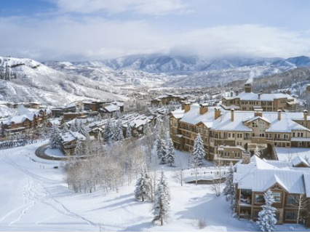

PACKAGE INCLUDES:
- Round trip airfare Pensacola (PNS) to Eagle County Regional Airport (EGE)
- Round trip ground transportation
- Grocery/Liquor stop
- 7 nights accommodations slope side
- Pre-trip party
- 2 FSC parties (1 dinner/1 après ski)
- Club Après ski
- Mountain Lunch (FSC)
- End of week left-overs & pizza party
- Discounted rental options
- 3, 4, 5 and 6 day lift ticket options

OPTIONS:
1. Trip insurance is recommended!
Go to: insuremytrip.com to find the policy that fits your needs.
2. Single Supplement (if available)
3. Florida Cup Race
4. Day Trip to Buttermilk Mountain
5. Breathtaker Alpine Coaster and Tubing Adventure

PRICING:
Full Package | $2,775
Land Only | $2,215
Lift Ticket Pricing | Full Plus Lift Ticket | Land Only Plus Lift Ticket
Buy 3 Ski 4 out of 10 days $441 | $3,216 | $2,656
Buy 4 Ski 5 out of 10 days $588 | $3,363 | $2,803
Buy 5, Ski 6 out of 10 days $735 | $3,510 | $2,950
4 day Senior (65+) $400 | $3,175 | $2,615
5 day Senior (65+) $500 | $3,275 | $2,715
6 day Senior (65+) $600 | $3,500 | $2,815
Single Supplement | additional $1590

Note:
Your membership must be current the week of the trip.
Note that our membership year is now July 1 to June 30.
Make checks payable to:
PENSACOLA SKI & TRAVEL CLUB
(on memo line, add 2025 SNOWMASS)

Mail payments to:

Lynn Greene
9817 Crestmont Circle
Pensacola, FL 32514

PAYMENT SCHEDULE:

Deposit with Trip App $500 per person
August 1 – 700 per person
September 1 - 700 per person
October 1 - $700 per person
November 1 - $700 per person
December 1 - remaining balance

Link to trip and membership applications
https://pensacolaskiandtravelclub.com/membrshp%2Ftrip-application

