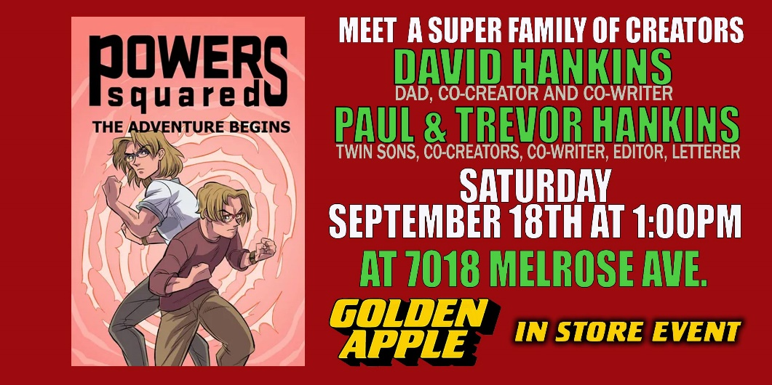
FOR IMMEDIATE RELEASE
POWERS SQUARED SIGNING AT GOLDEN APPLE COMICS RESCHEDULED
Los Angles (Sept 18). Persistence sometimes pays off. Last March, Powers Squared’s signing at Golden Apple Comics had to be cancelled due to COVID. “We were scheduled for March 14th and the world shut down on Friday the 13th,” said David Hankins, one of the co-creators of the book along with his twin sons, Paul and Trevor. “Like everyone else, our plans for 2020 were derailed.”
In the effort to get things back on track, a new signing has been schedule at Golden Apple for September 18th at 1 pm. The appearance is scheduled for two hours.
The signing will also come three days after the release on September 15th of Issue #12 of the series, “What’s in a Name?” Part 3. Powers Squared is a series about Marty and Eli Powers, twin brothers who discover they were granted super powers when they were young. “In this story arc, the brothers start to drift when they become involved in relationships,” says Paul. “At the same time, they become the targets of The Convincer, a villain who gets other people to do their dirty work.”
In addition to the most current issue, they will have copies of all the issues, as well as a special trading card that they’ve designed for the occasion. “The goal is to introduce ourselves to new people and get them as excited about Powers Squared as we are,” says Trevor.
Images of the cover and first pages for Issue 12 can be found here:
https://powerssquaredcomicbook.com/issue-%23-12
Information about the creative team can be found here:
https://powerssquaredcomicbook.com/creative-team
About Powers Squared
Powers Squared is based in the Lake Balboa area of Van Nuys. Created by Paul, Trevor and David Hankins, there are currently twelve ssues available. Written by David and Paul Hankins, the book is drawn by Rachel Wells and colored by Julia Canon, who replaced Nina Gaillard. Trevor handles the lettering. More information can be found on their website https://powerssquaredcomicbook.com.

