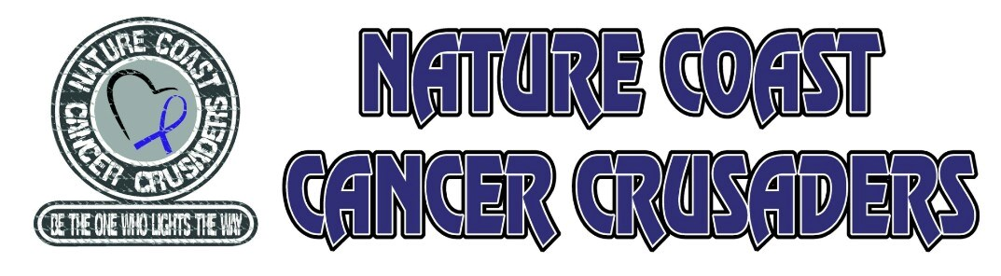”IT’S ALL ABOUT THE CAUSE” CANCER WALK MARCH 14, 2020 LECANTO HIGH SCHOOL 3:00 p.m. – 11:00 p.m.

SPONSORSHIP OPPORTUNITIES

$5,000 Event Sponsor
Speaker Opportunity during event
Business Name and Logo on Event Banner
Business Name and Logo banner at event entrance
Sponsor level mentioned in event program
Full page ad in event program
Business Name and Logo on all print advertising
Business Name recognition on Social Media advertising
Company items included in Survivor Goodie bags
18 X 24 Path Marker Sign with Logo
Business Name on Thank-You Board
Tent Space at Event

$2,500 Stage Sponsor
Business Name and Logo on banner on stage
Business Name and Logo on all print advertising
Sponsor level mentioned in event program
Half page ad in event program
Business Name recognition on Social Media advertising
18 X 24 Path Marker Sign with Logo
Business Name on Thank-You Board
Tent Space at Event

$1,000 Survivor Dinner Sponsor
Business Name and Logo on banner in Survivor Tent
Business Name and Logo on all print advertising
Sponsor level mentioned in event program
Half page ad in event program
Business Name recognition on Social Media advertising
Tent Space at Event
18 X 24 Path Marker Sign with Logo
Business Name on Thank-You Board
Tent Space at Event

$500 Crusader Sponsor
18 X 24 Path Marker Sign with Logo
Thank you in event program
Business Name on Thank-You Board
Tent Space at Event

$100 PATH MARKER LEVEL
18 X 24 Path Marker Sign with Logo
Thank you in event program

Name:____________________________________
Company:__________________________________
Address:___________________________________
City:_______________ Phone:__________________

Please make checks payable to: Nature Coast Cancer Crusaders

