For Immediate Release / (DATE)
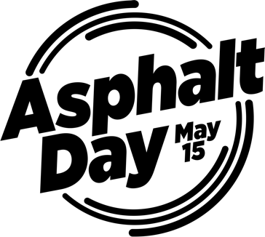
Media Release

From Roads to Rooftops, Asphalt Day Spotlights Essential Industry

(ADD COMPANY) is celebrating Asphalt Day on May 15, to increase awareness of the versatility of asphalt roofing and paving products while demonstrating the resiliency and growing sustainability of asphalt.

“Asphalt is part of everyday life – from the roads we drive to the roofs over our heads,” said Asphalt Institute President Reed Ryan. “Asphalt Day is about recognizing the people, innovation and impact behind it.”
Beyond its everyday use, asphalt plays a key role in building durable, sustainable communities. Asphalt payments can be quickly repaired after extreme weather events, helping restore mobility when it matters most. Asphalt is the most recycled material (by weight) in the United States, supporting a circular economy and reducing environmental impact.
Studies show 94 percent of all U.S. roads are paved with asphalt and 80 percent of U.S. residential roofs are covered with asphalt roofing shingles.
“Quote from (ADD COMPANY) leader.” Add two or three sentences about the details of (ADD COMPANY) specific plans for honoring or celebrating Asphalt Day in 2026.

Learn more about the May 15 celebrations at asphaltday.com and
nationaltoday.com/asphalt-day/.

###

Contact information (ADD COMPANY)
Name, Title
Email, Phone Number

