Sec. 28-320. Planned Industrial Development (PID).
Planned Industrial Development (PID)
(a) Purpose
The Planned Industrial Development (PID) district is created to provide for areas of large scale, high technology and other clean light industry in an attractive parklike atmosphere. It is further intended that this district be utilized to promote industrial activity, more efficient and economical industrial land use, harmony in physical design and industrial relationships, variety and amenity in industrial development and the protection of adjacent and nearby existing and future nonindustrial uses and activities. Planned industrial development districts will encourage originality, flexibility and innovation in site planning and development including architecture, landscaping, and graphic design. This district is intended to develop within those areas identified as Planned Industrial Park on the Comprehensive Plan Future Land Use Map. Developments within the PID zoning district shall also meet the regulations established in Chapter 33, Article II.
(b) Use Standards |  | Typical Lot Pattern
See Chapter 28 Article IV and Article V |  | 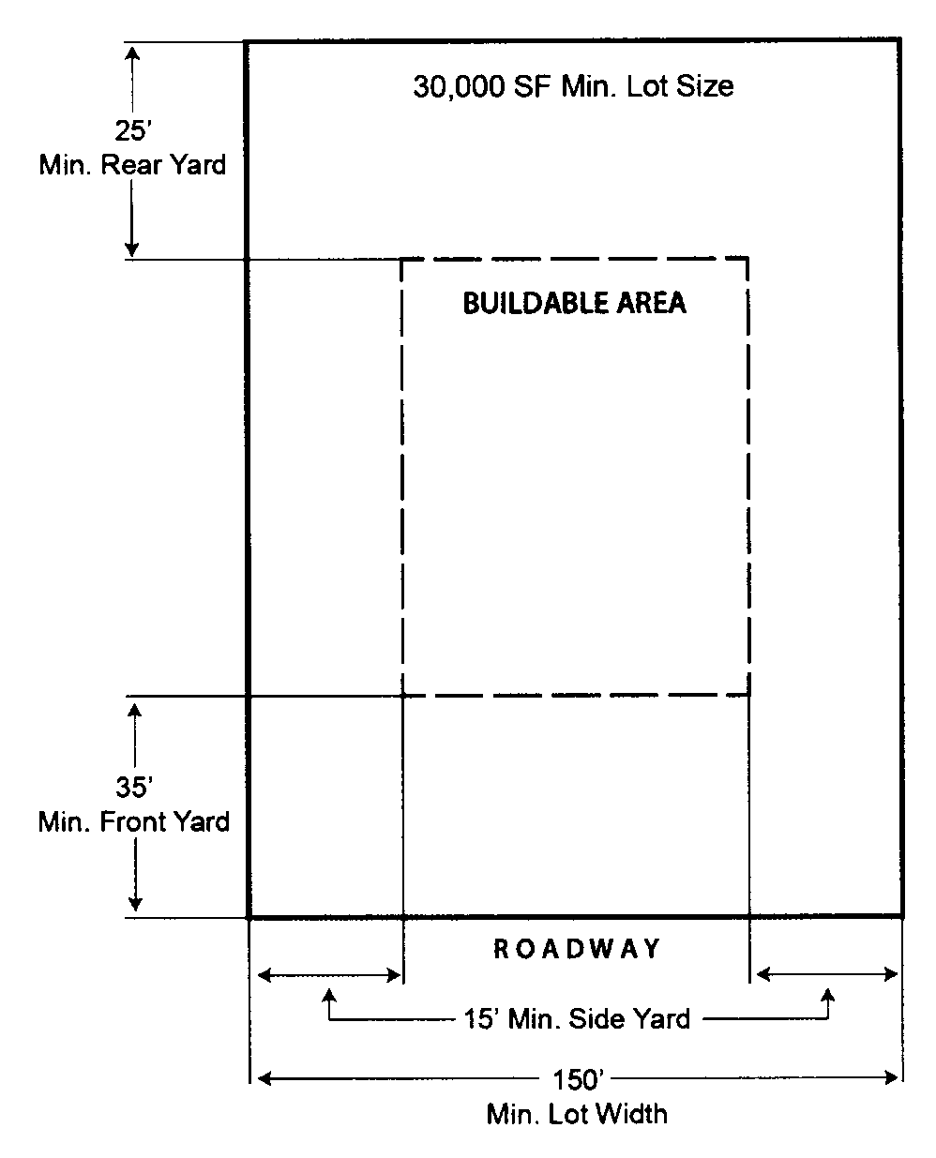
(c) Intensity and Dimensional Standards
Lot area, minimum (sq. ft.) | 30,000
Lot width, minimum (ft.) | 150
Density, maximum (du/ac) | NA
Floor area per dwelling unit, minimum (sq. ft.) | NA
Building coverage, maximum (% of lot area) | NA
Lot coverage, maximum (% of lot area) | None
Height, maximum (ft.) | 50¹
Front yard setback, minimum (ft.) | 35²
Side corner yard setback, minimum (ft.) | 35²
Interior side yard setback, minimum (ft.) | 15²
Rear yard setback, minimum (ft.) | 25²
Accessory Use Development Standards | See Chapter 28 Article VII
NOTES:
¹ Any structure which exceeds fifty (50) feet in height shall provide one (1) additional foot of setback in all required setbacks for each foot above fifty (50) feet.
² No portion of any building or structure and no activity related to any use within the PID shall be located any closer than one hundred (100) feet to any property which is utilized, zoned or which has a future land use designation for residential.
Typical Development Configuration (For illustrative purposes only)
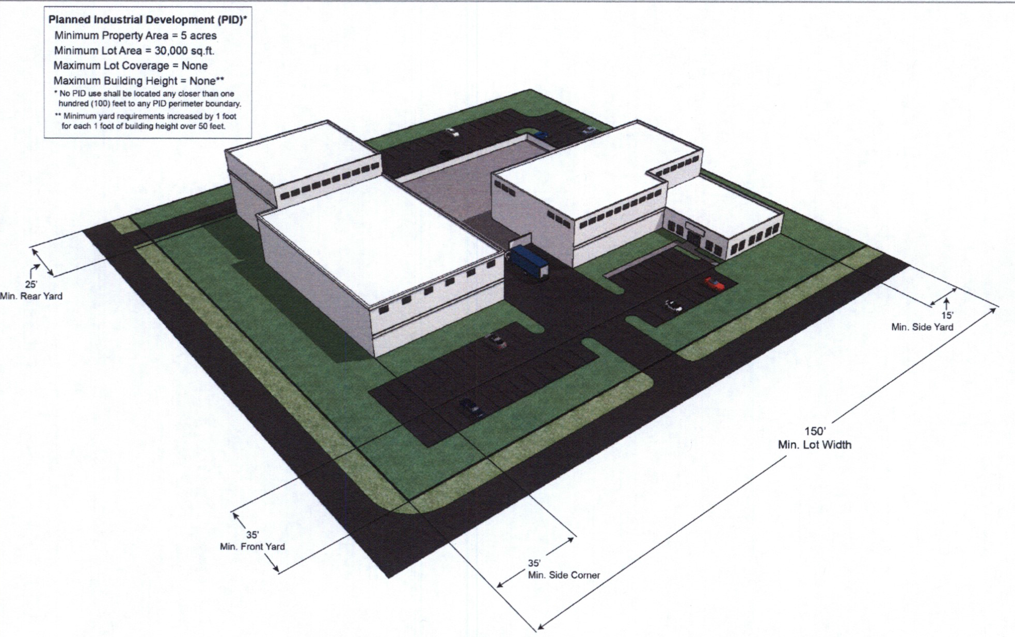

(Ord. No. 14-2019, § 1, 5-14-19)

