Mini Quilt Workshop Feb 2020

Before workshop make 48 Half square triangle units by your preferred method. These should measure 1 ½” unfinished or make them a bit larger (1 ¾” unfinished) for better accuracy. We will be trimming all squares in the workshop. Background & border fabric scraps large enough for quilt size. Backing fabric & flannel approx 11” X 13”

Finished size of Mini is approx 9 ½” X 11½ ”
Helpful Tools to Have :
• straight stitch plate for your sewing machine • stiletto, chopstick, or other purple thang-style tool to help feed tiny pieces through • seam ripper •small square ruler with a 45degree angle line • small cutting mat• scissors: a small pair for trimming threads, and a pair suitable for cutting fabric.
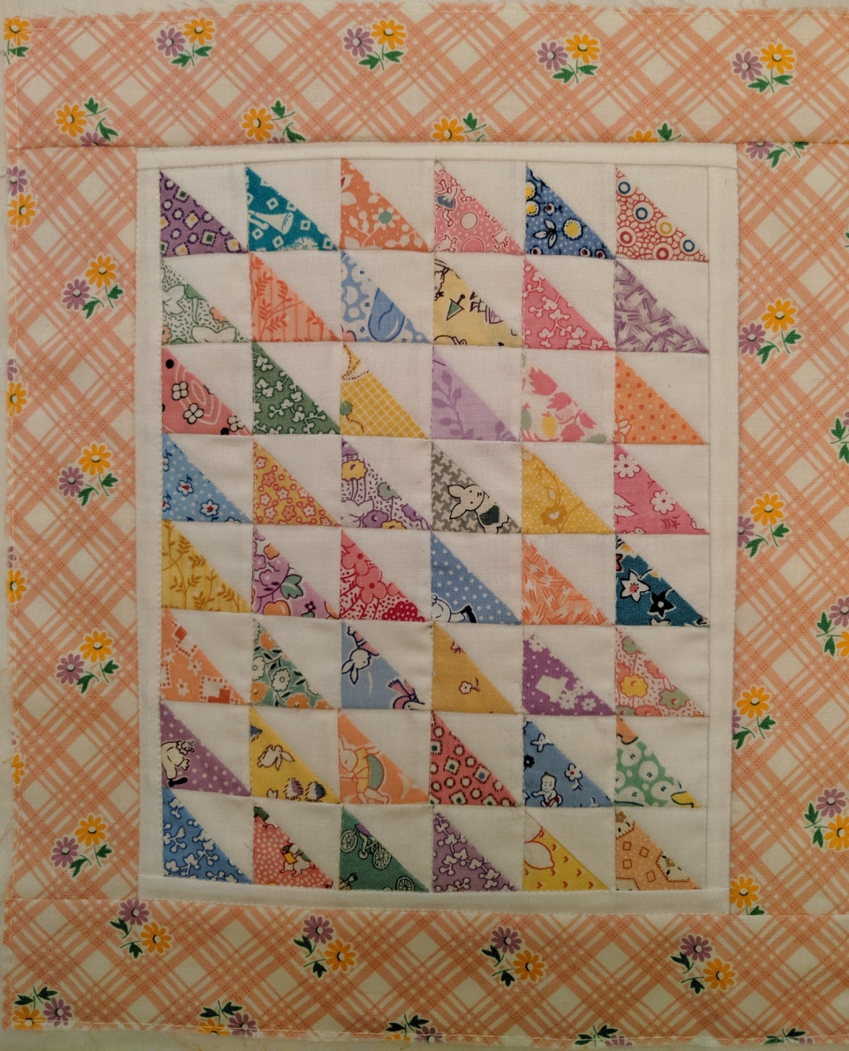

Alternate layouts:
