Corporate Donations
&
Sponsorships

A life worth living, worth saving.
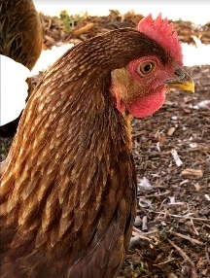
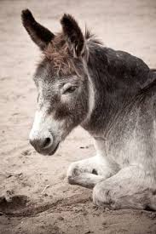
401 J A Rogers Road
Kittrell, NC 27544
919.607.4829
984.500.6463
www.freedomranchnc.org
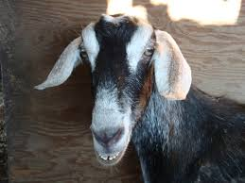
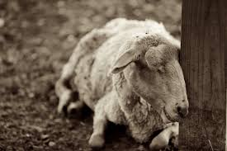
freedomranchnc@gmail.com

Who We Are
Freedom Ranch is more than an Animal Sanctuary
Freedom Ranch is a recognized 501(c)(3) charitable organization in Kittrell, NC on 80 acres. We are a volunteer-based organization and have no paid positions – 100% of the donations we receive are directed toward maintaining operations/grounds and providing for our animal residents. Freedom Ranch offers a safe, loving environment for permanent or temporary farm animal residents who will be matched with forever, loving homes. Our goal is to provide Freedom Ranch residents with the love and care they deserve. Animals and humans have a synergistic relationship that heals and makes both whole – we recognize the importance that animals have in our lives and also aim to help families who need resources to maintain safe and loving homes for their beloved animal companions.
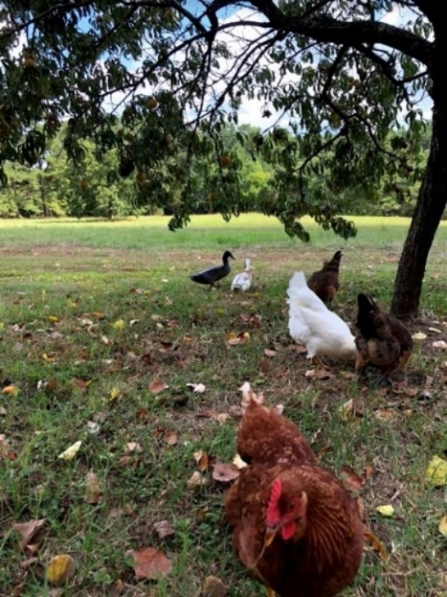
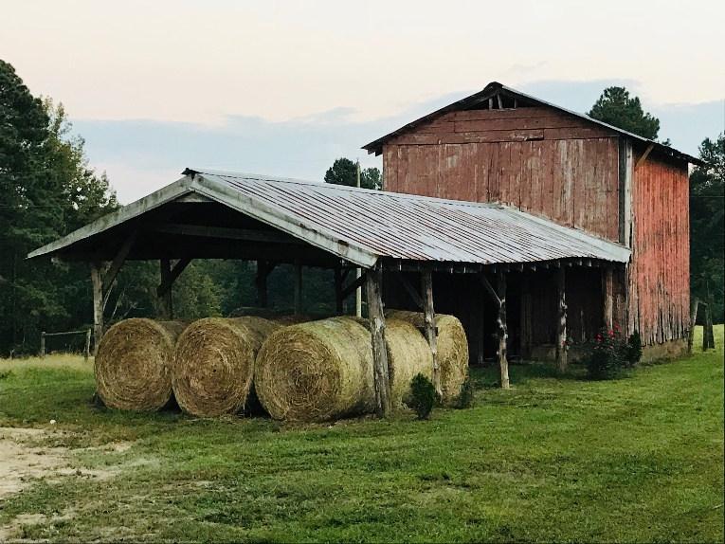

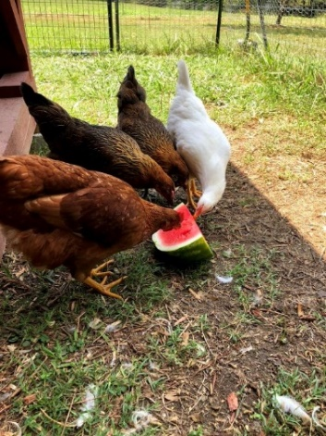
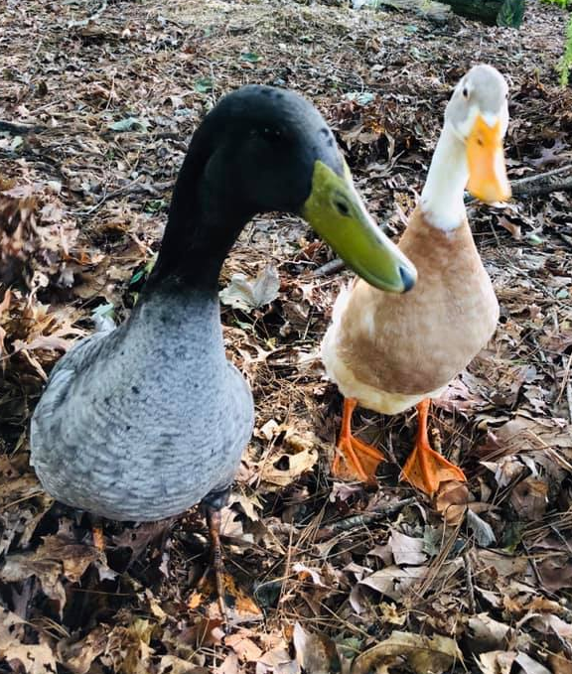
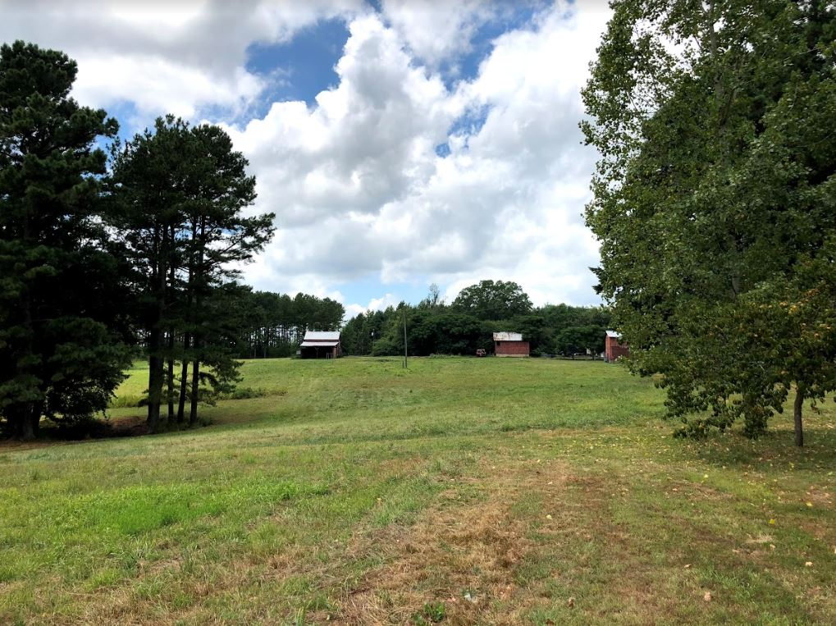
Fact Sheet
Freedom Ranch is more than an Animal Sanctuary
Our Mission
- Save Animals! Provide care for animals, be a resource for animals in need
- Provide safe, loving homes for animal residents
- Educate communities on animal welfare, care, and the importance of animal companionship
- Connect families with resources to maintain safe and loving homes for their animal companions
- Work with socially-good and other nonprofit organizations to promote safe and loving environments for ALL

Why
Millions of unwanted animals are sent to shelters, abandoned, and unnecessarily euthanized every year in this country. Many reasons families are unable to keep their animal companions include animal behavioral issues, housing restrictions, economic situations, and health changes that restrict families to care for their animal companion. There are many dog and cat rescues that help address this problem, but we typically don’t see many rescues and sanctuaries that serve Farm Animals.

Freedom Ranch acknowledges that animals and humans have a synergistic relationship and that the animal-human bond may improve the overall health and wellbeing for both. Freedom Ranch not only recognizes the importance of protecting animals from abuse and neglect but also acknowledges that no deserving human should be denied the opportunity to share a bond with an animal companion.
How
- Support from local and national organizations, including grants
- Educate our community on animal companionship and proper animal care
- Collaborate and partner with other socially good organizations and nonprofits
- Provide resources for qualified families to allow their beloved animal companions to live in safe, loving environments
How Can Your Organization Make a Difference?
Donations & Other Ways to Contribute

Freedom Ranch is currently accepting funds and donations for building and fence repairs/maintenance, animal transport, feed for animals, money for veterinarian services, and miscellaneous supplies needed to care for and provide safe homes and loving homes for our animal residents.

With your contribution, you can help us save animals!
Ways to give
Freedom Ranch website (PayPal)
freedomranchnc.org
Fees are 2.2%+$0.30 per donation*
Corporate Sponsorship (See Corporate Sponsorship page)
Check - Freedom Ranch Receives 100% of your donation
Credit Card – Fees are 2.6%+$0.10 per donation* (Square)
*All fees are paid directly from your contribution by Freedom Ranch

Other ways to contribute
Donations & Other In Kind Contributions
- Fencing and building supplies
- Feeding and watering supplies
- Accounting and legal services
- Administrative and public relations expertise
- Skilled carpenter, electrician, plumber, and other tradespeople
Volunteer
  - Is your organization looking for team building activities?
  - Are you a skilled tradesperson or experienced with animals?
  - Do you want to find ways your organization can give back?

Freedom Ranch
Corporate Sponsorship Levels
With your help, we can help animals in need.

Friend $250
Sponsor Recognition on the Freedom Ranch Website
Sponsor Recognition in the Annual Report to Members

Advocate $500
Sponsor Recognition on the Freedom Ranch Website
Sponsor Recognition in the Annual Report to Members
Business Name listed on 2019 Freedom Ranch Promotional Shirts

Bronze $1000
Sponsor Recognition on the Freedom Ranch Website
Sponsor Recognition in the Annual Report to Members
Business Name listed on 2019 Freedom Ranch Promotional Shirts

Silver $2000
Sponsor Recognition on the Freedom Ranch Website
Sponsor Recognition in the Annual Report to Members
Business Name listed on 2019 Freedom Ranch Promotional Shirts

Gold $5000 or more
Sponsor Recognition on the Freedom Ranch Website
Sponsor Recognition in the Annual Report to Members
Business Name listed on 2019 Freedom Ranch Promotional Shirts
Business Recognition Award – Building Dedication & Plaque

Freedom Ranch
2019 Corporate Sponsorship

Date ____/____/________
Business Name ________________________________________________________________
Street Address __________________________________________________________________
City/State/Zip __________________________________________________________________
Mailing Address ________________________________________________________________ City/State/Zip __________________________________________________________________
Contact _______________________ Contact email______________________________
Contact Title _______________________ Phone ____________________________________
Website __________________________________________________________________

Sponsorship
Please indicate which level of sponsorship your organization will contribute:

- Friend $250
- Advocate $500
- Bronze $1000
- Silver $2000
- Gold $5000 or more

Payment method:
- Check
- Other (please contact us at 919.607.4829 or freedomranchnc@gmail.com)

Please make checks payable to Freedom Ranch
Mail check donations with this form to
Freedom Ranch
c/o Emily Gail Currin
401 J. A. Rogers Road
Kittrell, NC 27544

Questions?
Please contact us at 919.607.4829 or email us at freedomranchnc@gmail.com

