Working with other Contractors Policy
Calforth Construction Ltd will be referred to as ‘The Company’ throughout this policy.
The Company recognises that is will be at times, required t work along side other Contractors while carrying out our work. With this in mind the Company will:
- Will forge a working relationship with other contractors.
- Discuss our work scope and discuss potential clashes of work with other contractors.
- Work in a professional manner to rectify any disputes between us, the Company, and other Contractors on site.
- Maintain a high level of health and safety at all times for our own staff, but also be aware of the safety of other contractors on site.
- We will attend site meetings as and when required and discuss with other contractors, in a professional manner, any issues.
- Raise any health and safety or quality issues with other Contractors in a professional manner at all times.
- We will respect and follow site rules at all times.

Signed on Behalf of: | Calforth Construction Ltd
Name (Print): | Steven Callander
Position: | Director
Signature: | 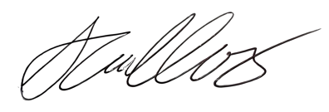
Date: | 28 Oct 2024

