Drugs and Alcohol
Calforth Construction Ltd recognises its statutory duty to comply with all relevant legislation and the resulting duties and obligations.
The Company prohibits the sale, medically unauthorised possession or use of illicit drugs on Company premises, or in the course of employment. This is not only because such activities are unlawful, but also because they may adversely affect the safety, health and welfare and seriously impair the value of our people.
- Anyone who is, at any time, found selling or distributing drugs, on or off Company premises, shall be deemed to have breached their terms and conditions of employment, and such actions may result in summary dismissal on the grounds of Gross Misconduct. Where the evidence so warrants, the Company will advise M2 Safety Consultants Limited, and inform the police where necessary.
- We are committed to preventing our people attending work whilst under the influence of drugs or alcohol. Contravention of this is likely to result in disciplinary action.
- The Company response to drug or alcohol problems will be consistent but also tailored to individuals and their circumstances. Full support will be given.
- The confidential nature of any records of employees with drug abuse problems will be strictly preserved, and attempts made by external sources to be allowed access to these records will be referred to our Safety Advisers and their advice followed.
In general, The Company will provide:
- Appropriate drugs and alcohol information to staff.
- Regular supervision and support for all our people.
This policy will be subject to regular review, and further development as necessary.
Signed on Behalf of: | Calforth Construction Ltd
Name (Print): | Fraser MorrisonFraser Morrison CMIOSH
Position: | Director
Signature: | 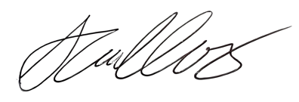
Date: | 28 Oct 2024

