Environmental Policy Statement
Calforth Construction Ltd will keep itself informed of all legislation, regulations and Codes of Practice on environmental matters that are relevant to its operations; make best endeavours to ensure that its personnel are aware of and adequately instructed in the requirements of this legislation etc.; and take all other reasonable actions to ensure compliance.
Whilst construction is in progress, the Company will take all reasonable precautions that are consistent with its clients; instructions, against environmental damage, disruption or nuisance on or adjoining its sites. It will at all times endeavour to keep its sites clean and tidy, and also any adjoining areas that may be affected by traffic to and from those sites, and to avoid pollution of the air, ground or water by noise, fumes, dust or the disposal of construction materials.
The Company will, wherever viable and consistent with its clients’ instructions, use materials and products from sustainable sources and that are re-useable or recyclable.
The Company will make every effort to conserve the use of materials and of energy and, where viable and consistent with its clients’ instructions, collect waste materials for re-cycling.
The Company will appoint a Director/Senior Manager to supervise the implementation and further development of its environmental policy.
The Company will prepare instructions for the implementation of its environmental policy on individual sites and will for each site nominate a competent person to supervise compliance with these instructions.
Any environmental problems encountered in carrying out the works according to the client’s instructions will be brought to the attention of the client, and of any competent authority, with a view to finding a satisfactory solution.
Signed on Behalf of: | Calforth Construction Ltd
Name (Print): | Steven Callander
Position: | Director
Signature: | 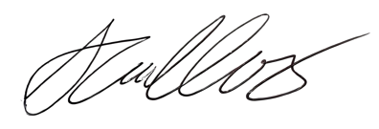
Date: | 28 Oct 2024

