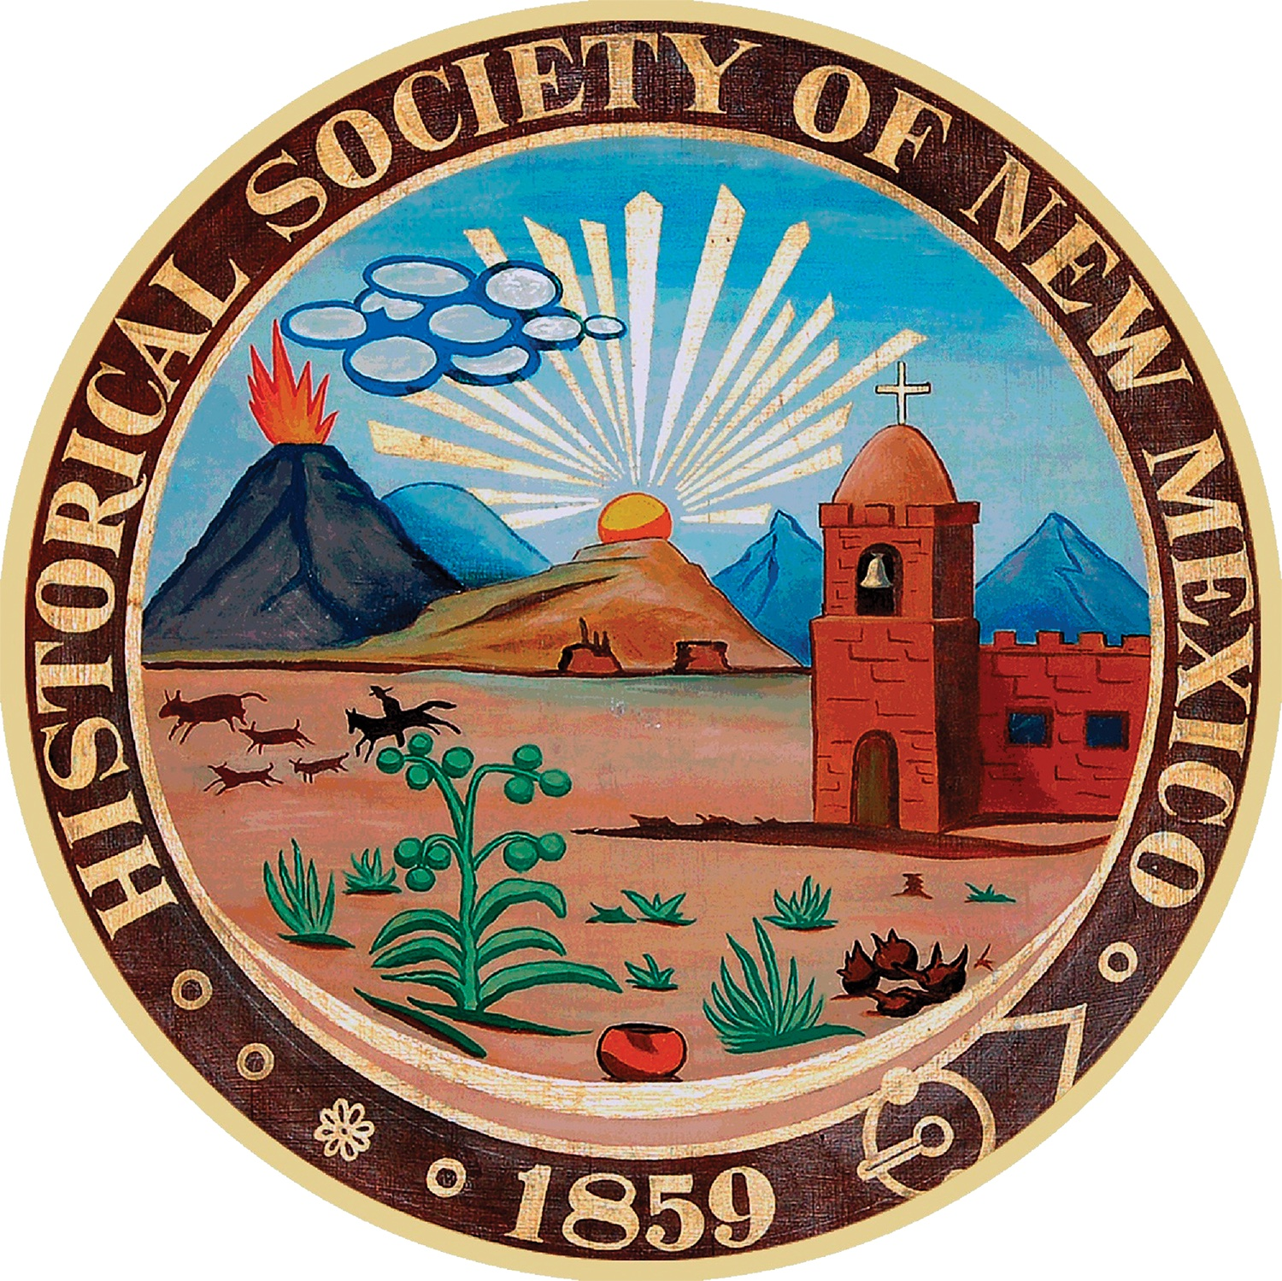

**Call for Presentations**

2025 Joint New Mexico-Arizona History Conference

The Historical Society of New Mexico invites proposals for presentations for the **rescheduled** 2025 New Mexico History Conference, **to be held in Las Cruces, September 25-27** in partnership with the Doña Ana County Historical Society. Given the change of venue, HSNM is also pleased to welcome a collaboration with the Arizona History Convention in hosting the conference.

**The deadline for proposal submissions has been extended to FRIDAY, APRIL 4, 2025.** Proposals on any aspect of New Mexico, Southwest, or Borderlands history and culture are welcome. Topics of particular interest include Native American and other ethnic groups, communities, mining, military, ranching, trails, women's history, border relations, architecture and preservation, cultural traditions, colorful or influential historical figures, and work of local historical organizations. Proposals related to Las Cruces-area history are especially encouraged.

Conference sessions are 90 minutes in length. Sessions will consist of two or three individual presentations delivered orally, each approximately 20-25 minutes, allowing time for a moderator's introduction and audience questions. The Program Committee will match proposals for individual presentations with similar topics to constitute a full session.

**Proposals for topical sessions occupying a full 90-minute period are especially encouraged.**

All presenters must register as conference participants. Each session room will be equipped with laptop, digital projector, and screen. Presentations should be compatible with PowerPoint. Speakers must bring their own projection equipment if videos are used.

**A Presentation Proposal form is required for each presentation**, whether submitted individually or as part of session. Please download the fillable Word form, save it to your computer, and enter the requested information. You can find the form at:

<https://hsnm.org/history-conference/>

* **If your proposal is an individual submission**, send completed form **in original Word format** as an email attachment to [program25@hsnm.org](mailto:program25@hsnm.org).

* **If recruited to participate in a particular session**, send completed form **in original Word format** directly to your Session Organizer, who will compile and transmit the forms from the session’s presenters to the Program Committee. **Session Organizers** **will also need to complete a Session Proposal form** and transmit it to [program25@hsnm.org](mailto:program25@hsnm.org) along with the presentation proposals in their session.

Notices of acceptance and program scheduling will be sent early in June. Please direct any questions to [program25@hsnm.org](mailto:program25@hsnm.org).