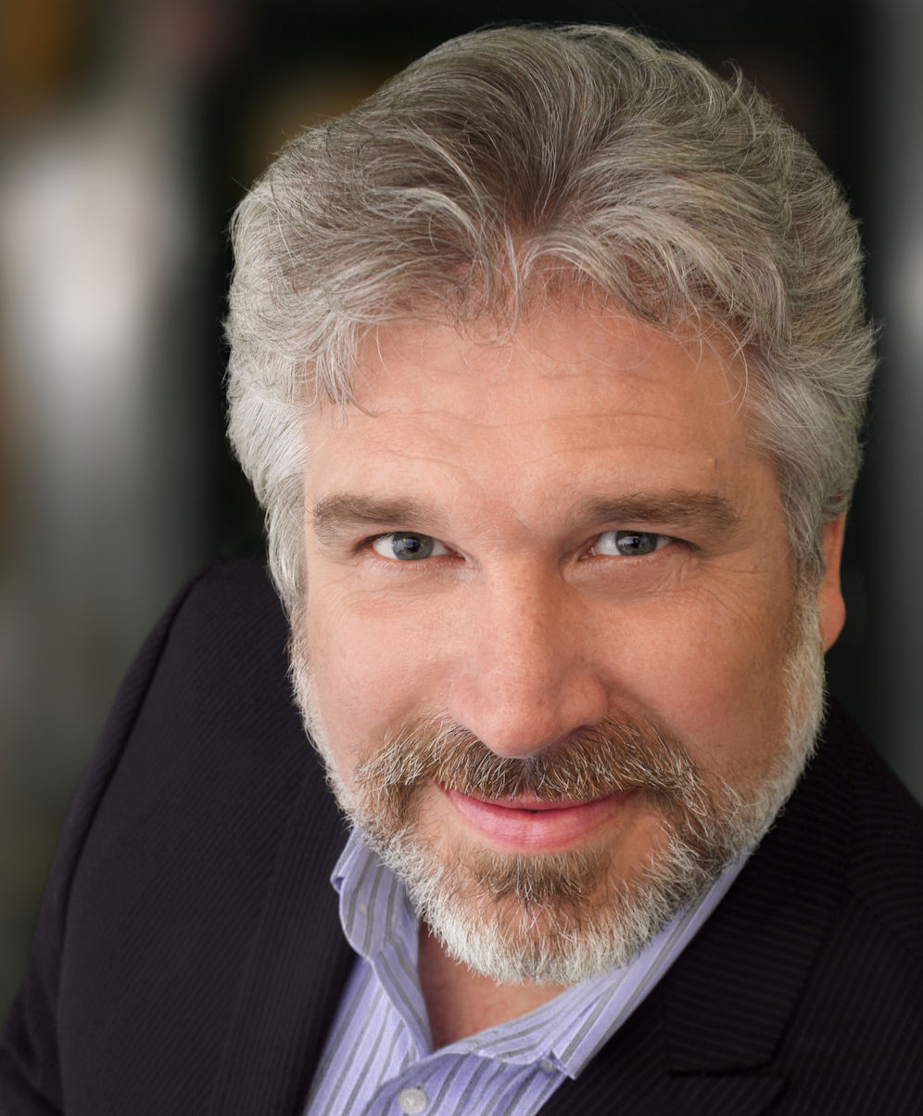
Artist Biography Michael Nansel
Management/Agent: Peter Randsman
Randsman Artists Management
400 West 43rd Street Apt. # 18E
New York, NY 10036
Telephone: 212-244-5874
Email: randsman@aol.com
Production/Season: 2019-2020
Date Created: 04/21/2020
Michael Nansel is an award winning singer and actor. Best-known as an opera singer, he is also an accomplished recitalist and concert artist, and appears frequently in musical theater classics. Between Opera and Musical, Mr. Nansel has over 75-roles to his credit. He sings music from the Mozart to Sondheim, from Verdi to Rodger & Hammerstein. He was the Wichita Grand Opera Singer of the Year in 2012 and was the dual winner in 2003 of the Washington Area Theatre Community Honors for Outstanding lead actor in a musical and Outstanding Featured Actor in a Musical. He has also twice been a member of Casts nominated for Helen Hayes Awards.

His voice has been described as “stentorian”, “rich” with “great vocal and emotional power”. Reviewers have also remark that his acting “communicates deep humanity”, can be “tender and anguished” and that he is “the top banana”. Mr. Nansel possesses a diverse repertoire ranging from the comedic Figaro (Barber of Seville), Don Giovanni (Don Giovanni) and Belcore (L'Elisir d'Amore) to the dramatic Count Di Luna (Il Trovatore) and Escamillo (Carmen). Among his most widely acclaimed roles are the Di Luna, Iago (Otello), Figaro, as well as Danilo (The Merry Widow), and the Title Character in Sweeney Todd: The Demon Barber of Fleet Street. His concert credits include: Mendelsohn’s Elijah, Haydn's Creation, Mozart's Requiem, Faure's Requiem, Handel's Messiah, Brahms’ Requiem, Beethoven’s Mass in C Major, and Block’s Sacred Service (Avodat Hakodesh).

He has been conducted by several Maestros of note including; Julius Rudel, Plácido Domingo, Eugene Kohn, Marin Alsop, Steven Mercurio and Gregory Buchalter. Directors of note include Stephen Lawless, Jonathon Loy, Jayme McDaniel, James Marvel and Scott Schwartz. He has shared the stage with Joyce DiDonato, Salvatore Licitra and Yunah Lee, Denise Graves, Lucas Meachem, Samuel Ramey and Paul Plishka.

Currently, Mr. Nansel resides in the Washington, DC area with his wife of 34 years and their pack of dogs, lizards and various fosters.

Quotes
In the title role, Michael Nansel exhibited an exceptionally vivid and powerful baritone, and he swaggered and blundered with engaging unself-consciousness. Opera News, Joanne Lessner, 07/26/2017

Baritone Michael Nansel’s Count Di Luna also displayed a great vocal and emotional power making his character compelling and believable. Wichita Eagle, David Baxter, February 6, 2012

Michael Nansel won the hearts of audience members in his portrayal of the brash and conceited Belcore, his baritone voice in fine, fluid form throughout the performance.
Wichita Eagle, Lori Linenberger, February 15, 2010

“...the top banana is unquestionably Michael Nansel.” Washington Post, Celia Wren, March 8, 2007

