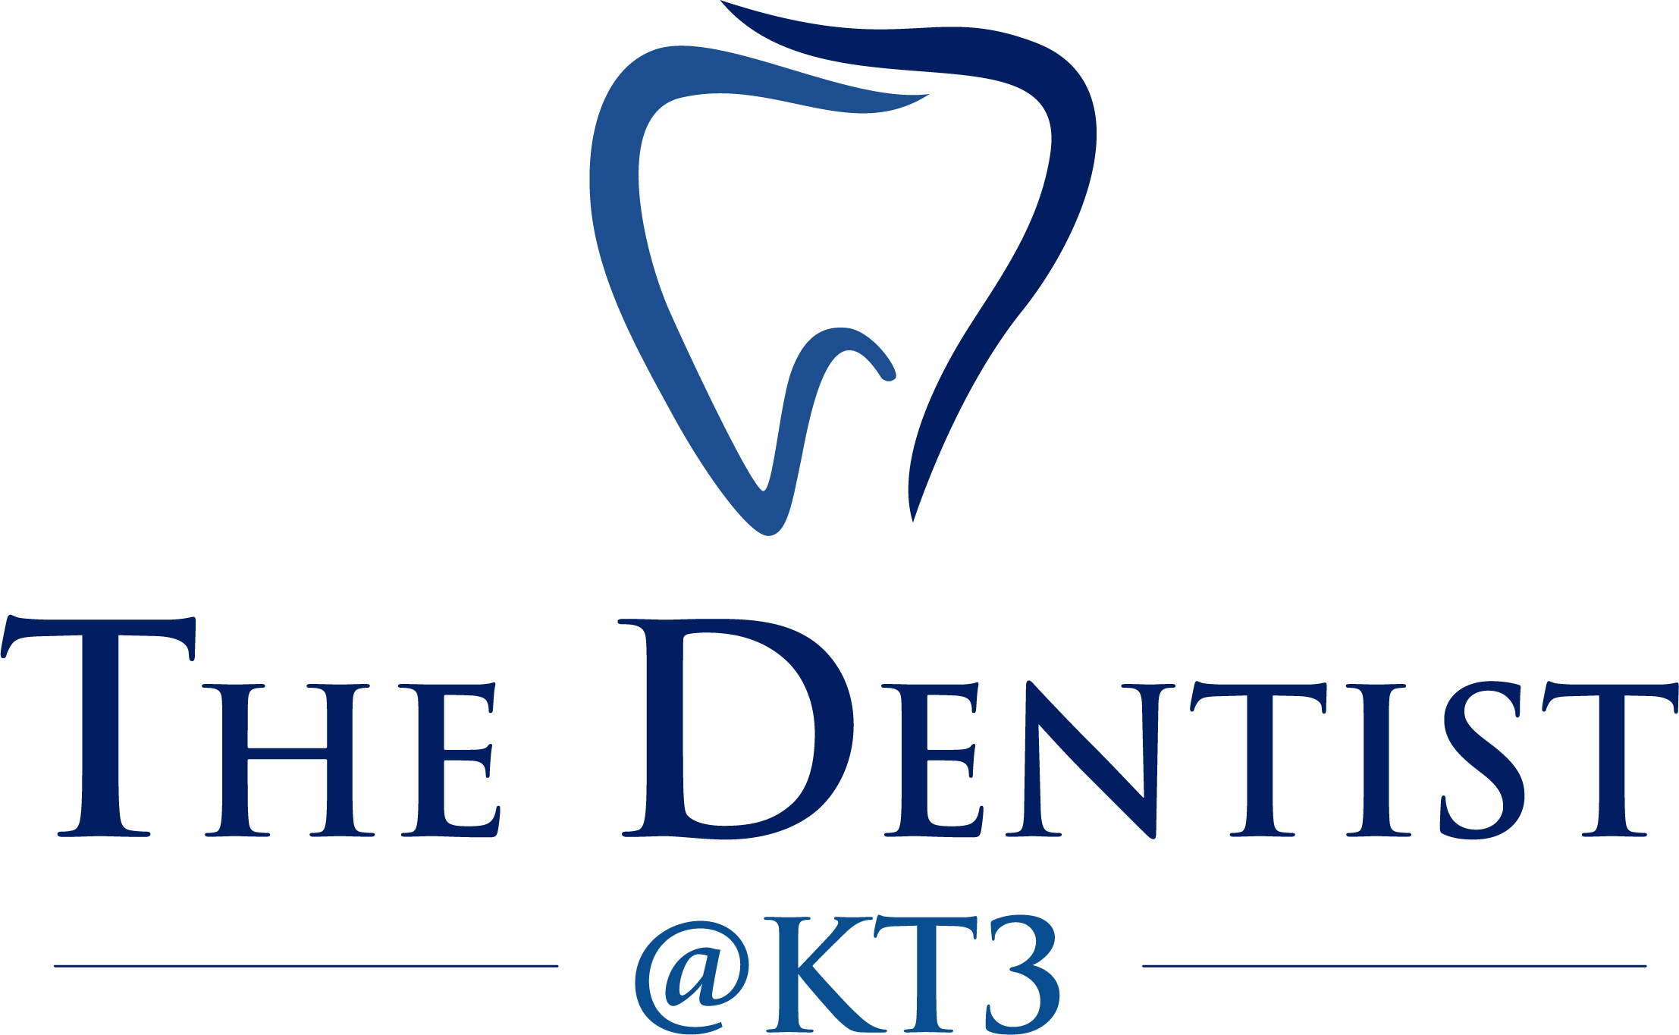

NHS: ----- IDC: ----- PRIVATE: -----

We ask you for information about your general health to help us treat you safely. Please write your contact details below, answer the health questions and then sign the form on the back page. We will use this form at later visits to discuss any changes in your general health. All information will be kept strictly confidential by the people caring for you.

Surname Title

Forenames NHS No.

Sex Male/Female Date of birth day____ month____ year______

Address

Postcode

Telephone home work

Mobile

Email

By entering your telephone numbers and email you are giving your consent to us to contact you by these methods. Your consent can be withdrawn at any time by calling us or emailing us at nhsdental.kingston.thedentistkt3v02338:nhs.net

Occupation

Date of last dental treatment
Day month year

Doctor’s (GP) name

Doctor’s address

Doctor’s telephone

Are you currently | Y | N | GIVE DETAILS
Receiving treatment from a doctor, hospital or clinic?
Taking any prescribed medicines (e.g. tablets, ointments, injections or inhalers, including contraceptives and hormone replacement therapy)?
Carrying a medical warning card?

Pregnant

Do you suffer from | Y | N | GIVE DETAILS
Allergies to any medicines (eg penicillin), substances (eg latex/rubber) or foods?
Hay fever or eczema?

Bronchitis, asthma or other chest condition?
Fainting attacks, giddiness, blackouts, epilepsy?
Heart problems, angina, blood pressure problems, or stroke?
Diabetes (or does anyone in your family)?
Arthritis?

Bruising or persistent bleeding following injury, tooth extraction or surgery?
Any infectious diseases (including HIV and hepatitis)?
Did you, as a child or since, have: | Y | N | GIVE DETAILS
Rheumatic fever or chorea?

Liver disease (e.g. jaundice, hepatitis) or kidney disease?
Any other serious illness?

Blood refused by the Blood Transfusion Service
A bad reaction to general or local anaesthetic?
A joint replacement or other implant?
Treatment that required you to be in the hospital?
Heart surgery?

Drinking | UNITS / WEEK
How many units of alcohol do you drink per week?  (A unit is half a pint of lager, a single measure of  spirits or a single glass of wine/aperitif.) | Units per week

Smoking and Chewing | Y | N | IN PAST | QUANTITY
Do you smoke any tobacco products now (or did you in the past)? |  |  |  | times per day
Do you chew tobacco, pan, use gutkha or supari now (or did you in the past)? |  |  |  | times per day

Please give any other details which your dentist might need to know about, such as self-prescribed medicines (eg aspirin)

Completed by (please tick) Self Parent Guardian

SIGNATURE DATE

Please check that the health information on this form is still correct (including information on smoking and drinking). If not, amend as necessary or note any changes below.

Date | No change | Changes | Patient’s  initials

ADDITIONAL NOTES:
If you think you may be exempt from dental charges, proof of exemption will be required at every appointment. You will have to sign a declaration and if a false or incorrect declaration is made you may be liable to a fine and the full cost of the treatment.

MISSED APPOINTMENTS:
If you fail to attend your first appointment or cancel without 24 hours’ notice we will be unable to care for your oral health at this Practice.

Date | No change | Changes | Patient’s  initials

