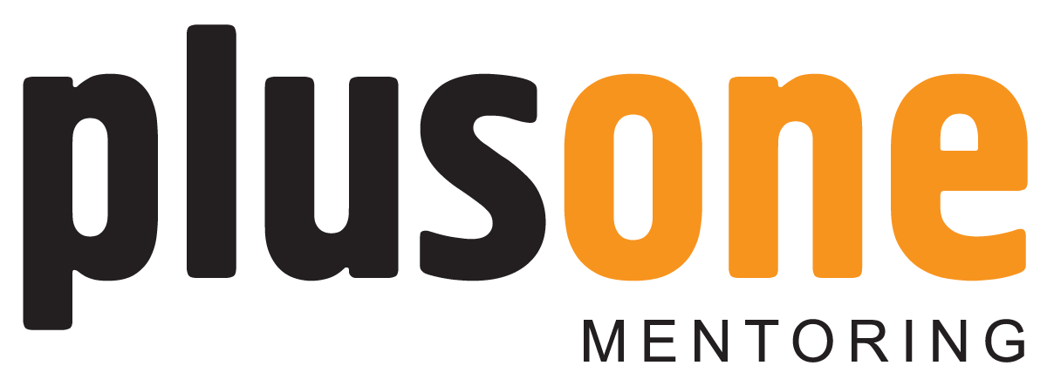

PLUSONE MENTORING ROLE DESCRIPTION

Title Volunteer Mentor

Summary

We are looking for volunteers who are eager to make a difference in their own community and make a difference in the life of a young person. The mentor will regularly meet up with a young person offering a friendly ear, support and guidance and advice on making positive life choices. There will also be a need for the mentor to build a relationship with the young person’s parents/guardians, although the main focus is the young person. Full training will be given (over 5 weeks) and a PVG Scheme Record check will be required (no cost involved).

Role Description

A mentor will be expected to regularly meet up with the young person and do things together that are fun and engaging. You must be a good listener and be able to engage in conversations with the young person to encourage them to develop important life skills. You will always set a good example to the young person and encourage positive behaviour. You will play an important role in helping a young person achieve their full potential and build on the young person’s strengths.

Skills/Experience

We require no formal qualifications – the only thing on paper that we need is PVG Scheme Record. If you are a parent you will immediately bring direct experience of relationship, of different responses to authority and of a wide range of attitudes and behaviours.

You will be able to reflect on life experiences where you personally have faced difficulties and challenges in life, with which you gained essential learning and understanding about many of the experiences that a young person will face.

Empathy

Mentors will need to be able to show empathy to a young person and see things from the perspective of the young person. It will be important to help the young person develop empathy for others.

Non Judgemental Approach

An absolute vital quality of a good mentor is that he or she will not be judgemental towards a young person. There will be times that mentors will disagree with choices being made and behaviour patterns, however maintaining a trusting relationship relies on mentors avoiding making judgements and avoiding criticising the young person.
Motivation to see Young People succeed

It is important that mentors show a motivation to see children and young people succeed in life. Often this can be expressed as an understanding of the difficulties and challenges vulnerable young people might face. It can also be reflected in a mentor looking beyond the behaviour of a young person to see the root causes, to see the reasons why they may be behaving this way. The mentor wherever possible seeks to encourage and praise the positive decisions and changes young people make.

If you are interested in becoming a mentor or would like more information and an informal chat please contact:

Mike Kerracher

Plusone Programme Manager
Acorn Centre
YMCA Edinburgh
1 Junction Place
Edinburgh
EH6 5JA
Tel: 0131 553 7877 / 07844032200

 YMCA Edinburgh SC004425 