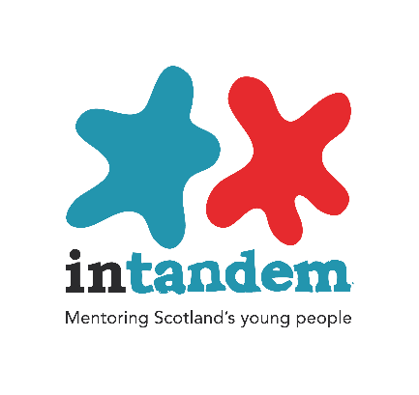

Information and Role Description: intandem Mentor

Summary

intandem, Scotland’s mentoring programme for young people, brings together vulnerable young people aged 8-14 with a mentor to build a consistent and trusting relationship, and improve their chances in life. The Scottish Government has appointed Inspiring Scotland to lead the development of the intandem programme, with YMCA Edinburgh one of the delivery organisations in Edinburgh

intandem aims to focus on and promote the wellbeing of every child who is matched with a mentor. The focus of every mentoring relationship will be on supporting the development of the child by listening to them, recognising and building on their existing strengths and providing support and encouragement to deal with difficult and challenging situations in their lives.
YMCA Edinburgh has a wealth of experience operating mentoring services, through our award winning Plusone Programme and Aspire community mentoring. We know first-hand the significant difference mentoring can make to children and young people, as well as the equally valuable rewards it offers volunteers.
Mentors Role
As an intandem mentor you will undergo training and then be matched with a young person referred to the project. The mentor’s role is to regularly meet up with the young person (typically once a week for 2 hours), to take part in activities in the community that are fun and engaging, acting as a listening ear and positive role model to the child.

The time that mentoring takes place is flexible and arranged between the young person and mentor, however it usually occurs out of school hours (evenings or weekends). Mentoring relationships last at least one year, therefore we require individuals to make a commitment to a minimum of 1 years mentoring. Regular support is provided throughout the mentoring relationship, through meetings with the project coordinator as well as regular opportunities to meet with other mentors at training events, peer support nights and social events.

Skills/Experience

You must be a good listener and able to engage in conversations with the young person to encourage them to develop important life skills. You will set a good example to the young person and encourage positive behaviour. You will play an important role in helping a young person achieve their full potential and build on the young person’s strengths.
Being a mentor does not require qualifications but does involve showing empathy, understanding, being motivational and having a commitment to your mentee. Some of the young people live in very challenging circumstances therefore it is essential you have a non-judgemental approach.

As a mentor, you will be expected to provide your mentee the young person with the consistency and time dedicated to them that they may be lacking in life, so preparing for the role by using the ongoing support and training available is expected from our mentors.

As a mentor, you will also be encouraged to reflect on your personal life experiences, particularly those situations in which you have faced difficulties and challenges, as this essential learning and understanding will support you in any discussions with the mentee about their experiences.

Becoming a mentor

Completed application forms should be emailed to intandem@ymcaedinburgh.com and if you have any queries and would like a chat before taking things forward then don’t hesitate to call on 0131 553 7877 or to send an email.

Our office and centre is located at:
YMCA Edinburgh
1 Junction Place
Edinburgh
EH6 5JA

